TRANSITIONAL CURRICULUM FOR BAMS 1ST PROFESSION
2025-26
(27.11.2025 TO 12.12.2025)
A REPORT

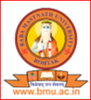

SHRI BABA MAST NATH AYURVEDIC COLLEGE & HOSPITAL
ASTHAL BOHAR, ROHTAK 124021

SCHEDULE OF TRANSITIONAL CURRICULUM 2025
27th Nov 2025 (1ST DAY)
(Thursday)
9:00 to 11:00 am Lord Dhanvantri Pooja
– Lamp Lightening
– Dhanwantri Vandana by students
- Oath Taking Ceremony
- Introduction about the Institution by Dr. Neeraj khare
- Inaugural Function

11:00 to 12:00 am –Introduction to Ayurveda, what is Indian Knowledge System (IKS)? Overview: Orientation lecture on Vision of reality, Holistic view of human wellbeing. Public Health and Ayurveda in community (Role of (IKS) Role of Ayurveda in public health dilevered by Dr Timsi.
12:00 to 12:45– Administrative Structure: Who is Who in the CollegeCampus Rules, Regulations& Dress Code: Generalconduct, timings, andcampus policiesRules by Dr. Pradeep JM.
12:45 to 1:00- pre – test google form (30 question ) Conduct by Dr Sonika.

1:00 to 2:00 – Lunch
2:00 to 4:00 – Shishyopanayam Sanskarm Campus visit academic blocks, meet faculty of Rachana sharir & kriya sharir.

28th Nov 2025
9:00 to 10:00 – वदतु संस्कृतम् , Dhanwantri prayer – Dr. Jagdish
10:00 to 11:00 – , Overview of other Indian Medical Systems: Unani, Siddha, Sowa Rigpa, Yoga Naturopathy & Homeopathy Regulatory Bodies – Dr. Vikas
11:00 to 12:00 – Motivational speech (guest lecture) – Dr Sanjiv Vashishth
12:00 to 1:00 – Dhanvantari Prayer & Who is good Vaidya (Charaka’s view)who is good vadiya (charak ‘s view)- Dr. Anupama patra

1:00 to 2:00 – Lunch
2:00 to 4:00 – photography in academic blocks, Pharmacy visit

29th Nov 2025
9:00 to 10:00 – वदतु संस्कृतम् – Dr. Jagdish
10:00 to 11:00 – Thought for the day Ayurveda and yoga as indian soft power diplomacy , mindfulness and sitting in silence – Dr. Gourav
11:00 to 12:00 Scope of Ayurveda: Current status, legal recognition, and national scope. Global Scope of Ayurveda: Growing acceptance and international opportunities
Dr. Manish
12:00 to 1:00 – Effective time management strategies –Sankalpa to Siddhi" - Time Management for Obtaining Academic and Clinical Excellences Dr. Arunachal
1:00 to 2:00 – Lunch
2:00 to 3:00 – Intergrative tradition with Ambition Goal setting in Ayurveda Education -Dr A.P. Nayak.
3:00 to 4:00- OPD visit photography in hospital, OPD/IPD – Dr shushan, dr Parveen

1st dec 2025
9:00 to 10:00 – वदतु संस्कृतम् – Dr. Jagdish
10:00 to 11:00 – self – directed , self motivated, learning skills and studying skills – Dr. Seema Jaglan
11:00 to12:00 – Lecture on stress management yoga meditation, Relaxation techniques – Dr Gourav
12:00 to 1:00 – Ayurveda based practice capacity building in Entreprenurship development in contest of Ayurveda field – Dr Sanjeev Madan
1:00 to 2:00 – Lunch
2:00 to 4:00 – fun & Intraction with 2021- 2022 batch.

2nd Dec 2025
9:00 to 10:00 – वदतु संस्कृतम् – Dr. Jagdish
10:00 to 11:00 – LMS – Dr. Devender Vashishth
11:00 to 12:00 – Introduction to Bruhatrayi charak, sushruta vagbhata– Dr Vijender Kumar gupta
12:00 to 1:00 – Stress management/ how to feel happiness through meditation – Dr Gourav dalal
1:00 to 2:00 – Lunch
2:00 to 4:00 – Interaction with 2024-25 batch (fun) – Dr Deepak, Dr Sonika, Dr pooja

3rd Dec 2025
9:00 to 10:00 – वदतु संस्कृतम् – Dr. Jagdish
10:00 to 11:00 – Basic life support emergency, protocol, CPR theory ( adults, children, infants)– Dr. Devender yadav
11:00 to 12:00 – Research awareness and evidence based Ayurveda Orientation Academic Writing: Introduction to Scientific Writing & Plagiarism – Dr Manjula
12:00 to 1:00 – Heritage in young hands: Youth as brand ambassadorsof Ayurveda (Search for start-ups, wellness industry on digital platforms)– Dr Rajeev verma
1:00 to 2:00 – Lunch
2:00 to 4:00 – Interaction students batch 2023- 24

4th DEC2025
9:00 to 10:00 – वदतु संस्कृतम् – Dr. Jagdish
10:00 to 11:00 – Inspirational talk by senior vadiya/Professor about why Ayurveda is more relevant than ever/ my journey as an Ayurvedic doctor. – Dr. Vijaya Kaushik
11:00 to 12:00 – Laghutrayee with elobration of Ashtang haridya – Dr brajlal
12:00 to 1:00 – Ayurveda& personalised medicine.Parkriti as a key to preventive and curative health. – Dr Naveenta
1:00 to 2:00 – Lunch
2:00 to 4:00 – Learning form seniors Interaction batch 2021-2022

5th Dec2025
9:00 to 10:00 – वदतु संस्कृतम् – Dr. Jagdish
10:00 to 11:00 – Ayurveda Physiology Corelation of Satvavjeya chikitsa – Dr. Ajay Dahiya
11:00 to 12:00 – Addiction of Satvavjeya chikitsa and rasayan– Dr chandranshu
12:00 to 1:00 – Reflection becoming a vaidya discovering my path to purpose – Dr Raj kailash
1:00 to 2:00 – Lunch
2:00 to 4:00 – Intergrative tradition with Ambition goal setting with Ayurveda Education- Dr Sonika

6th Dec 2025
9:00 to 10:00 – वदतु संस्कृतम् – Dr. Jagdish
10:00 to 11:00 – Computer Basic Skills – Dr. Devender Vashishth
11:00 to 1:00 – Basic Life support & First Aid – Dr pooja
1:00 to 2:00 – Lunch
2:00 to 3:00 – Lecture on Institutional officials & their roles in the hierarchy – Dr Nisha Jaglan
3:00 to 4:00 – Musical Chair

8th Dec 2025
9:00 to 10:00 – वदतु संस्कृतम् – Dr. Jagdish
10:00 to 11:00 – Computer basic skills – Dr. Devender Vashishth
11:00 to 12:00 – Orientation speech – Dr Ajay dhsiya
12:00 to 1:00 – Demonstration, Procedure, Library related etc (Ms. Kusum)
1:00 to 2:00 – Lunch
2:00 to 4:00 – Visit to computer lab for practical purpose – Dr Devender Vashishth

9th Dec2025
9:00 to 10:00 – वदतु संस्कृतम् – Dr. Jagdish
10:00 to 11:00 – Health awareness fitness and hygiene – Dr. Sandeep
11:00 to 12:00 – Team building Activities – Dr Gourav Dalal
12:00 to 1:00 – Gender Sensitisation- Dr. Sushma
1:00 to 2:00 – Lunch
2:00 to 3:00 – Availing health care facilities in campus- Dr Amrit
3:00 to 4:00 – Library Visit

10th Dec, 2025
9:00 AM TO 10:00 AM - Orientation to learning methods, Self-learning, collaborating learning, life long learning strategies, time management, Examination Strategies – Dr. Austluxmi
10:00 AM TO 11:30 AM – Lecture on happiness – Dr. Gourav Dalal
11:30 AM TO 01:00 PM – Motivational Lecture by International Speaker
01:00 AM to 02:00 PM – Lunch
02:00 AM to 04:00 PM – Musical Chair
11th Dec2025
9:00 to 10:00 – वदतु संस्कृतम् – Dr. Jagdish
10:00 to 11:00 – Smart goals for academic – Dr. Deepak
11:00 to 12:00 – yoga, meditation session – Dr Gourav Dalal
12:00 to 1:00 – basic of Ayurveda ethics Dr. Rakesh
1:00 to 2:00 – Lunch
2:00 to 3:00 – Availing health care facilities in campus- Dr Amrit
3:00 to 4:00 – Library Visit
11th Dec 2025

9:00 to 10:00 – वदतु संस्कृतम् – Dr. Jagdish
10:00 to 11:00 – students safety & Ragging free campus– Dr. Nisha Jaglan
11:00 to 12:00 – yoga, meditation session – Dr Gourav Dalal
12:00 to 1:00 – proposed higher education pathways in Ayurveda- Dr Varun Setia
1:00 to 2:00 – Lunch
2:00 to 3:00 – Environment hygiene concept of Janapadadwamsam in Ayurveda and Its Relevance to Environment hygiene Dr Shankarma patil.
3:00 to 4:00 – Timeline creation ,time line of the institution milestone (documentary play, introduction and Ayurveda college) -Dr Jagdish.

12th Dec 25 ( minute to minute)

10:00 to 10:10 – Dhanwantri Vandana - Dr Berkha, Dr Austluxmi
10:10 to 10:15 – Arrival of Chief Guests
10:15 to 10:30 – Deep Prajavalan
10:30 to 11:00 – Kuldeep
11:00 to 11:10 – Feliciation of Chief guest
11:10 to 11 :30 – welcome speech by VC
11:30 to 12:00 – Speech by Honorable chancellor sir
12:00 to 12:20 – charak shapat
12:20 to 1:00 – certificate distribution
1:00 to 2: 00 - lunch
2:00-3:00– Cultural Performance
3:00 to 3:30 – certificate distribution
3:30 to 3:45 – vote of thanks
3:45 to 4:00 – National Anthem

1ST DAY 27.11.2025, Thursday
As per instructions given by NCISM, Government of India, New Delhi, Shri Baba Mast Nath Ayurvedic College, Asthal Bohar, Rohtak 124021 has started the Transition Curriculum for the 1st Professional BAMS Students on 27th Nov 2025.By 10:00 AM, the programme started with Shri Ganpati Pooja and Shri Dhanwantri Pooja, followed by lamp lighting. The Chief Guests were Vice-Chancellor Dr. B. M. Yadav and Registrar Dr. Vinod Kumar. All faculty members and newly joined students participated in the programme. It was followed by a welcome speech, chanting, and a warm welcome to the new students.
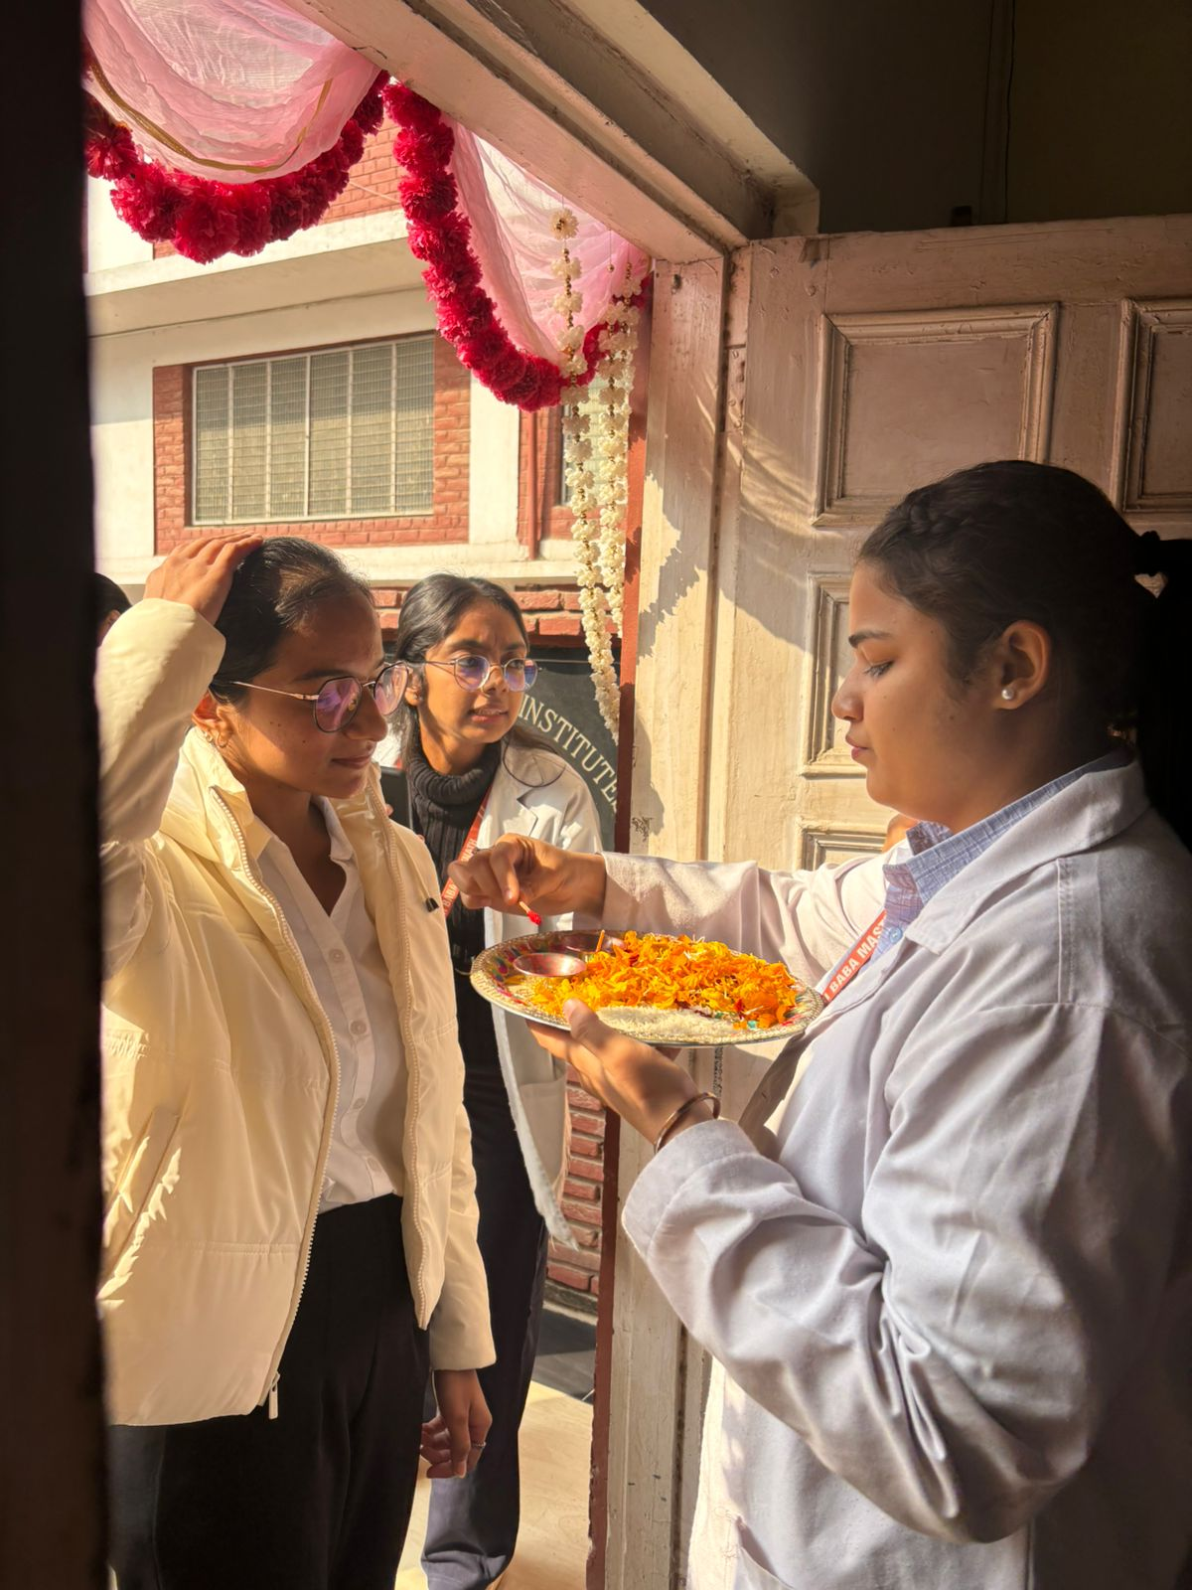

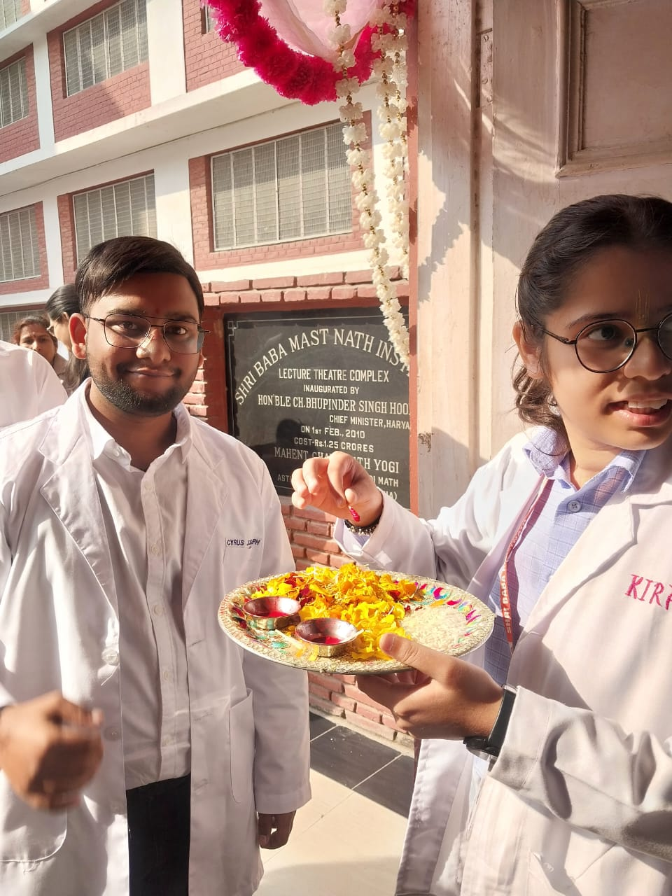

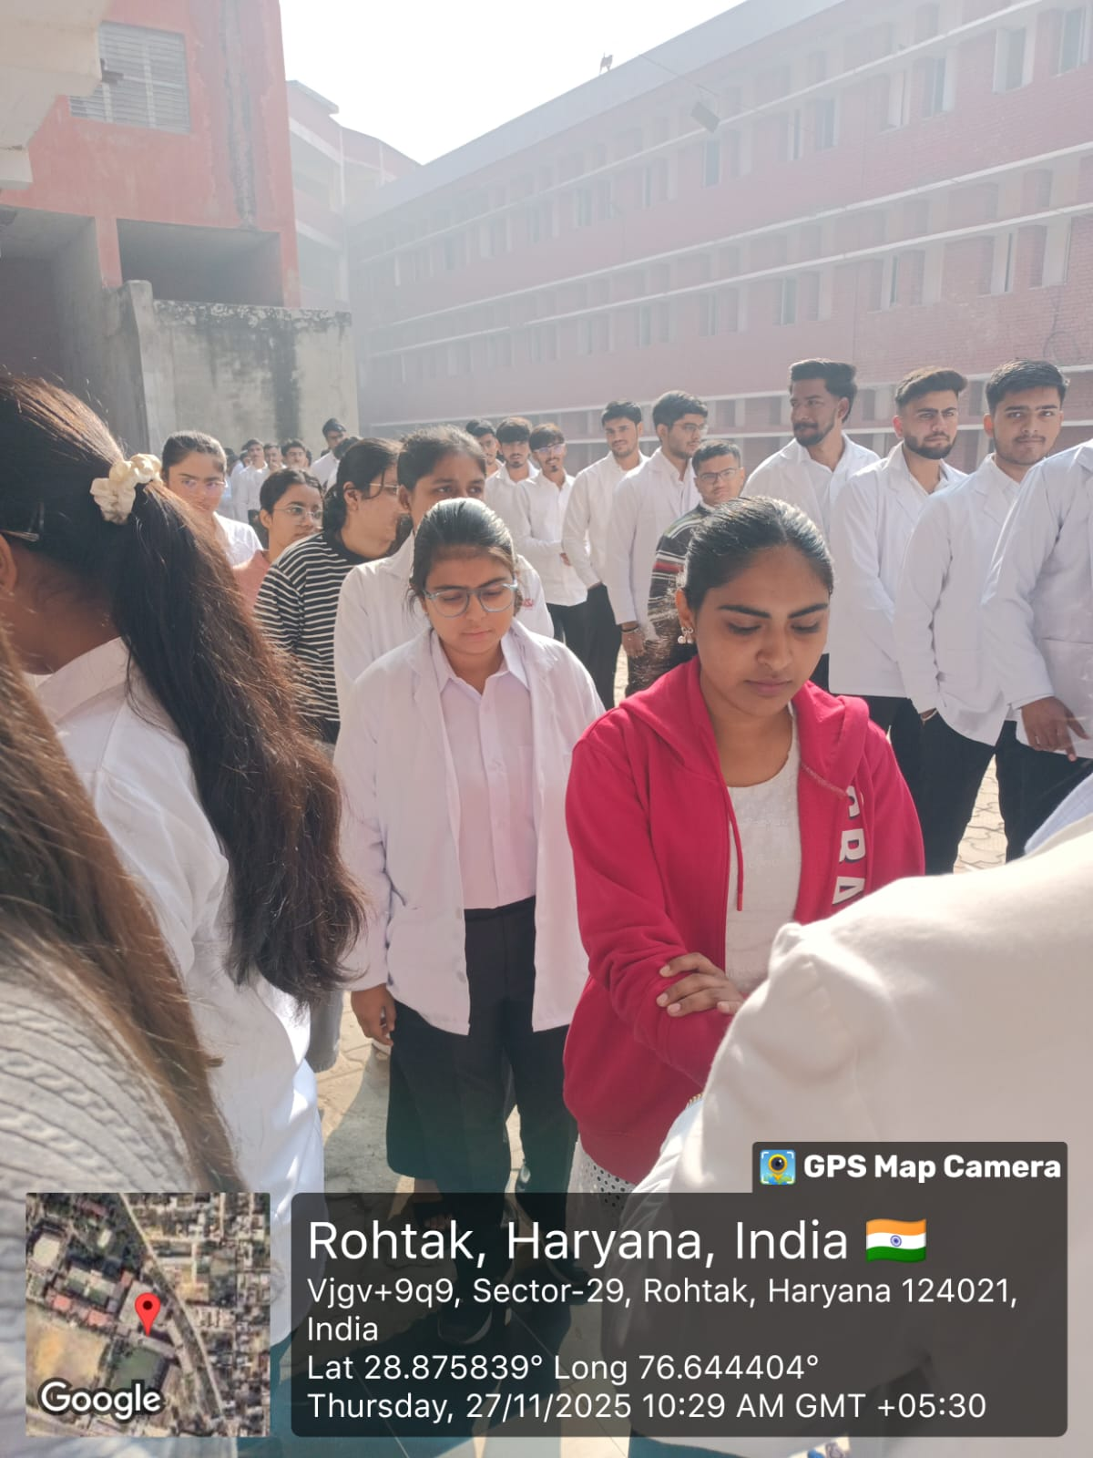
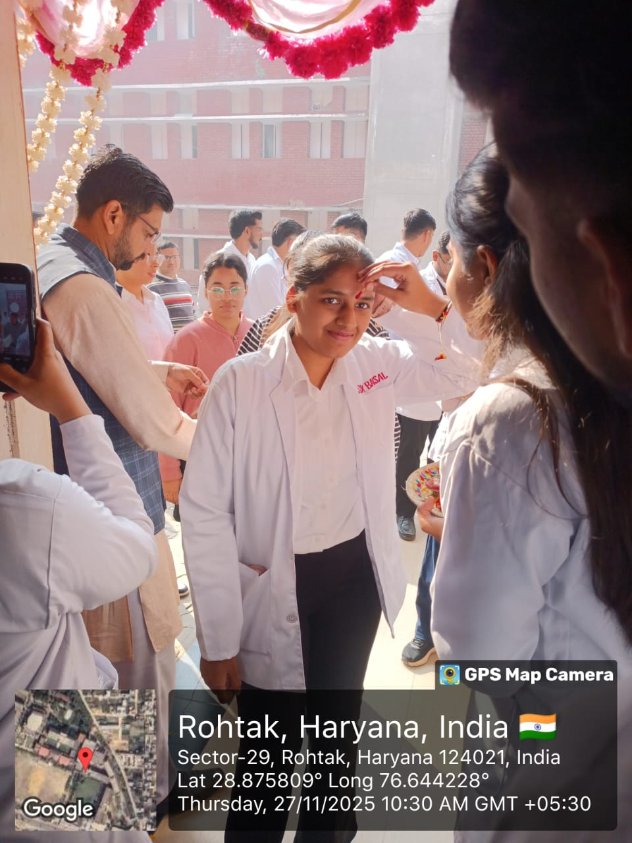

followed welcome speech, Lamp Lighteing , chanting
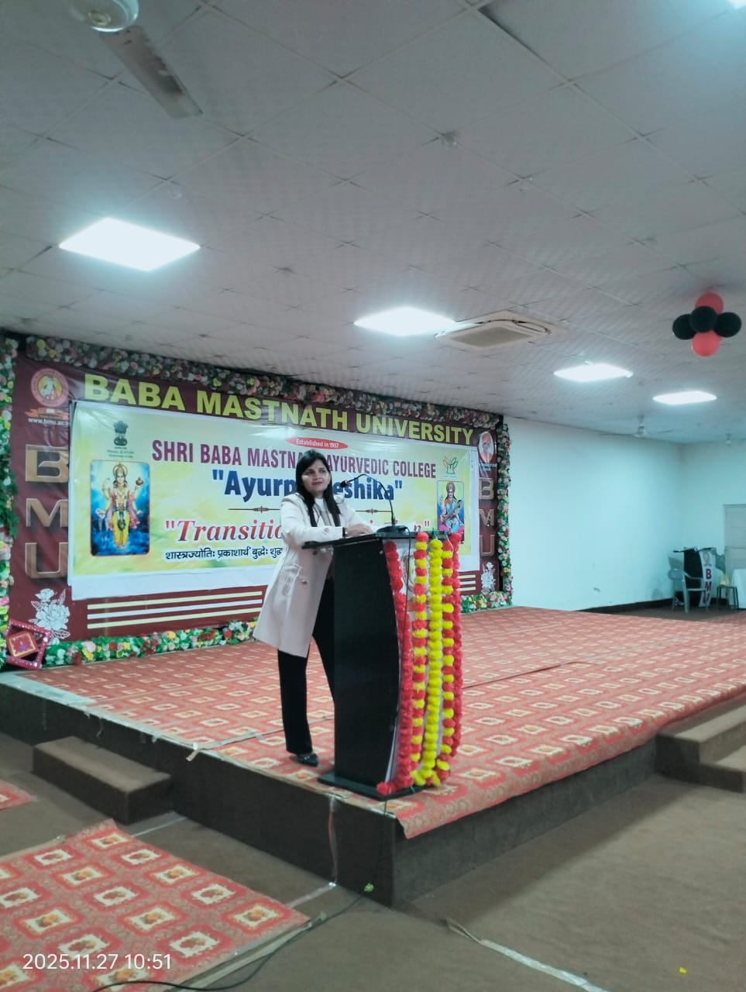
Dr. Naveenta extended a warm welcome to the Guests, the Vice-Chancellor, the Registrar, and the Principal.
INAUGURATION
The Transitional Curriculum programme was inaugurated by the Chief Guest Vice-Chancellor Dr. B.M Yadav, and Registrar. Dr. VINOD Kumar

The Lamp Lightening
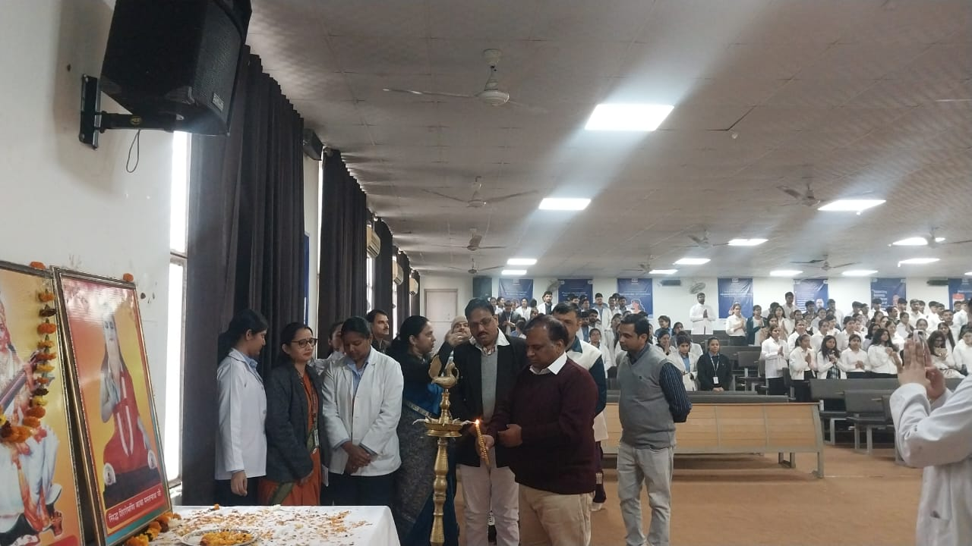

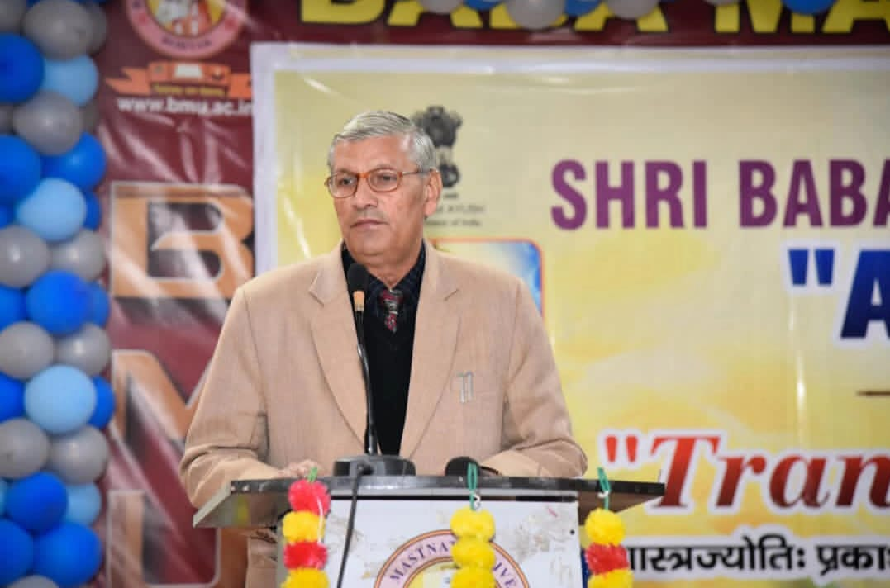

Our Principal, Dr. Neeraj Kumar Khare explained the idea behind introducing the 15-day Transitional Curriculum Programme for 1st Professional BAMS students. He also blessed the students and elaborated on the rules and regulations of the institute, hostel facilities course structure, attendance requirements, professional conduct in a medical college, and the mentorship system of the college. He further clarified the doubts raised by the students.'"
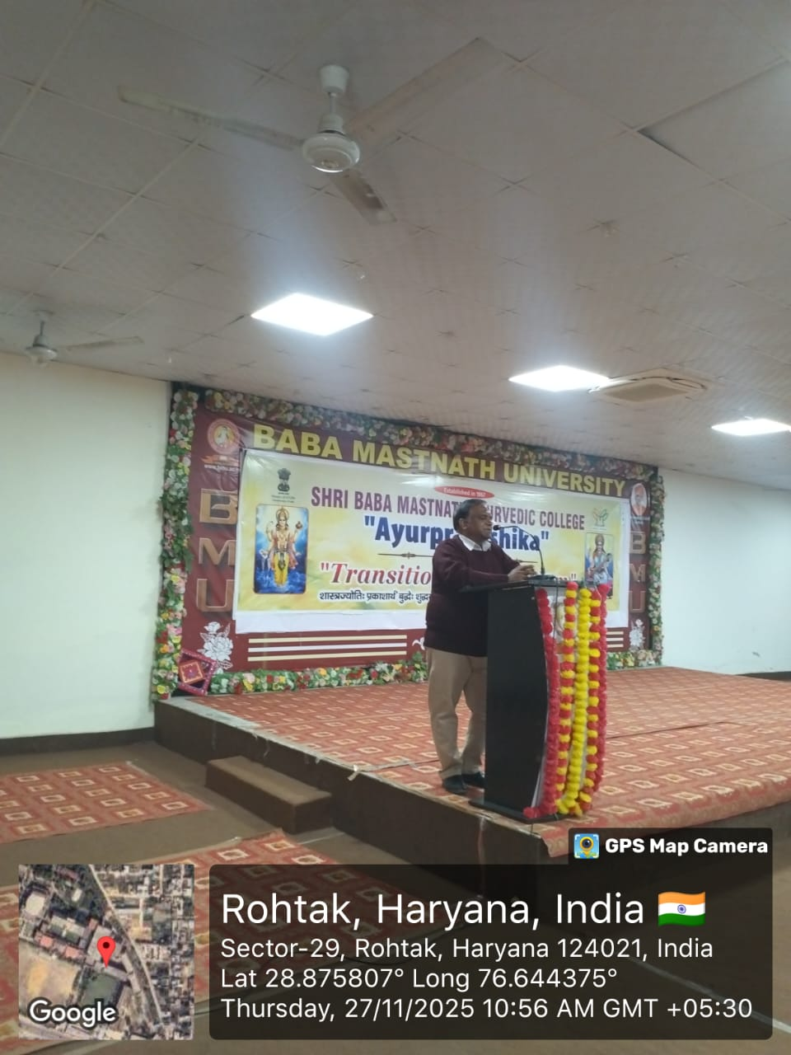

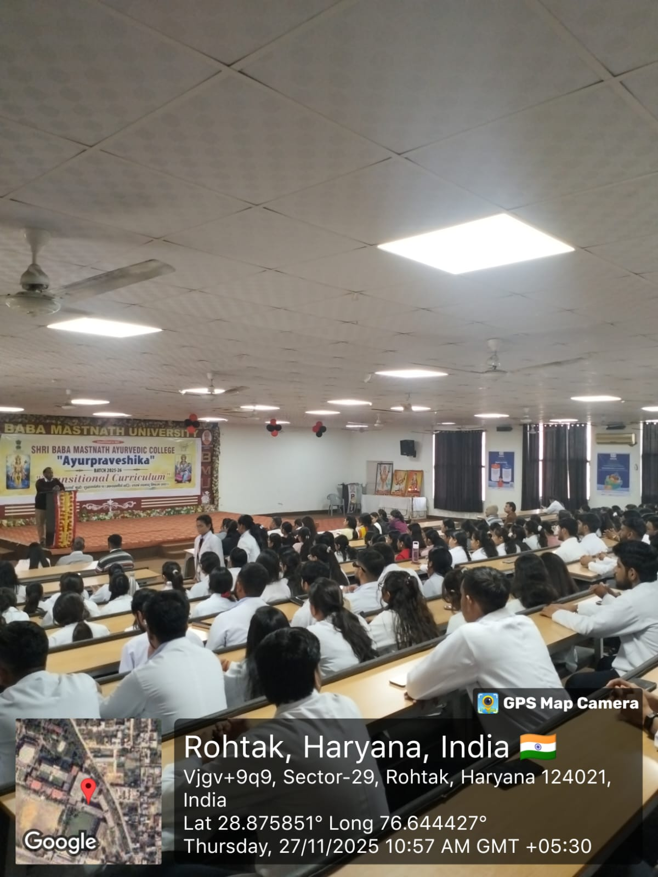
OATH TAKING CEREMONY

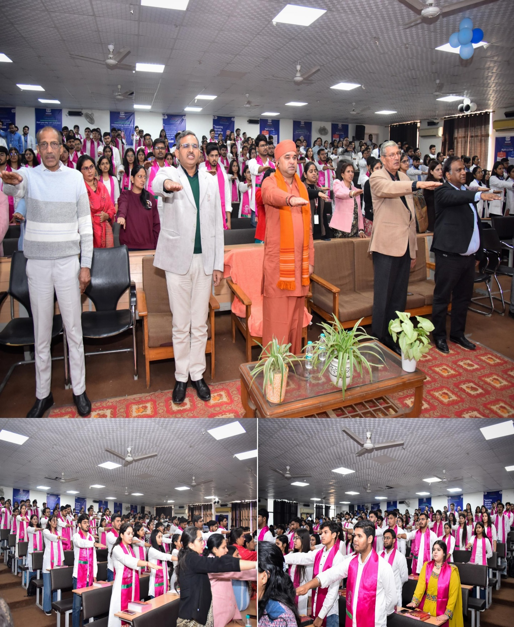

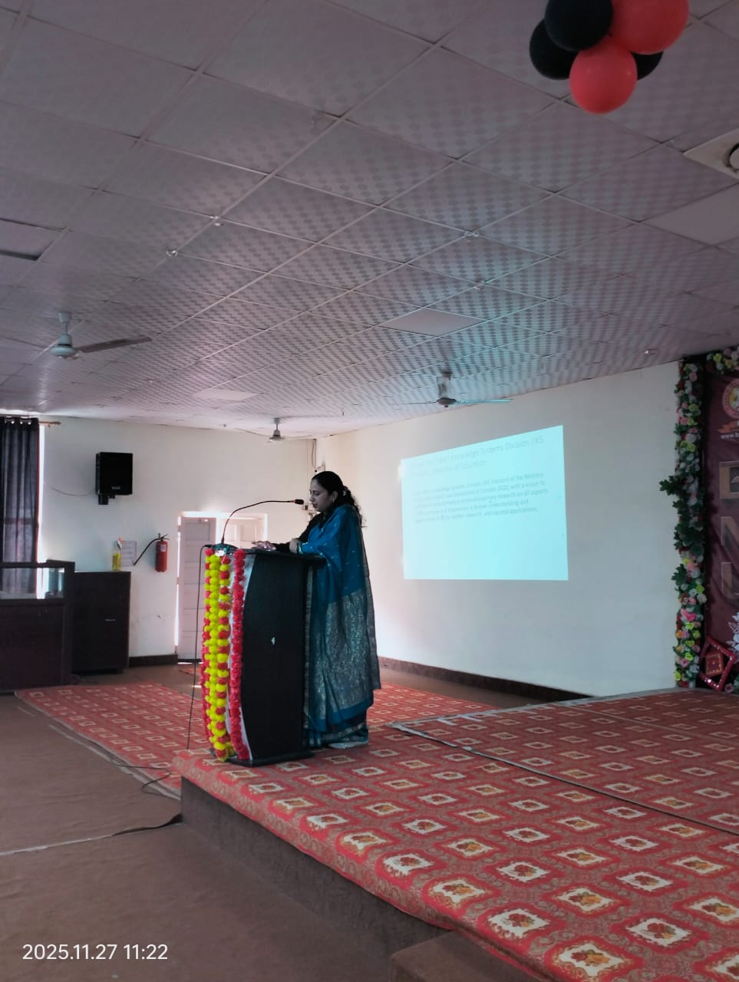
11:00-12:00 Dr. Timsi, Professor, Department of Swasthavrit, delivered a very informative lecture in which the students were explained the role of Avurveda in public health.

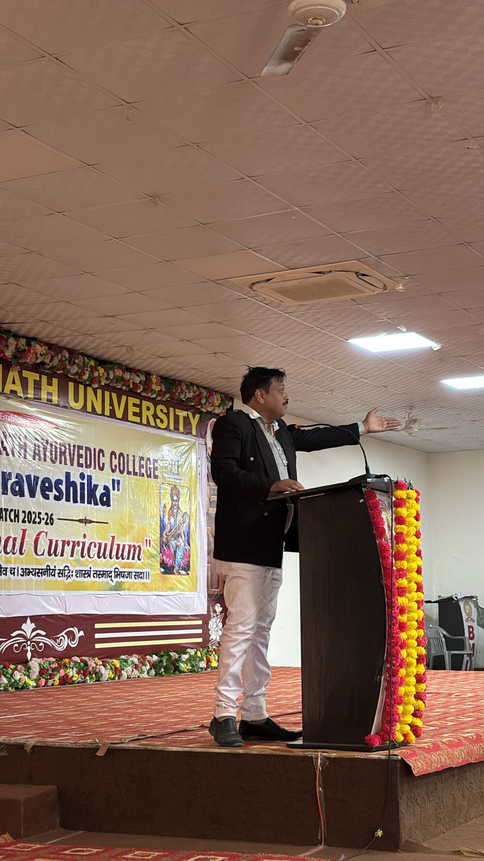
12:00- 1:00 Dr. Pradeep J.M., Department of Kayachikitsa, delivered a lecture on the administrative structure.”
The college administrative structure defines clear roles and responsibilities to ensure smooth campus functioning. The Principal serves as the chief authority, supported by the Vice-Principal, Heads of Departments, and administrative officers. Each role contributes to maintaining discipline, academic quality, and adherence to campus rules. This structure helps students understand whom to approach for academic, disciplinary, or administrative concerns.

12:45- 1:00 Dr sonika given pre- test google form
Pre-Google test helps assess students’ baseline knowledge before the transition programme begins.

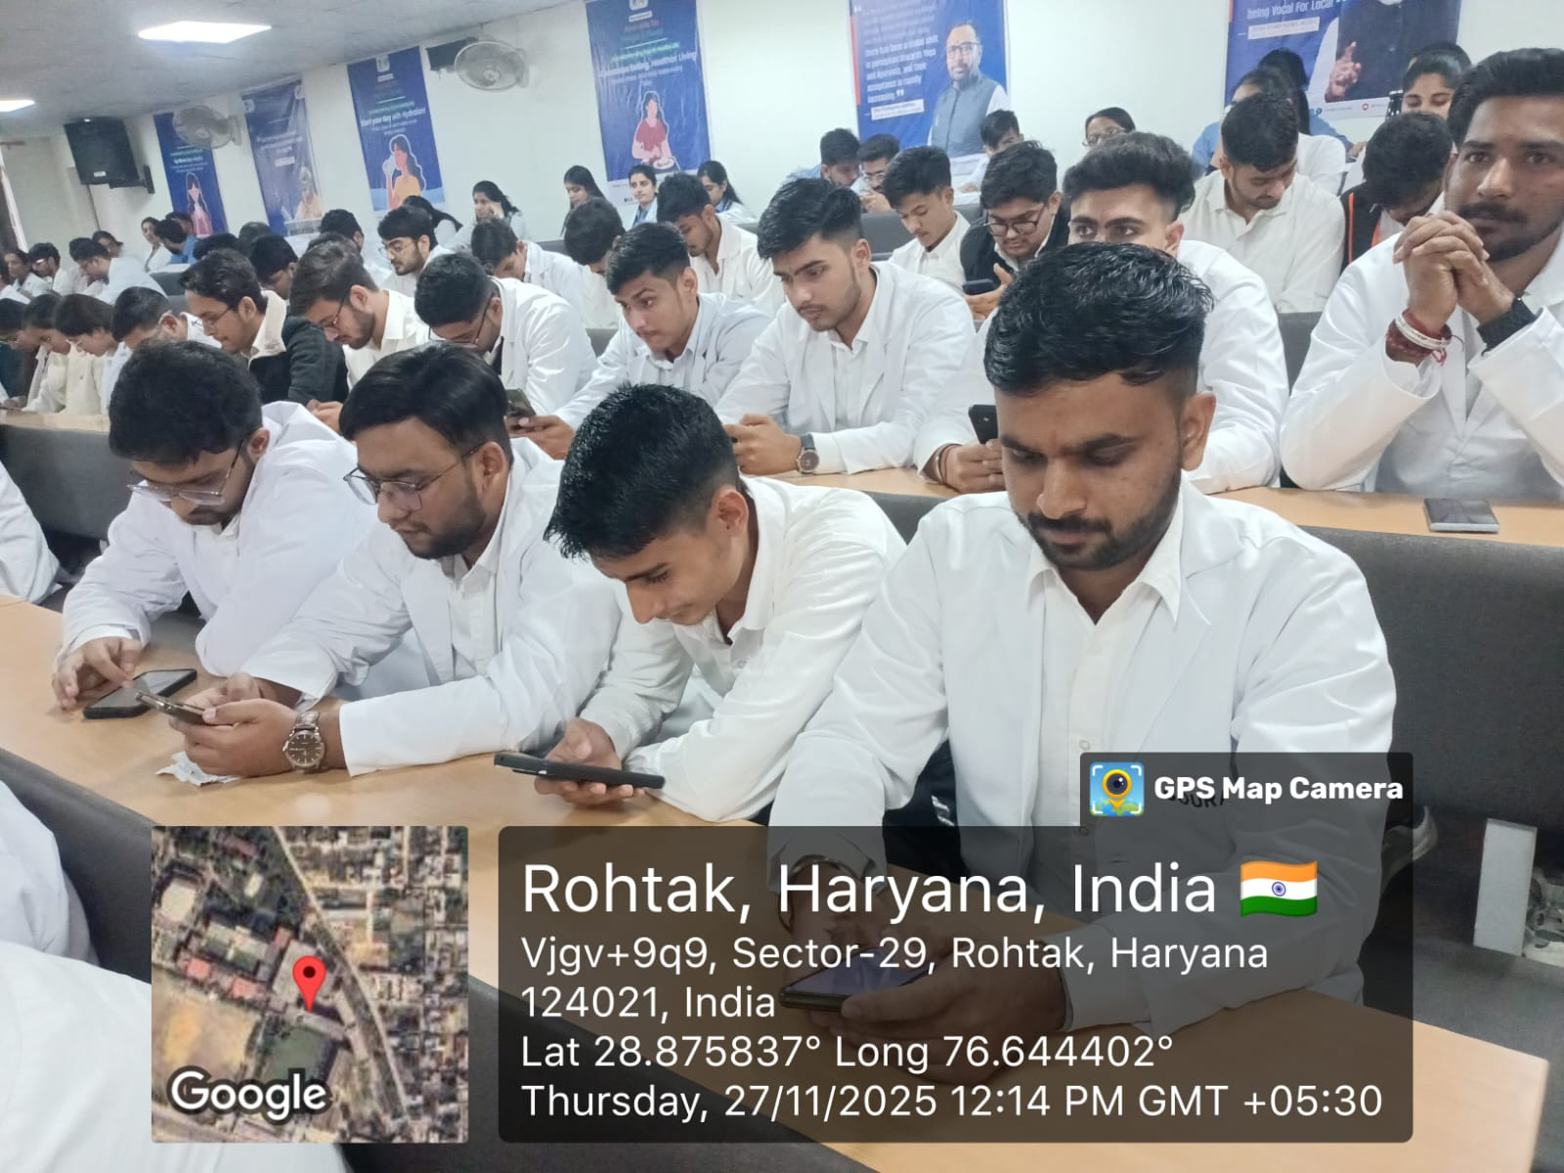

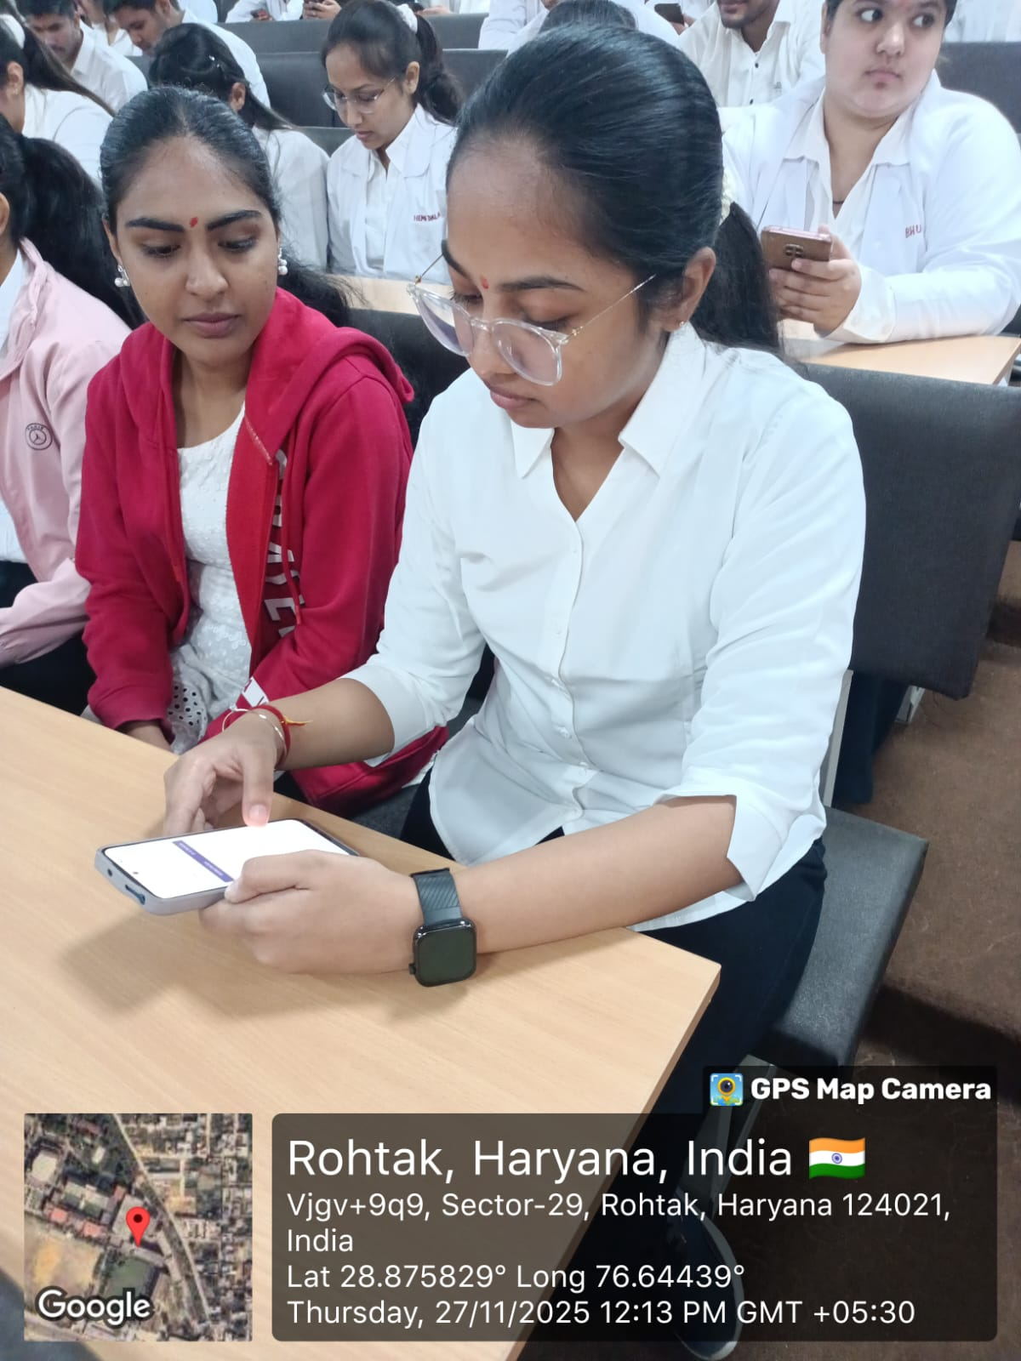

2:00- 4:00 Rachana & kriya sharir visit
Rachana sharir Department visit –“A visit to the Rachana Sharir Department was conducted, during which Dr. Sonika provided an explanation of various bone and organ specimens.”
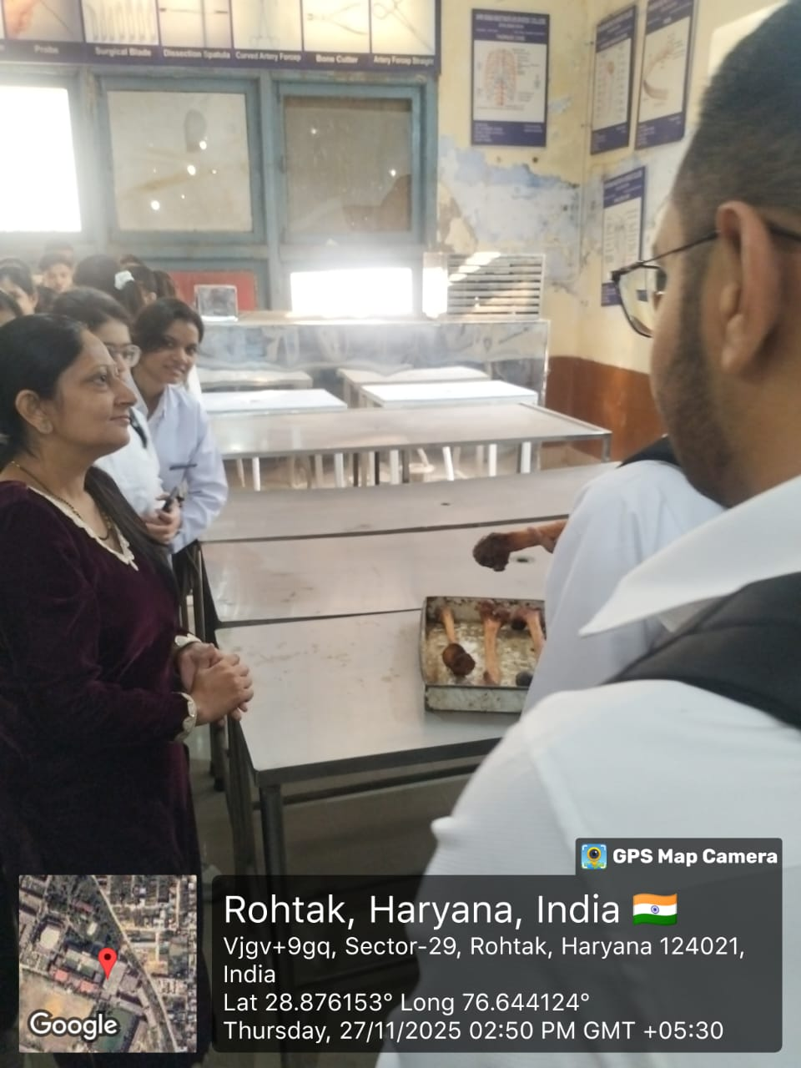
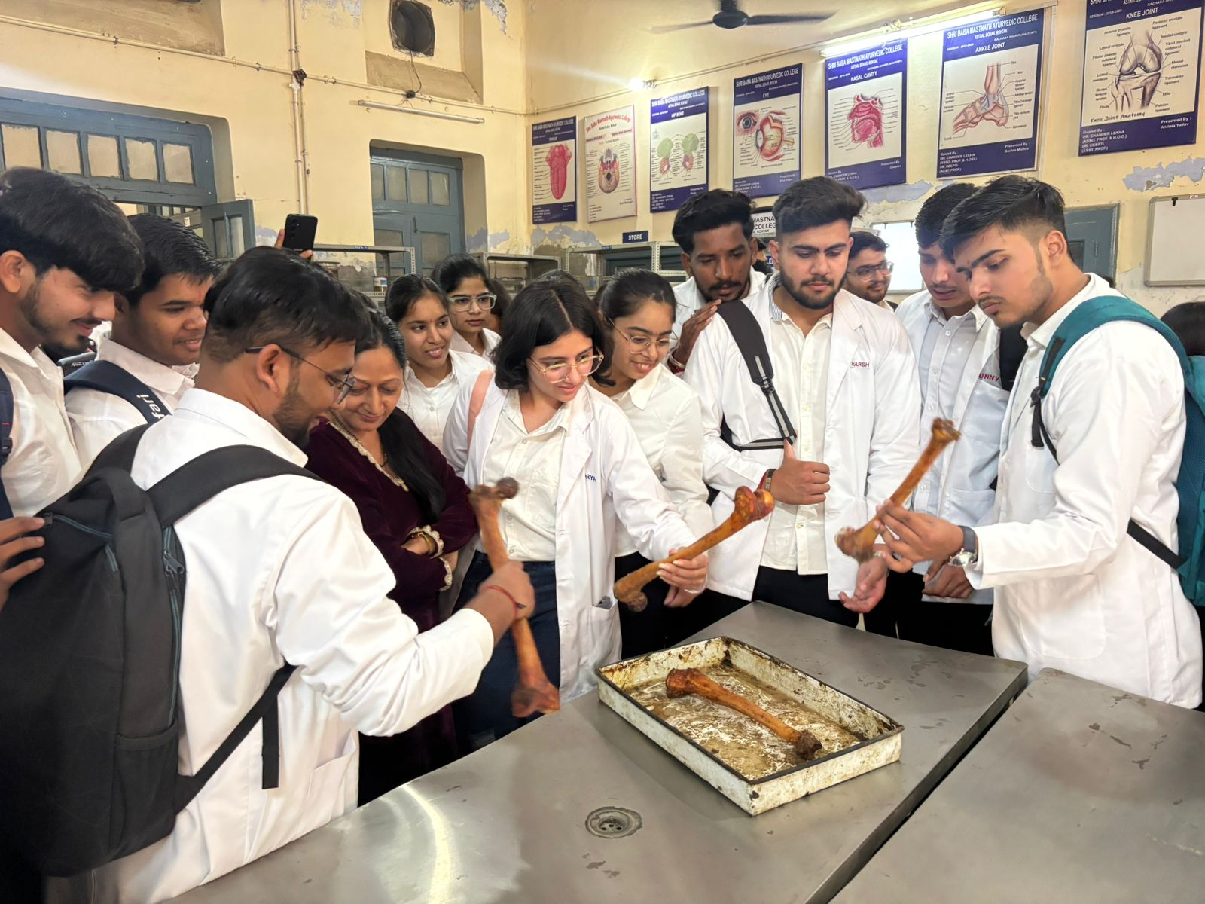

A visit to the Physiology Department was conducted, during which Dr. Ajay dhaiya explained various physiology laboratory instruments.”
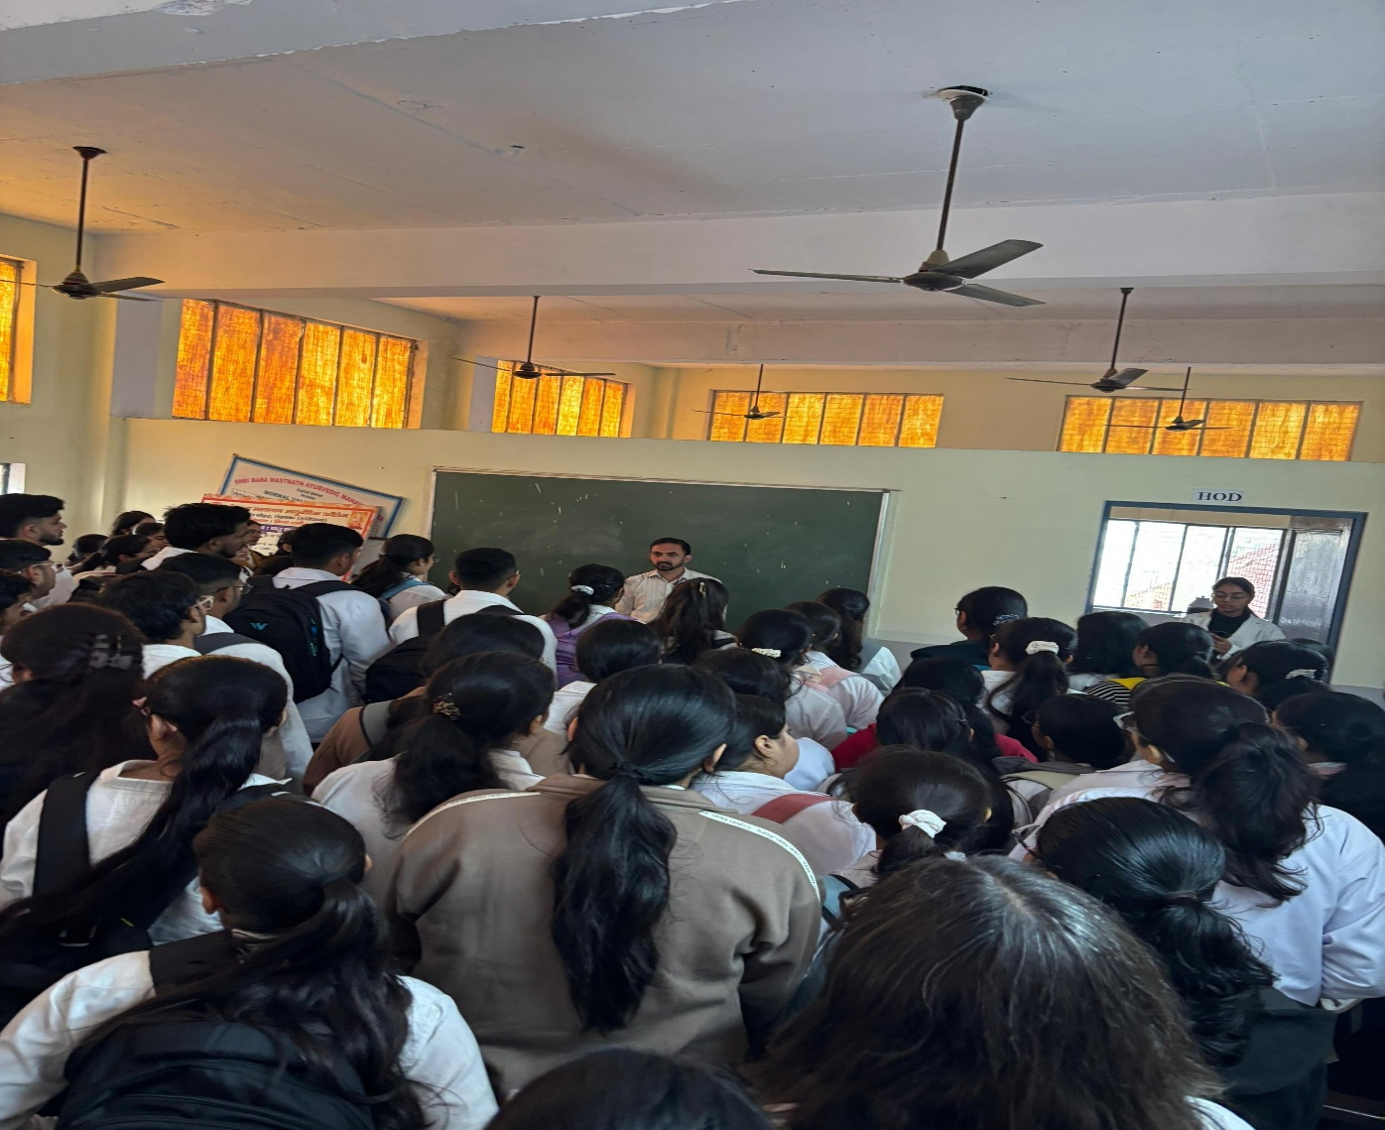

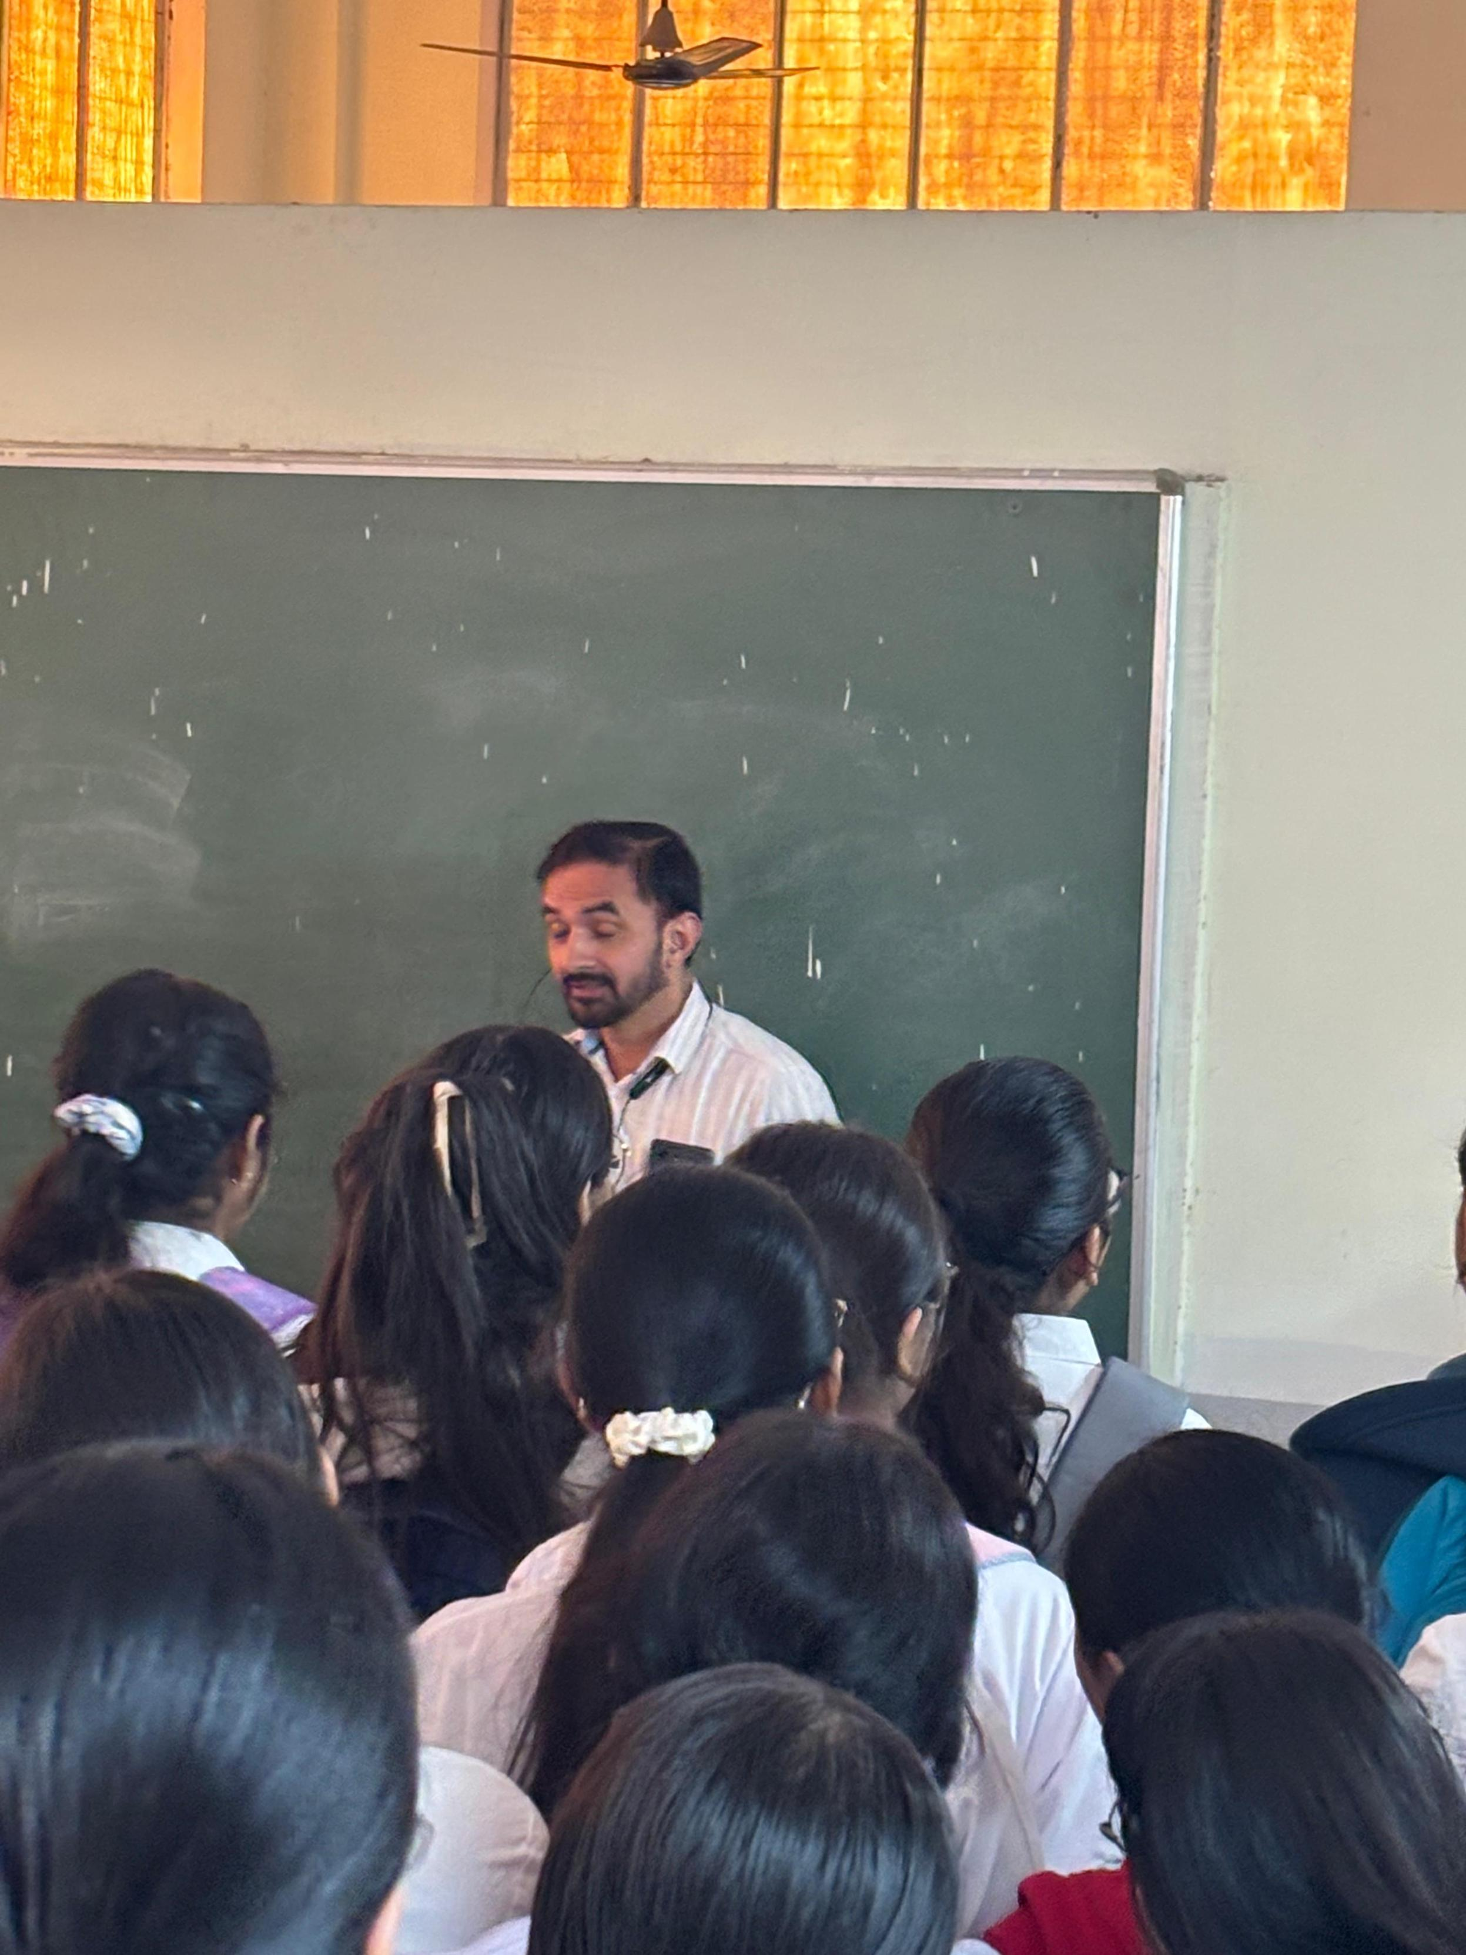

2nd day
28/11/2025 friday
9:00 to 10:00am- 2nd day of transitional curriculum starts with “ Vadatu Sanskritam” by Dr Jagdish . he explained about the importance of Sanskrit language in ayurveda. He gave the basic knowledge of Sanskrit to the students.

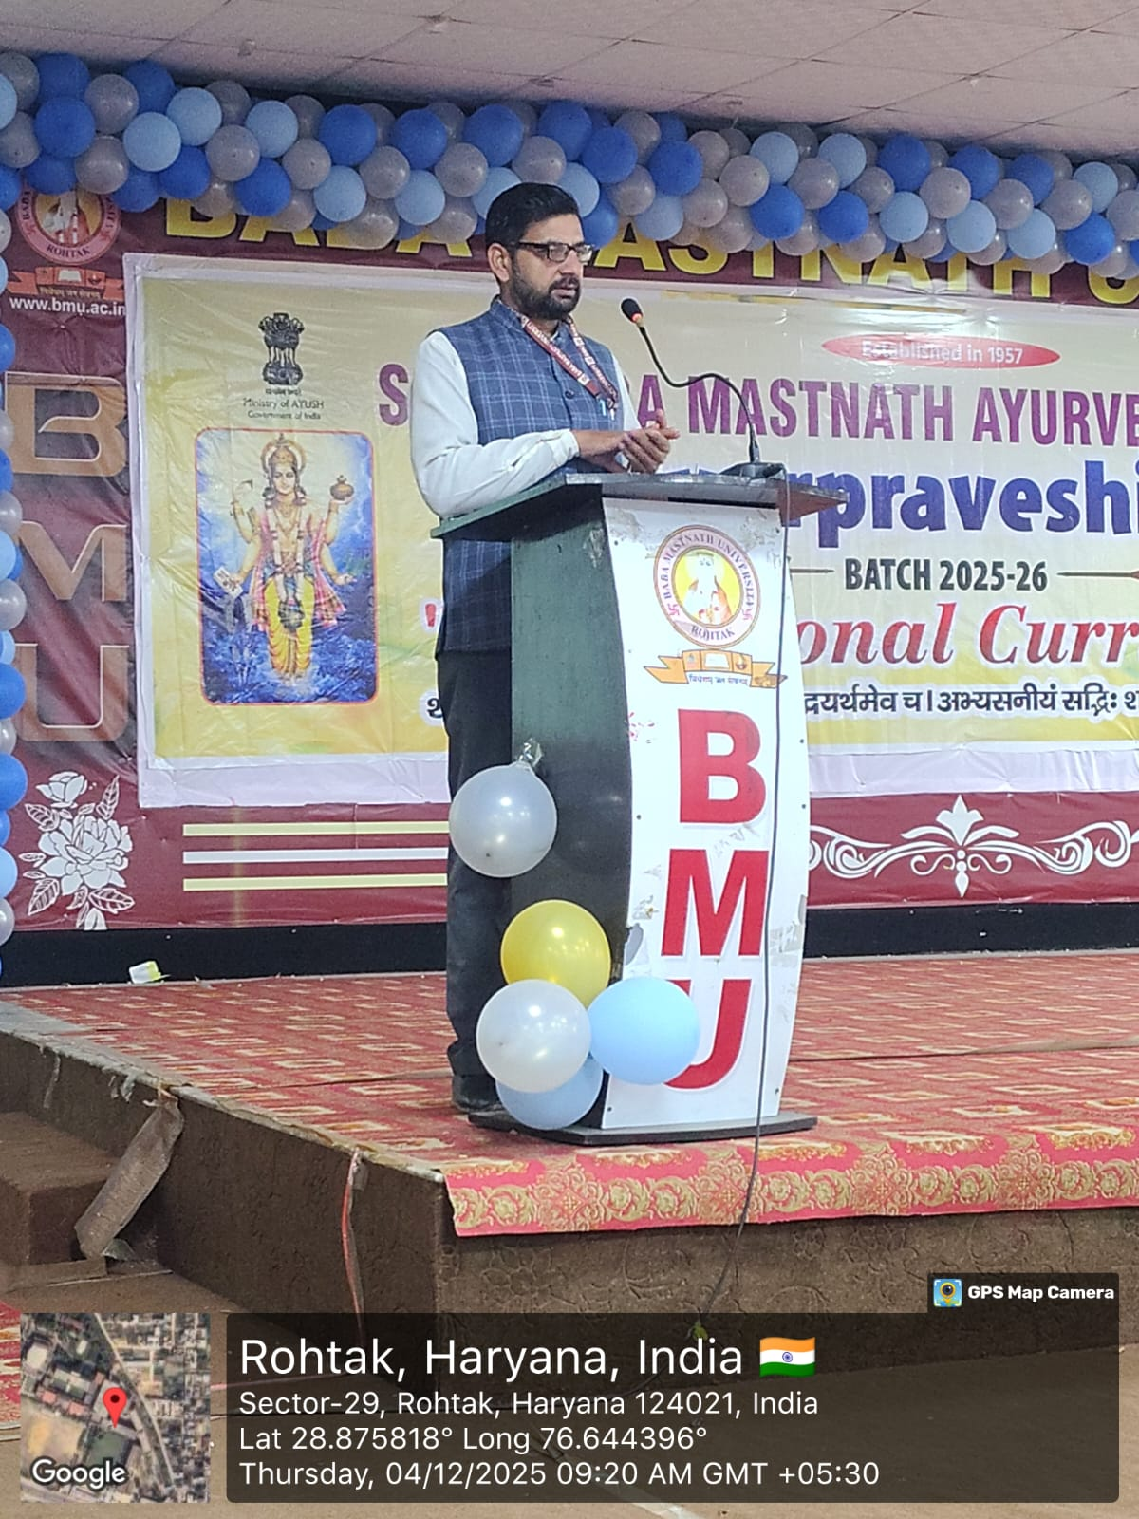

10:00 to 11:00 am. Dr. Vikas Sharma, Professor, Department of Rasshastra given a lecture on uniqueness of Ayurveda/ Siddha / Sowa Rigpa / Unani (ASSU) compared to other systems of Medicine for one hour. This lecture is very much informative & Students are explained about various systems of Indian Medicine & greatness of Ayurveda.
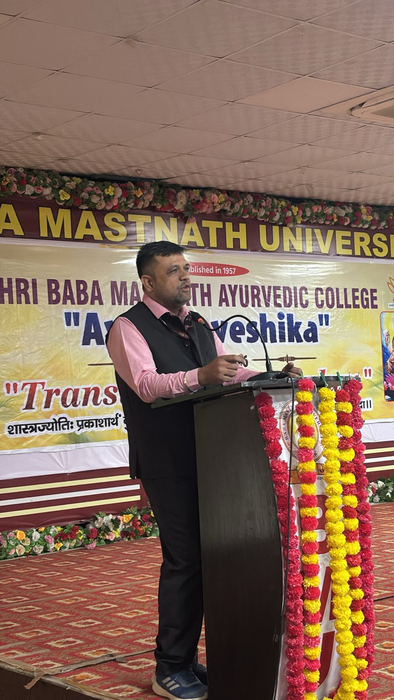

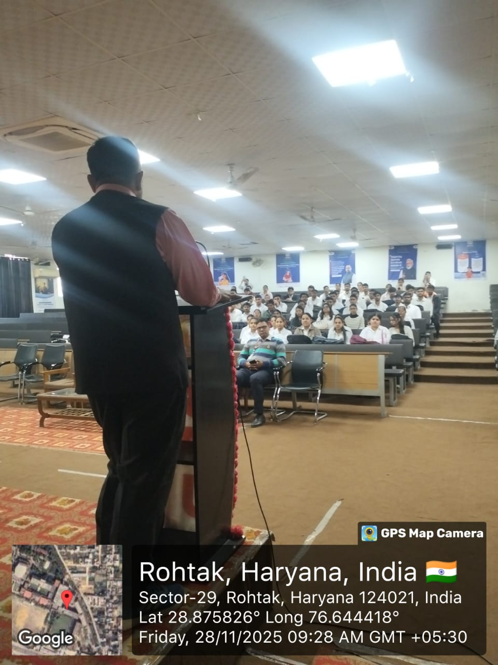

11:00 to 12:00 pm- Dr Sanjeev Vashisht, Assistant delivered a lecture on goal setting. He motivated and guided the students towards development of their action plan and set a goal in their life.
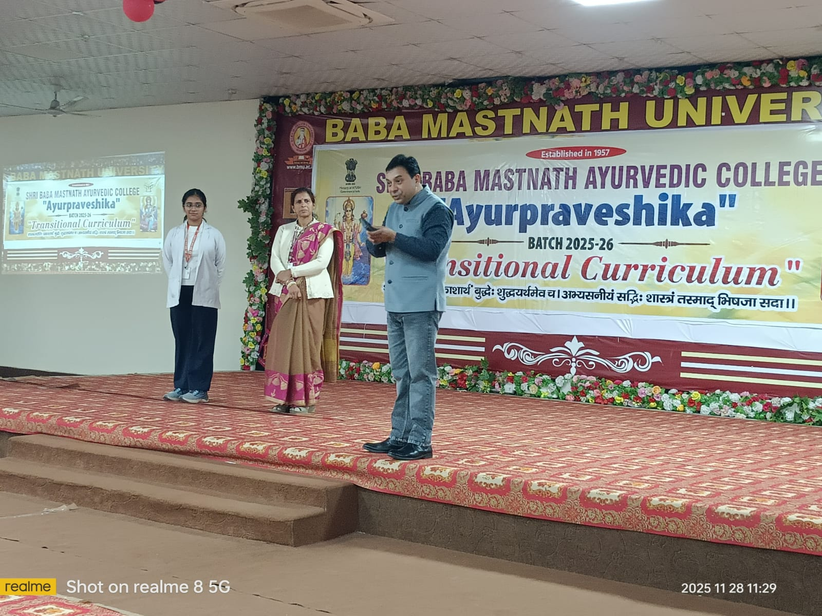

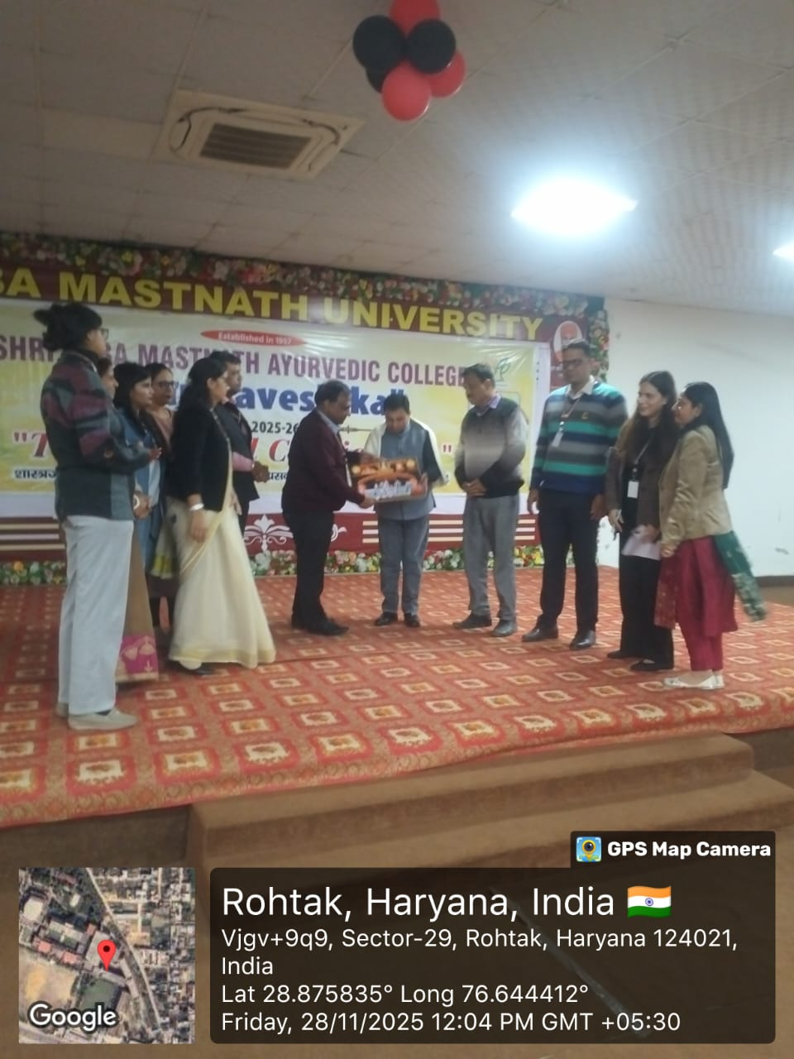

12:00 PM to 1:00 PM- Dr. Anupama Patra Department of shalakya tantra professor delivered an excellent lecture on the views of Acharya Charak.

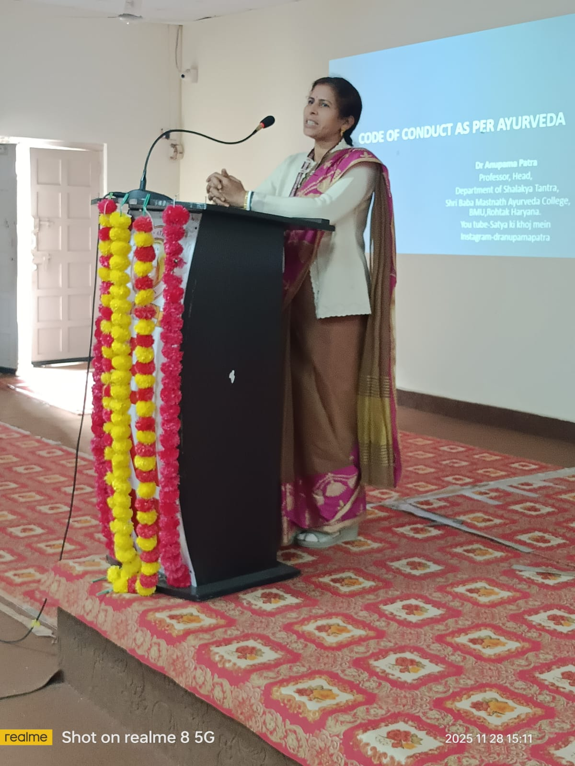

1:00 to 2:00 pm- LUNCH

2:00 to 4:00 pm- Pharmacy visit
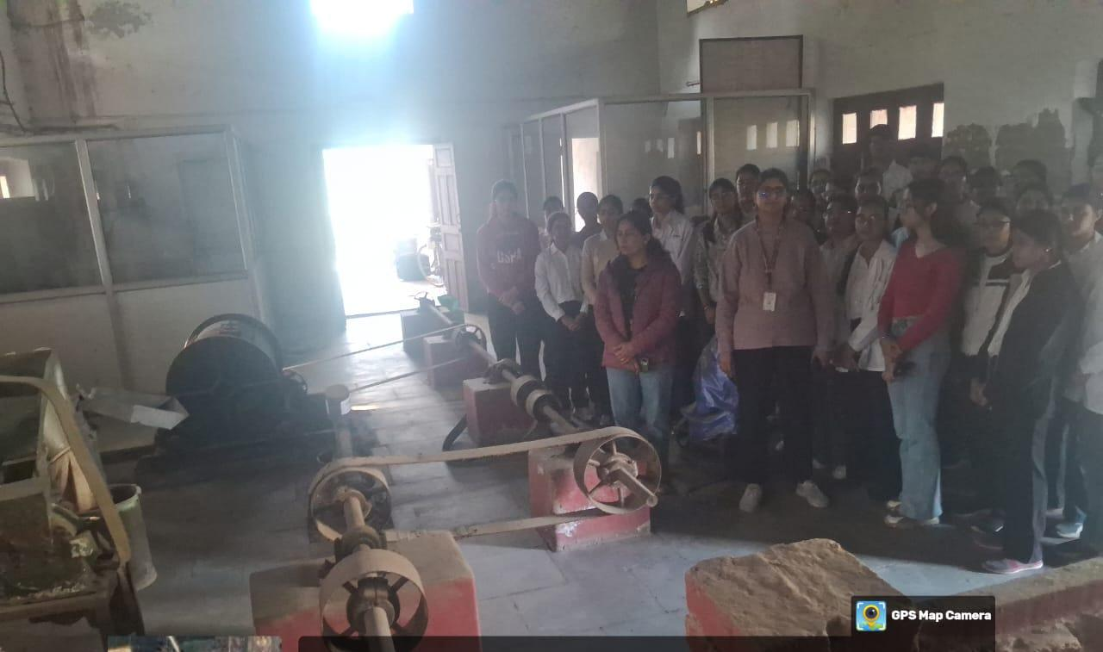

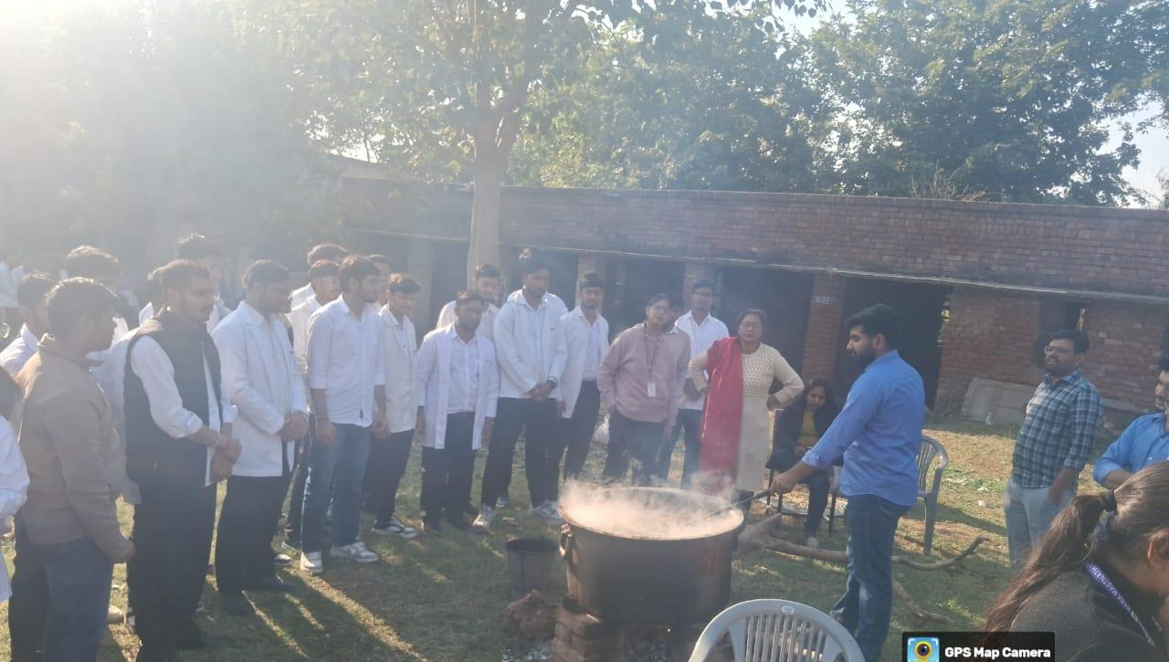

3nd day29/11/2025 Saturday
9:00 to 10:00 am- Language ( Vadatu Sanskritam) spoken class has been taken by Dr Jagdish

10:00 to 11:00am-“Dr. Manish delivered an excellent and informative lecture on the international scope of Ayurveda.”
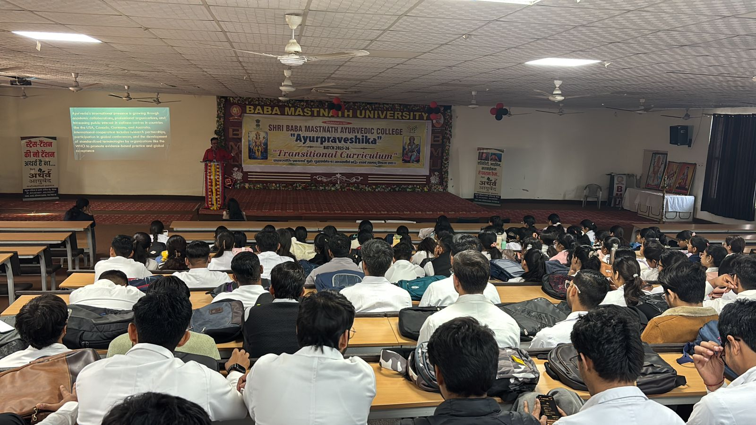

11:00 to 12:00 pm- Dr , Gourav Assistant Professor, Dept. of PSM and Yoga, has delivered a lecture on Stress management through Yoga. In this lecture various issues related to mental disorders were discussed, he explained that today every body is in stress, streses become a part of our life. Thus in this lecture various stress management techniques were discussed and how to over come from that situation through yoga that was also discussed in this lecture.

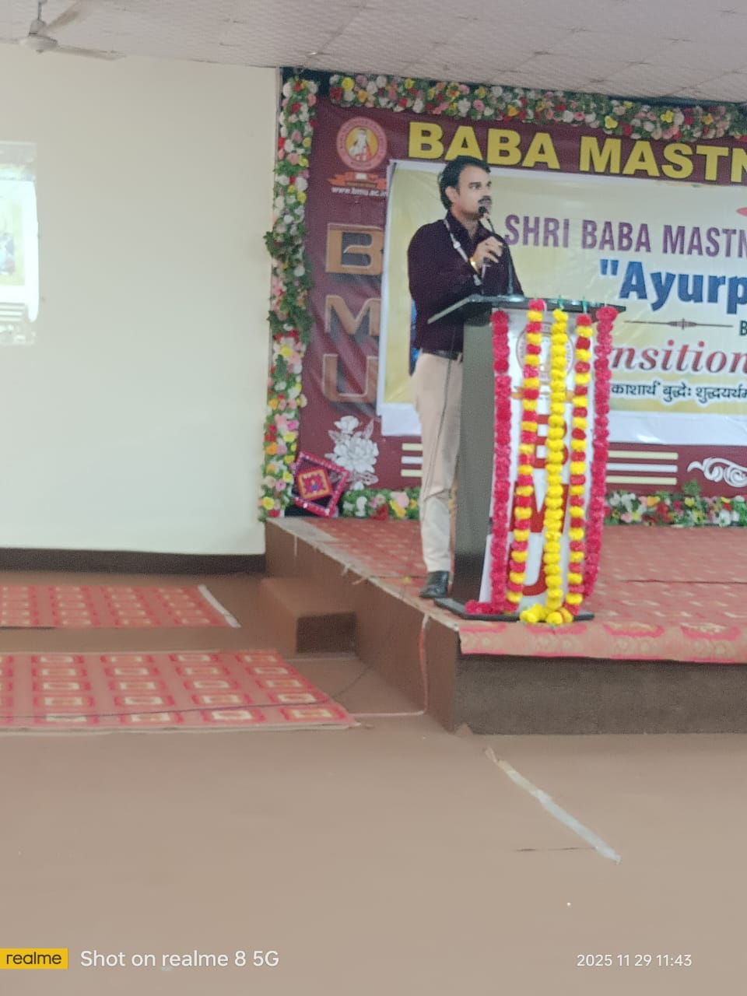

12:00 to 1:00 pm- Dr Arunachal has delivered a lecture on Recent Effective time management Strategie: Sankalpa to Sidhi.
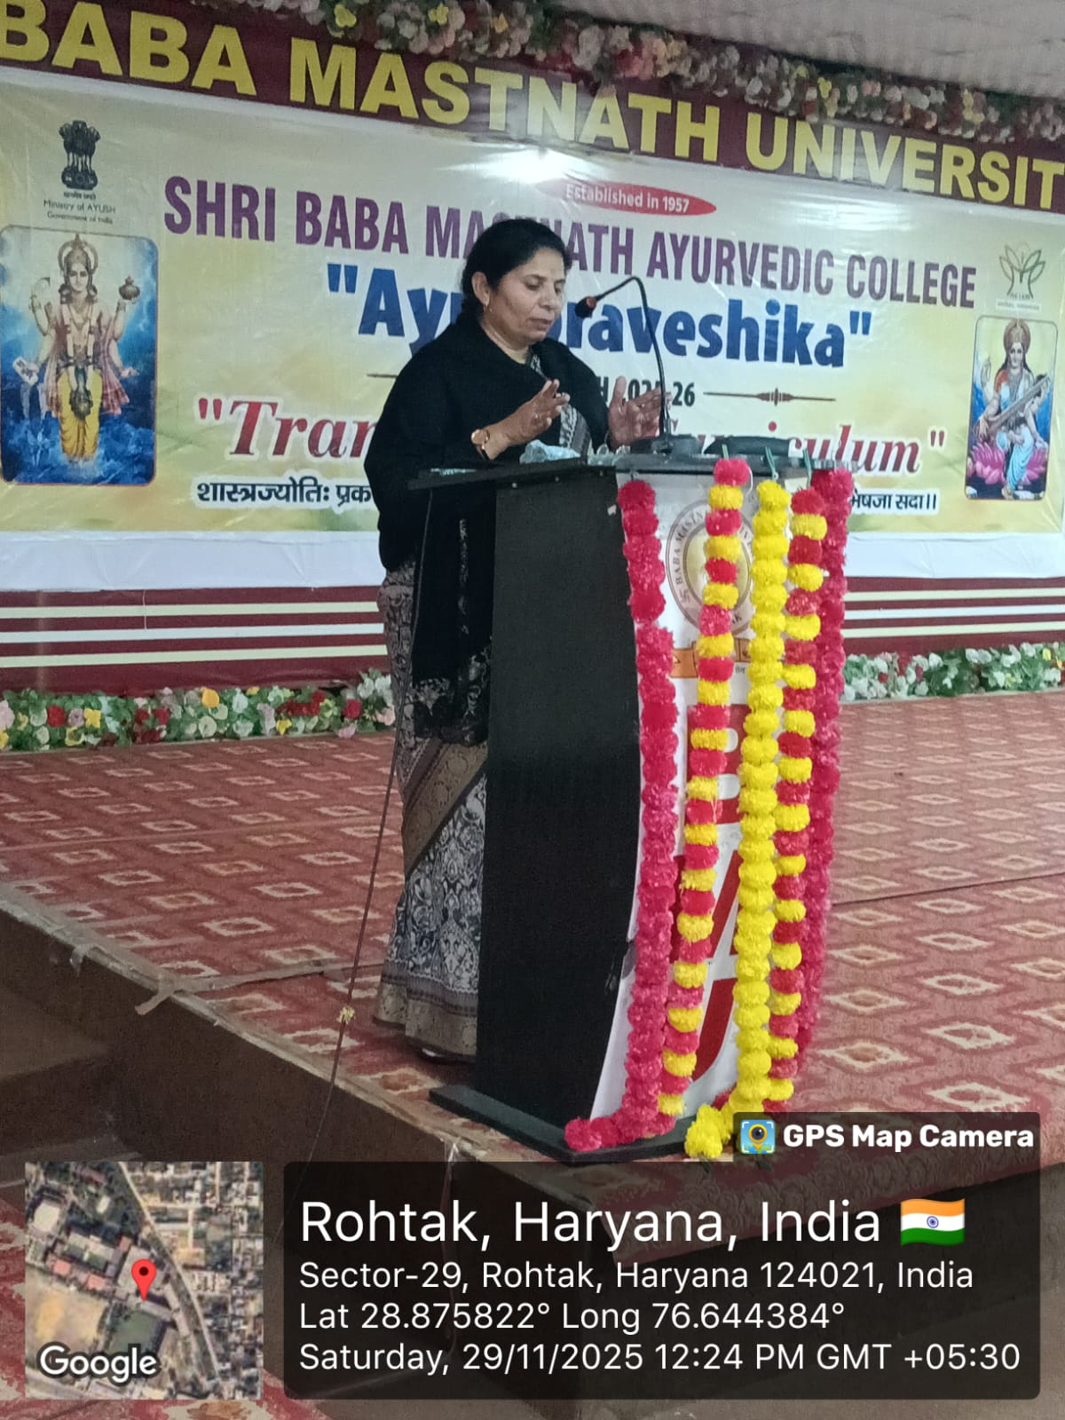

1:00 to 2:00 pm- LUNCH

2:00 to 3:00 pm- Intergrative tradition with Ambition goal setting in Ayurveda Education informative lecture given by Dr. A.P. NAYAK Professor Department on kayachiktsa.
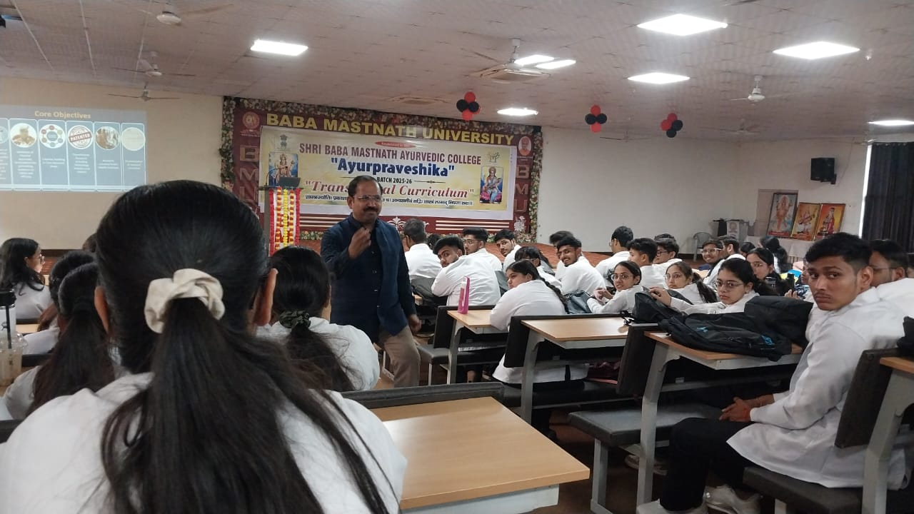

3:00-4:00 pm opd visit

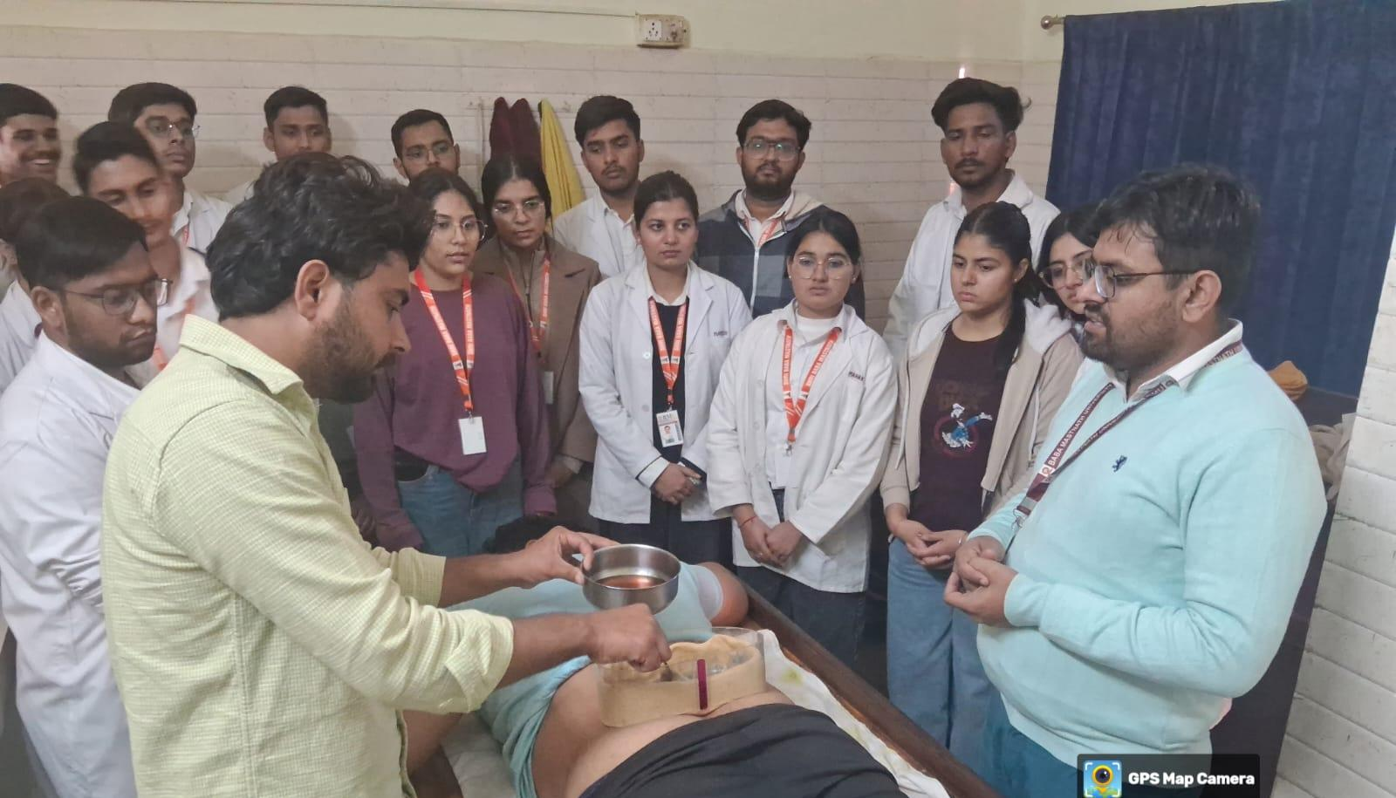

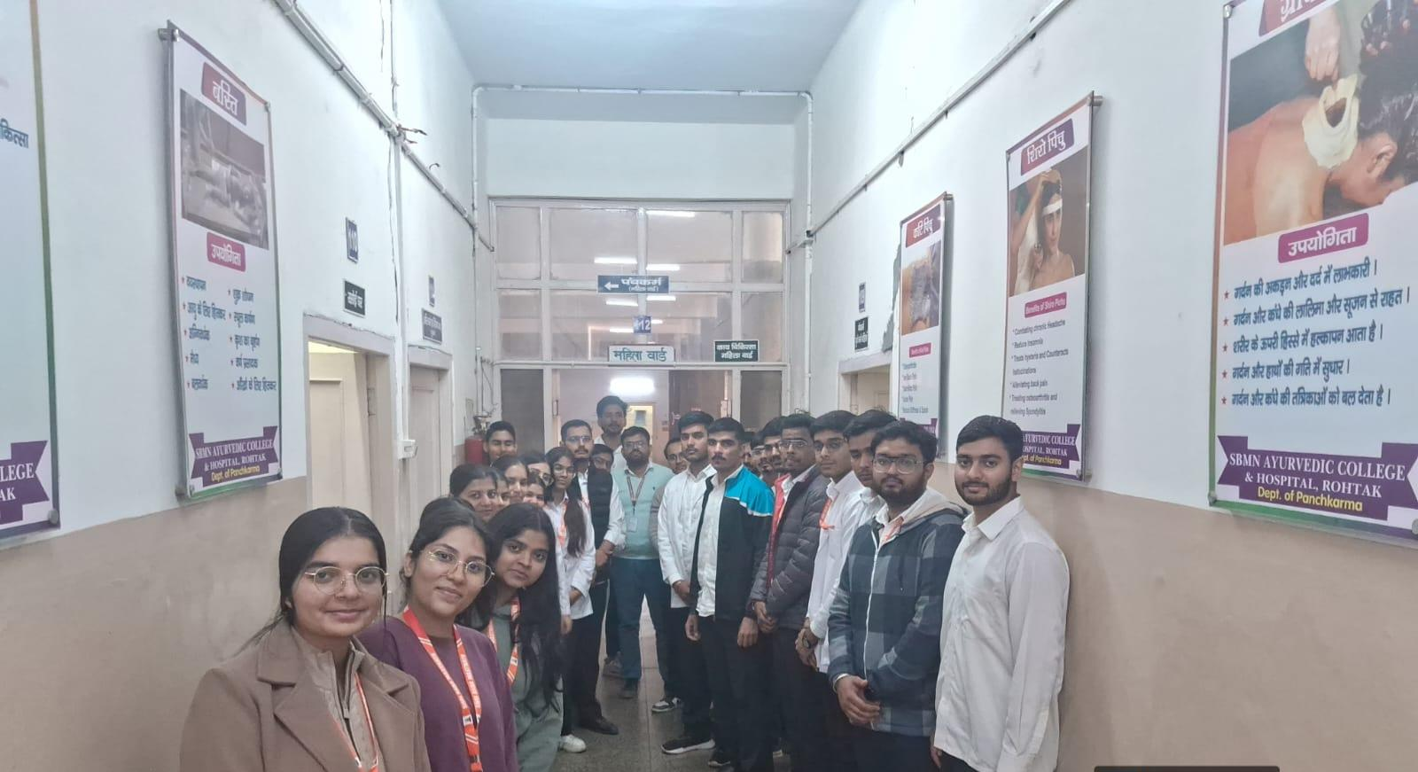
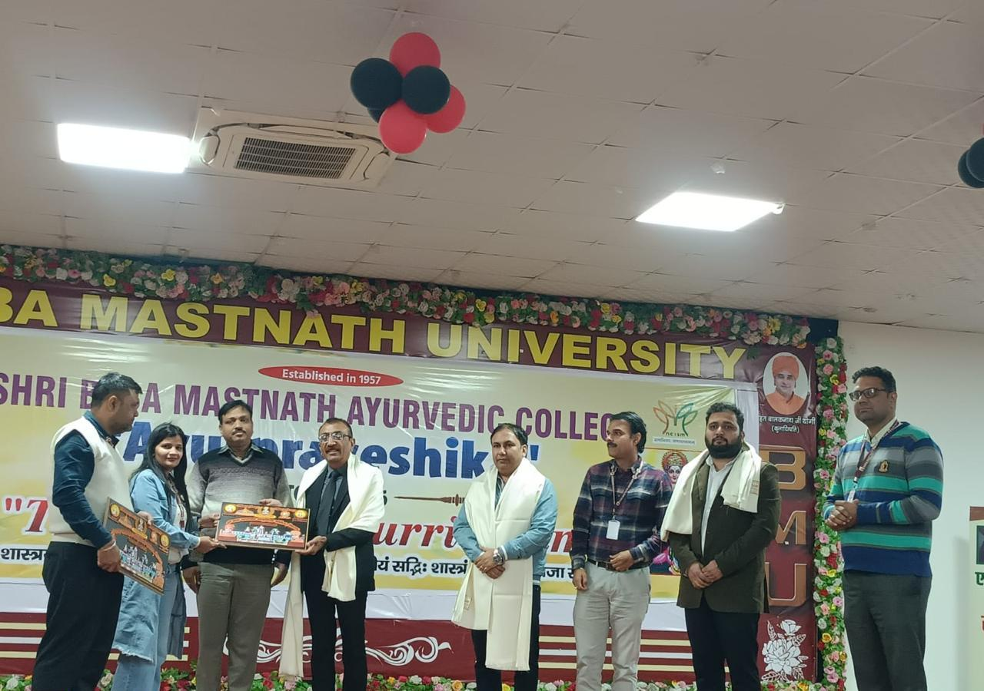
4TH DAY
01/12/2025 Monday
9:00 to 10:00 AM- Language ( Vadatu Sanskritam) spoken class has been taken by Dr Jagdish.
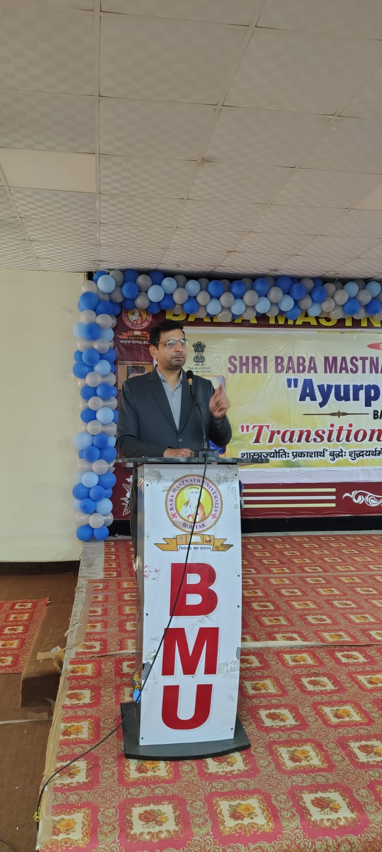

10:00 to 11:00am- Dr Seema Jaglan has told the students about self directed self motivated and study skills.
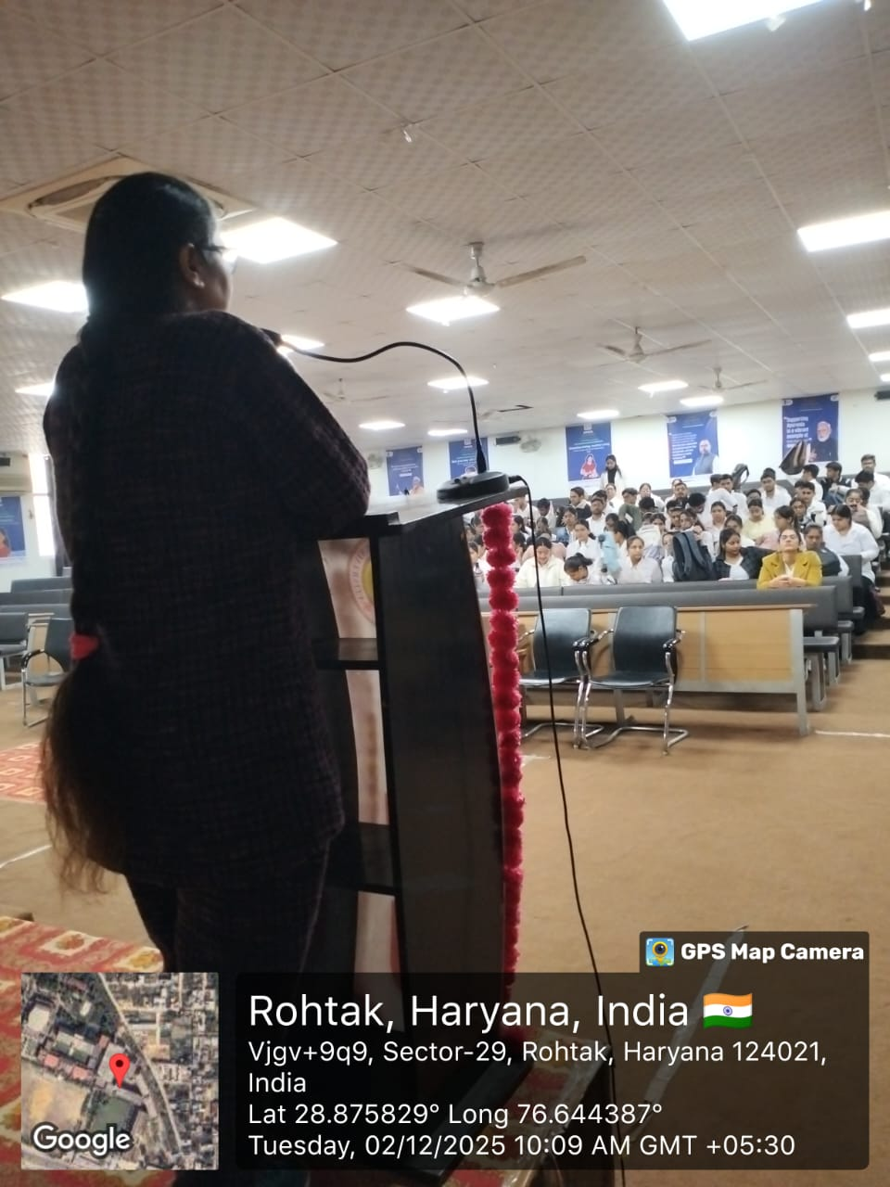

11:00 to 12: 00 pm- Dr Raj kailash, Associate Professor, Dept. of Rogvikrti vigyan, has delivered a lecture on Reflection becoming vadiya.
12:00 to 1:00 pm- Dr Sanjeev Madan delivered lecture on Ayurveda based practice capacity building in Entreprenurship.

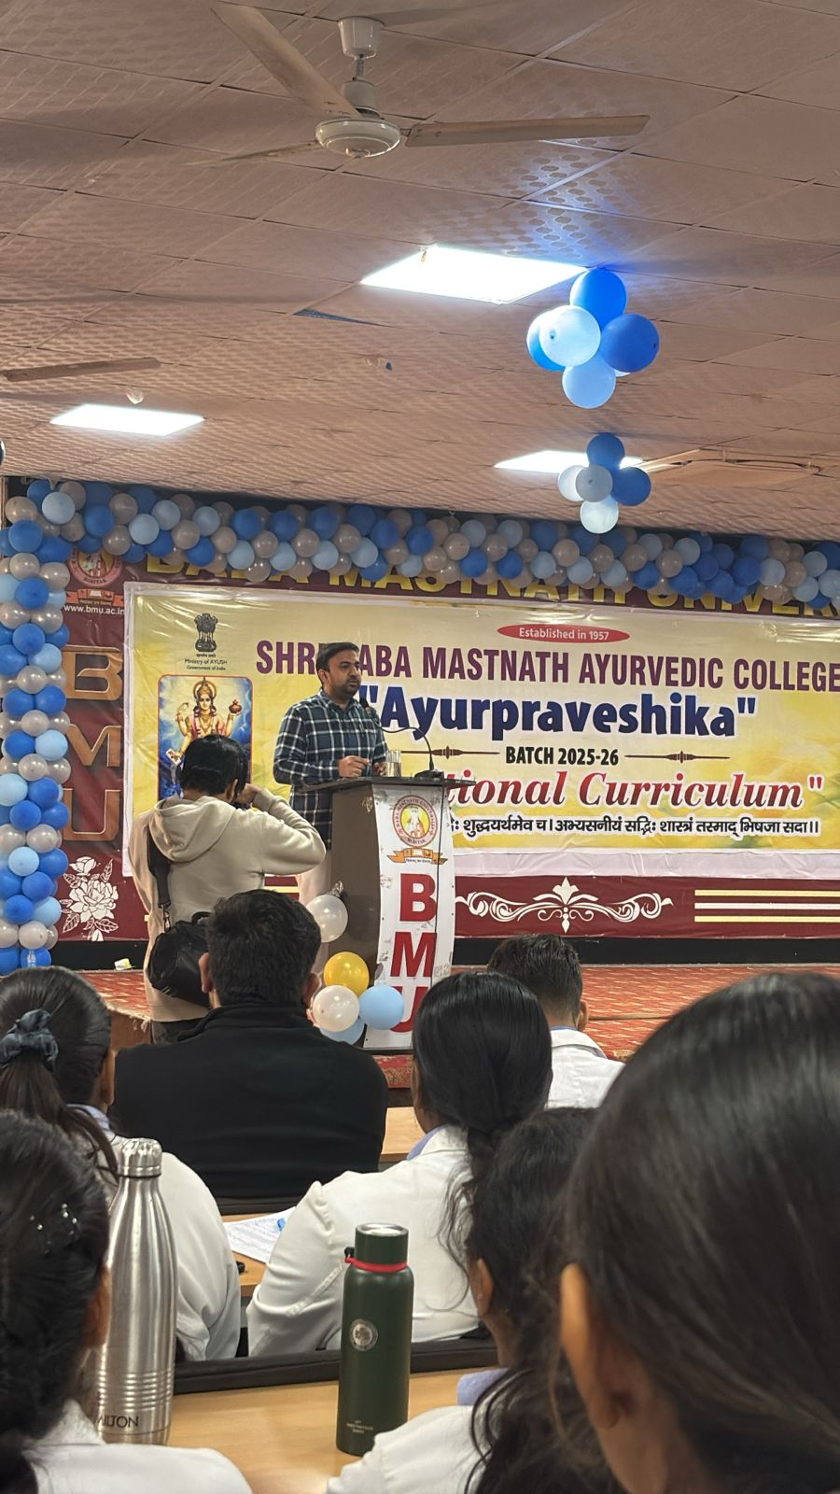

1:00 to 2:00 pm- LUNCH

2:00 to 4:00Pm fun Interaction 2021- 2022 batch.

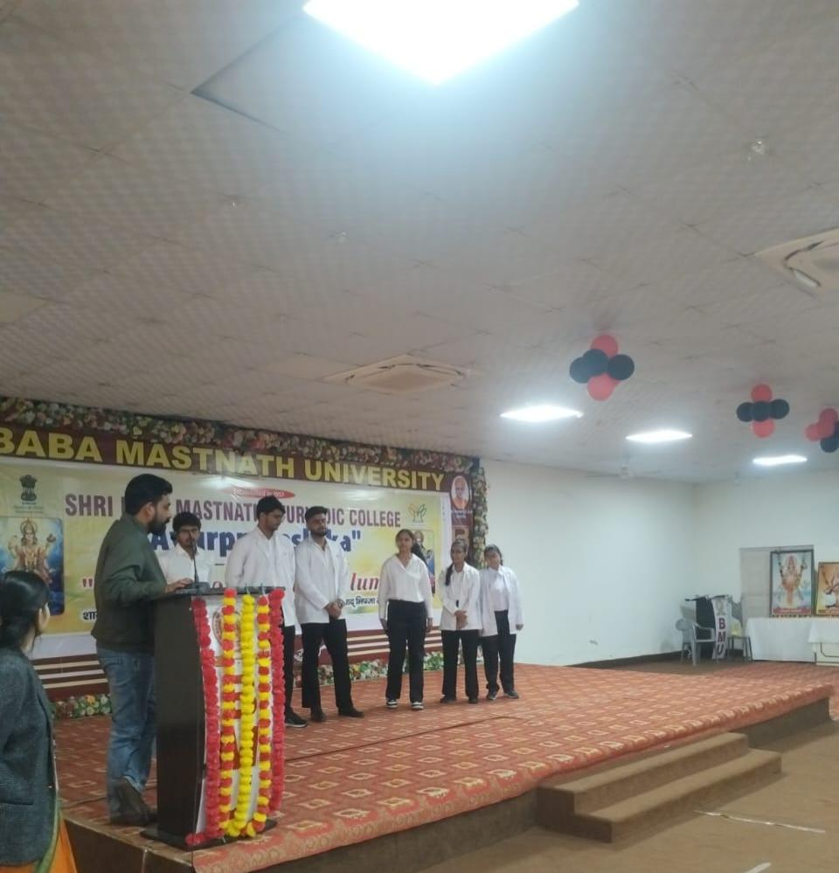

5th Day
02/12/2025 Tuesday

9:00 to 10:00 AM- Language ( Vadatu Sanskritam) spoken class has been taken by Dr Jagdish.

10:00 to 11:00am- Dr Devender Vashishtha, Associate Professor, has delivered a lecture on Computer Skills and powerpoint etc.
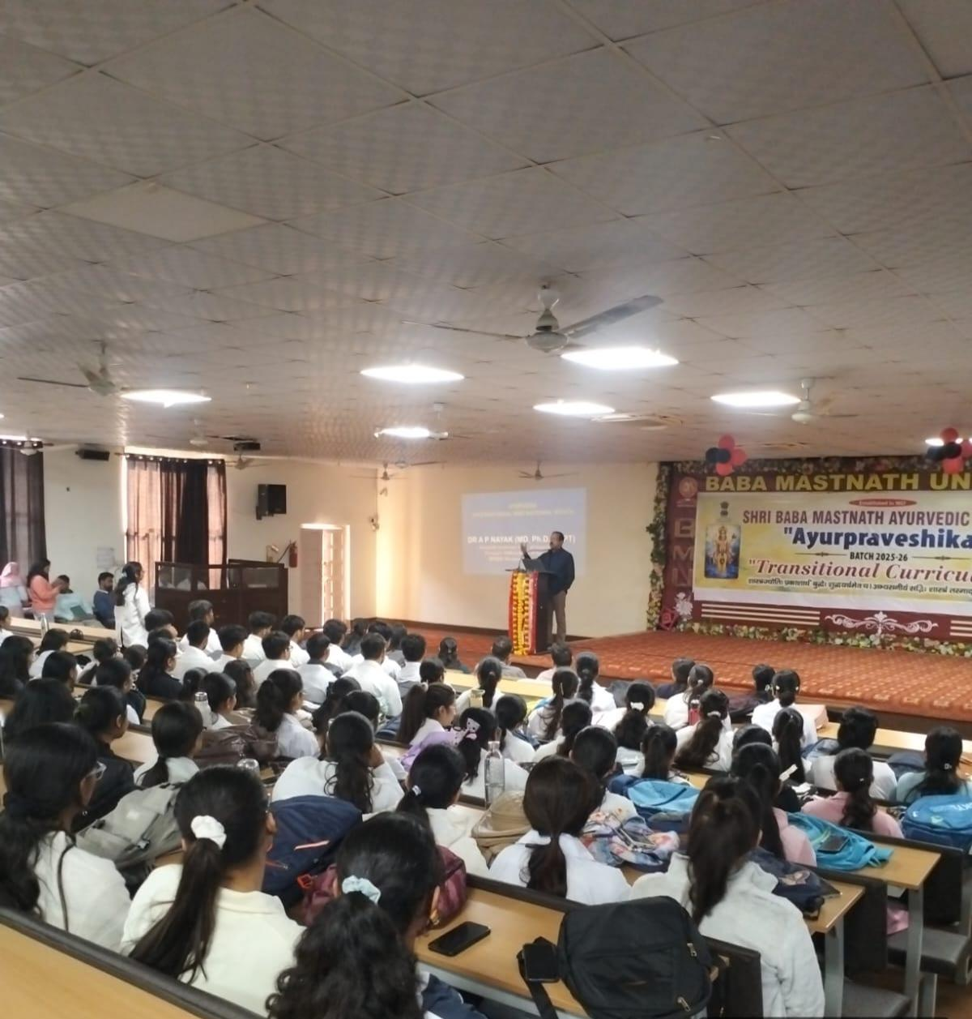

11:00 to 12:00 PM Dr Devendr yadav delivered lecture basic life support

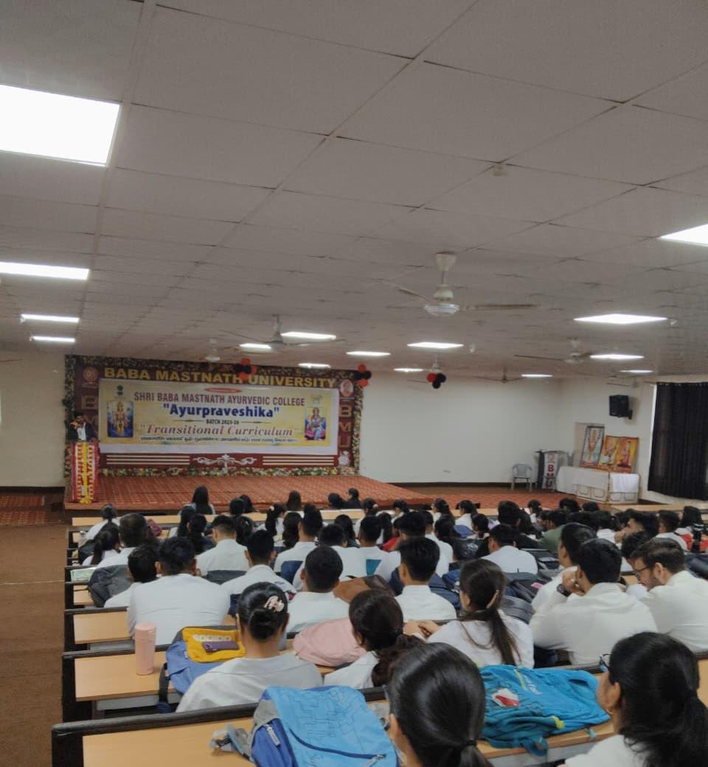

12:00 PM TO . Dr Vijender Kumar delivered lecture on Introduction to Bruhatrayi.
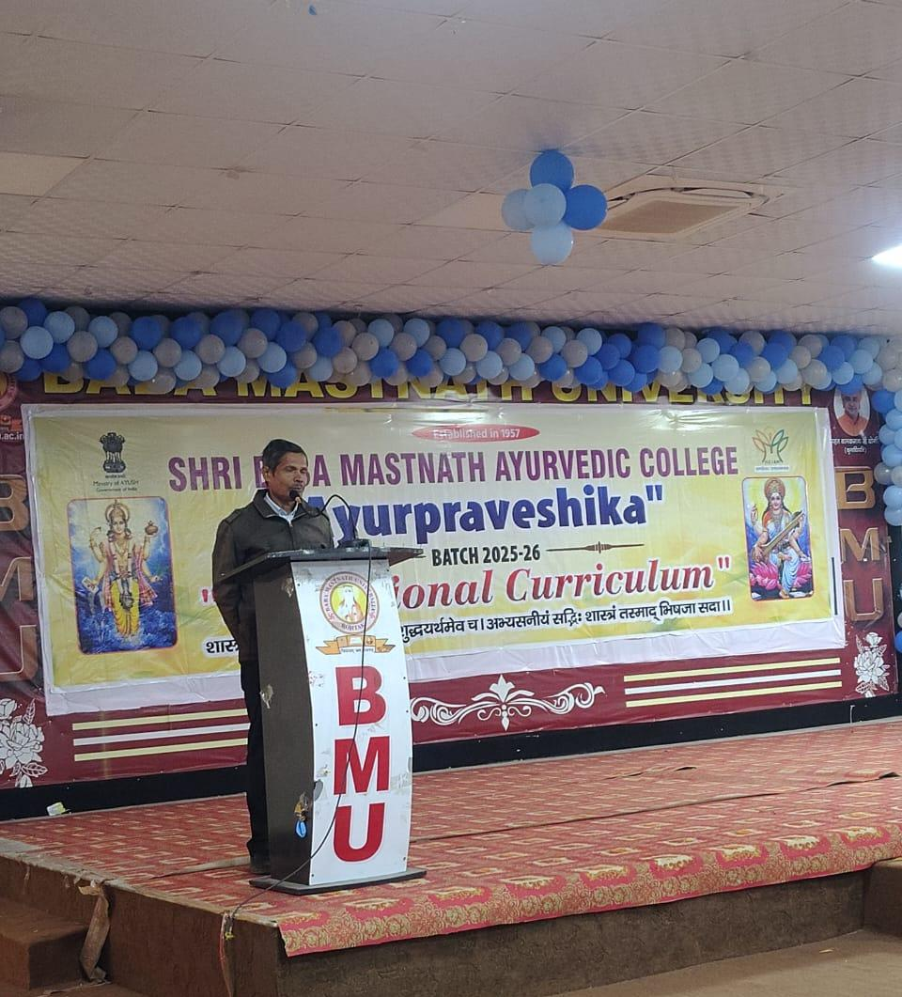

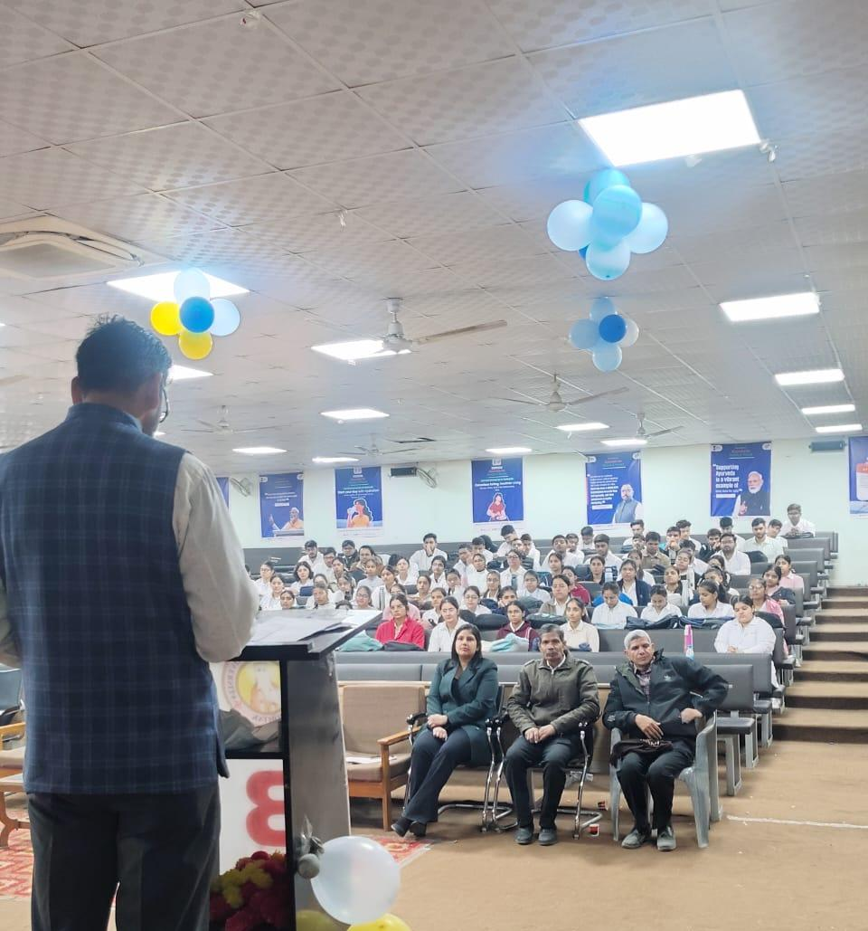

1:00 to 2:00 pm- LUNCH

2:00 to 4:00 pm- Interaction with senior students. Batch 2024-25
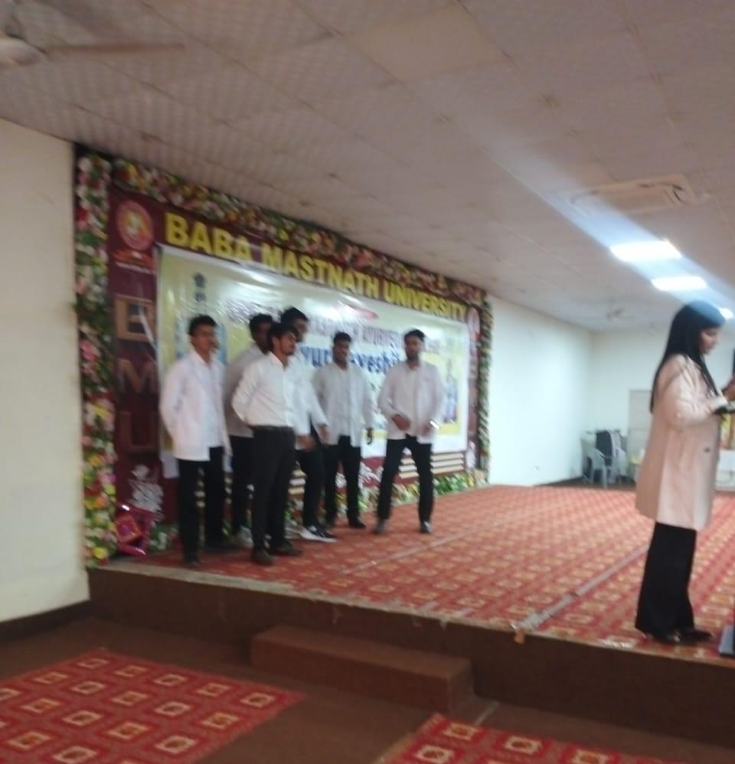

03:00 PM to 04:00 PM : CAMPUS VISIT – All the Students have divided into two batches and they were taken to the Hospital for visiting various clinical departments by Dr. Sakshi to have a basic idea about various specialities of Ayurveda and Departmental visit by Dr. Nitin Jain.
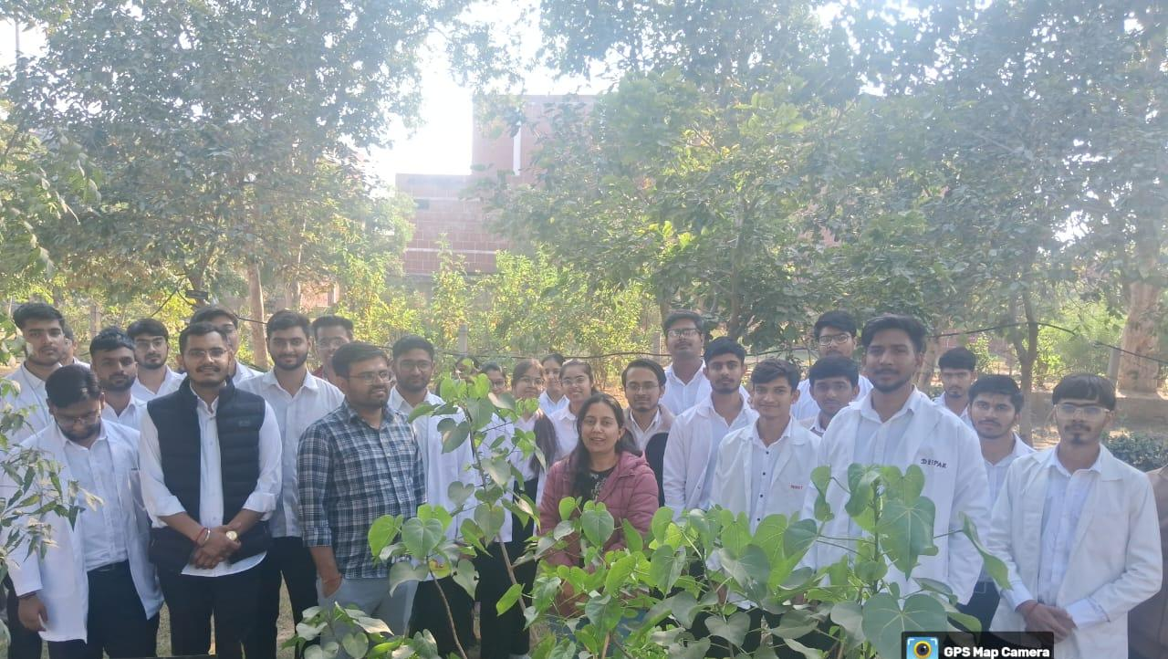

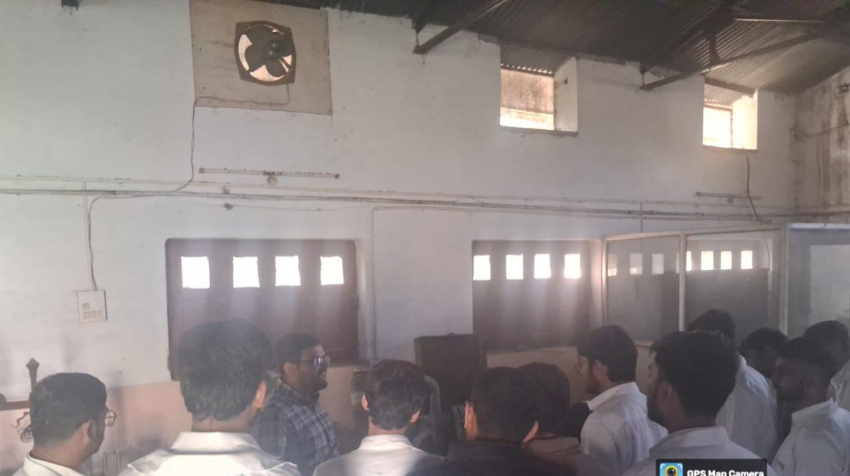

6th Day
03/12/2025 Wednesday
9:00 to 10:00 AM- Language ( Vadatu Sanskritam) spoken class has been taken by Dr Jagdish.
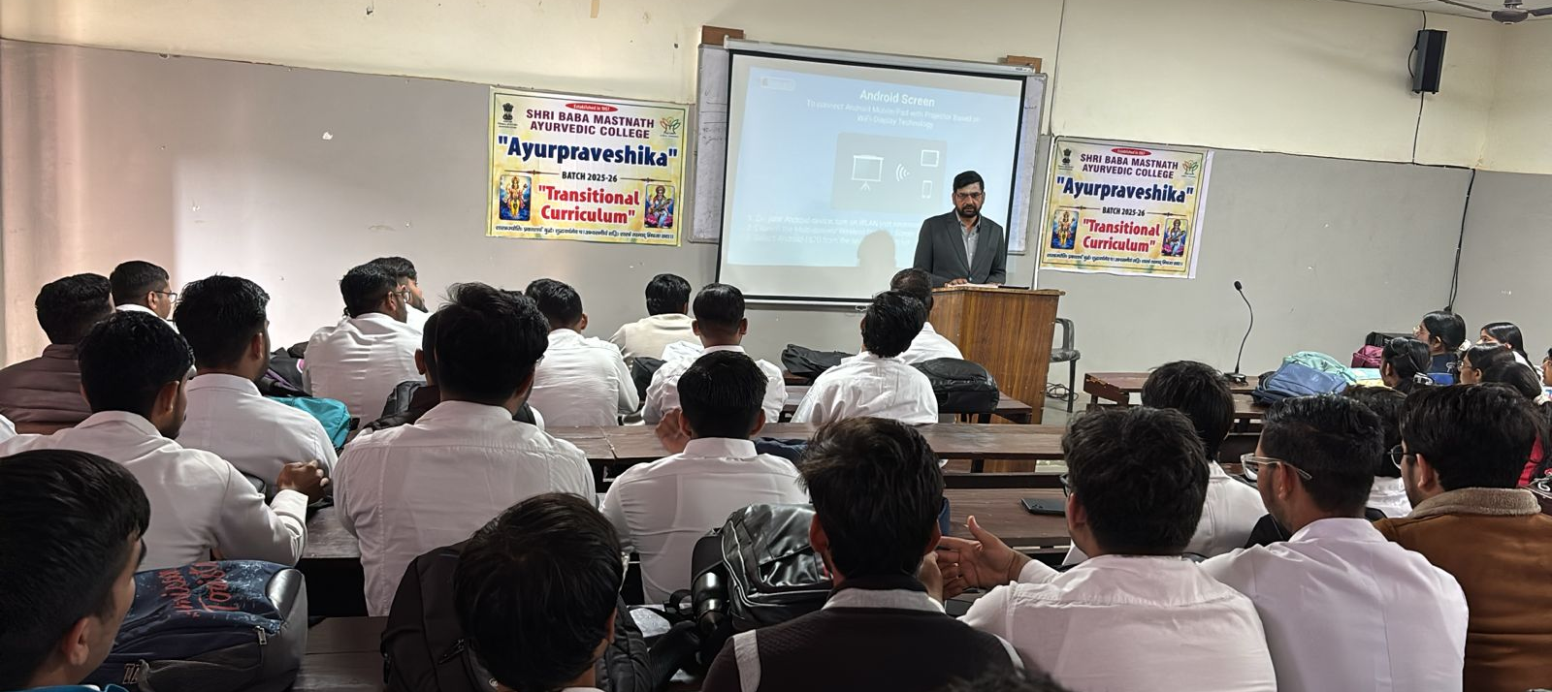

10:00 to 11:00 am - Dr. Devender Vashishtha, Associate Professor, has told about E-Mail correspondence and Internet browsing.

11:00 to 12:00 pm- Dr Manjula, Associate Professor, Department of Dravyaguna delivered a lecture on Research awareness and evidence based Ayurveda.she has explained scientific writing and plagiarism.
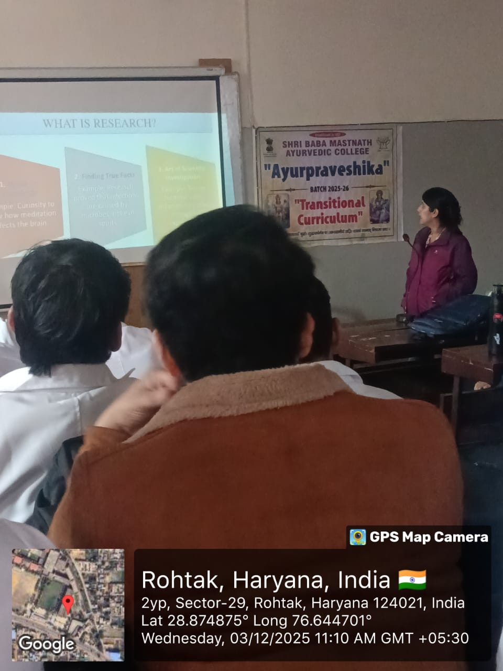

12:00 PM TO 01:00PM : Dr. Rajeev verma has delivered a lecture on National and International opportunities for Ayurvedic Scholars. He told Ayurveda Students that BAMS Doctors builts a career successfully in five categories i.e. Clinical Practice, Academic, Research, Management and Drug Manufacturers. This lecture is very informative and students were explained about various opportunities in future.

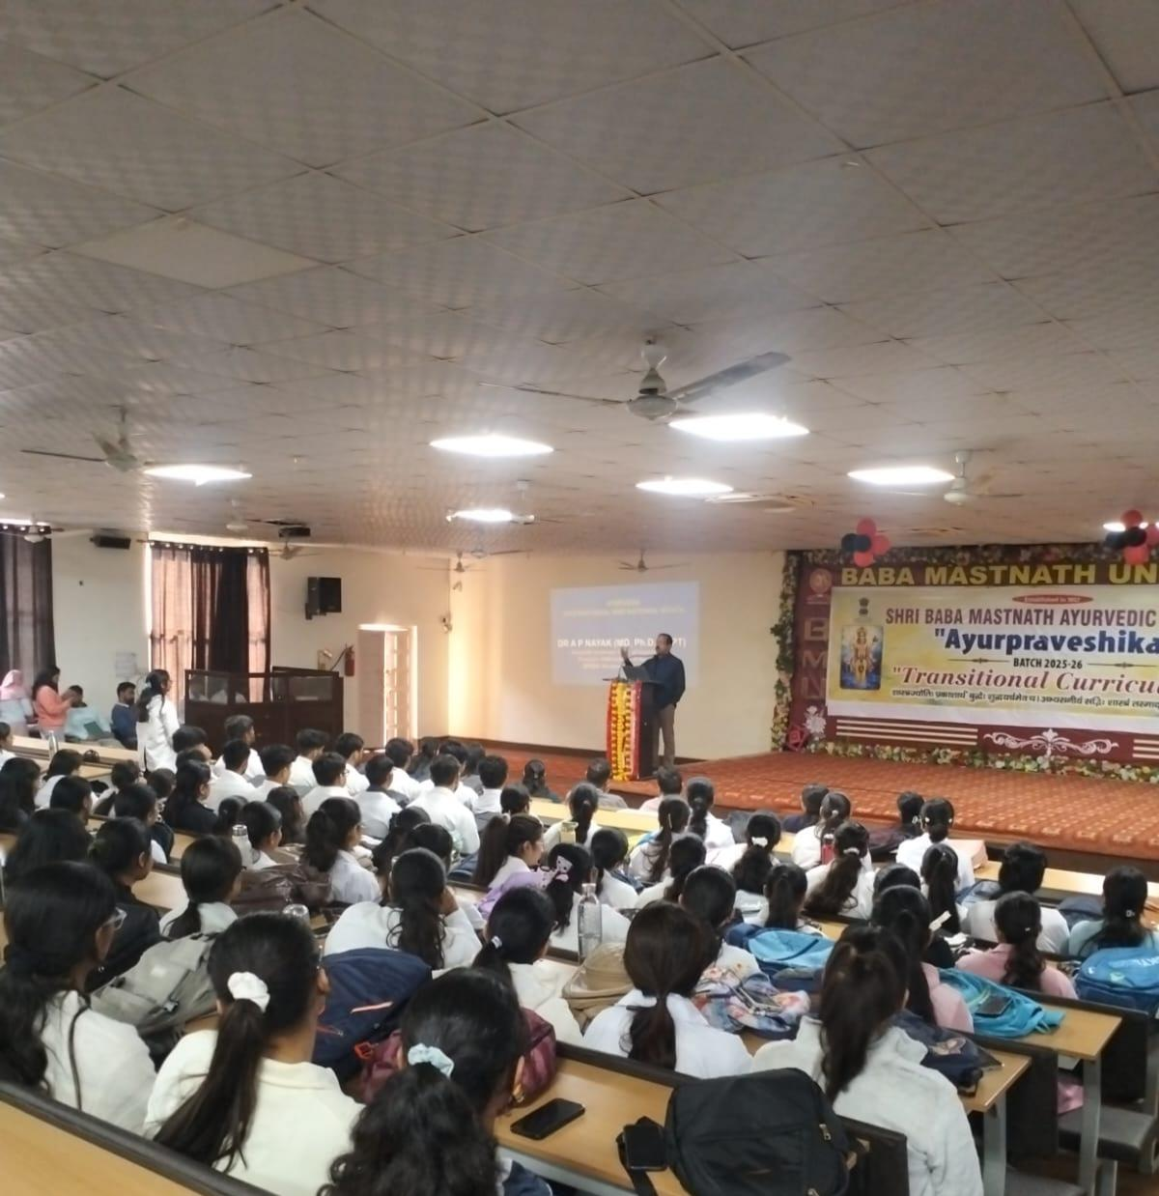
1:00 to 2:00 pm- LUNCH

2:00 to 4:00 pm- Learning form seniors Ask me anything Q/A with senior
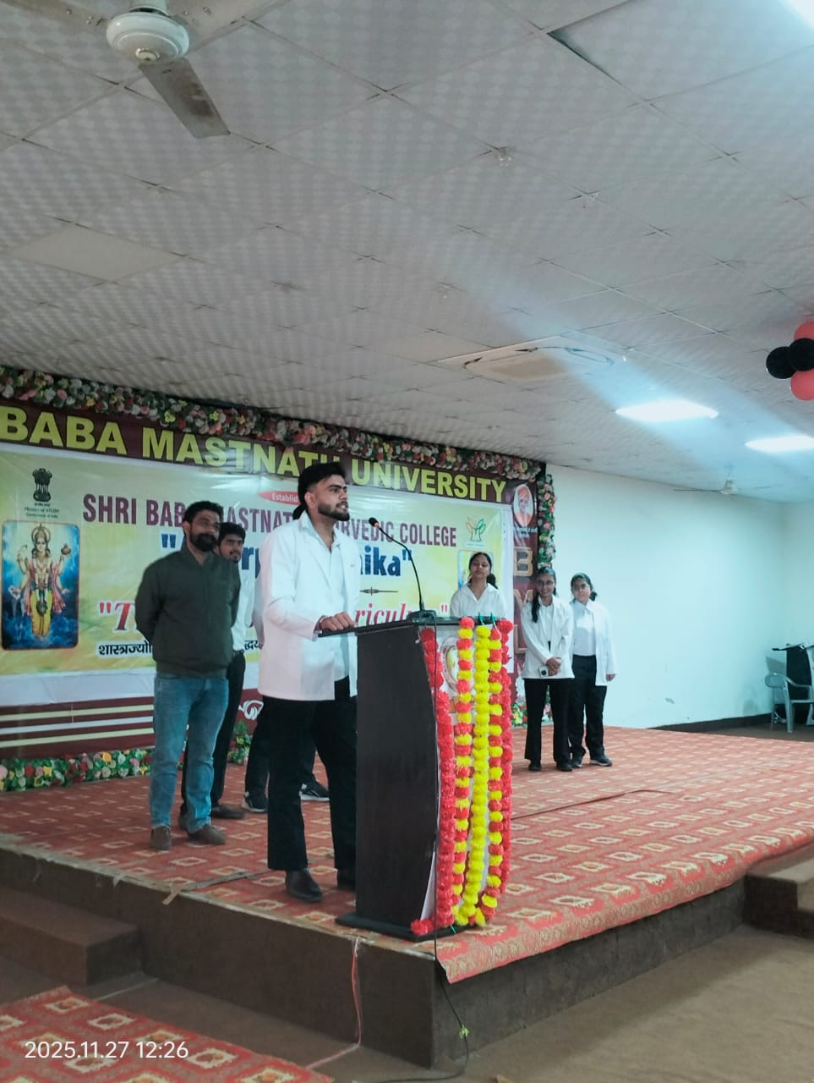

7th day
4/12/2025 Monday
9:00 to 10:00 am- Language ( Vadatu Sanskritam) spoken class has been taken by Dr Jagdish
10:00 to 11:00 am- Dr Devendra Vashistha has delivered a lecture on safety app installatiom( 122 india, my safetypin)
11:00 to 12:00 pm- Dr Vijay Kaushik, Professor, Dept. of Kayachikitsa has delivered a lecture on Role and impact of physician in the society. He starts his lecture by defining the physician as ‘ A Physician is a person with extensive knowledge in the field of medical science, who applies and dedicates his or her knowledge to identify a medical problem presented by the patient and then use their skills to prevent or cure it. He appealed the students to be remembered forever to become a successful and an ideal physician in the society.
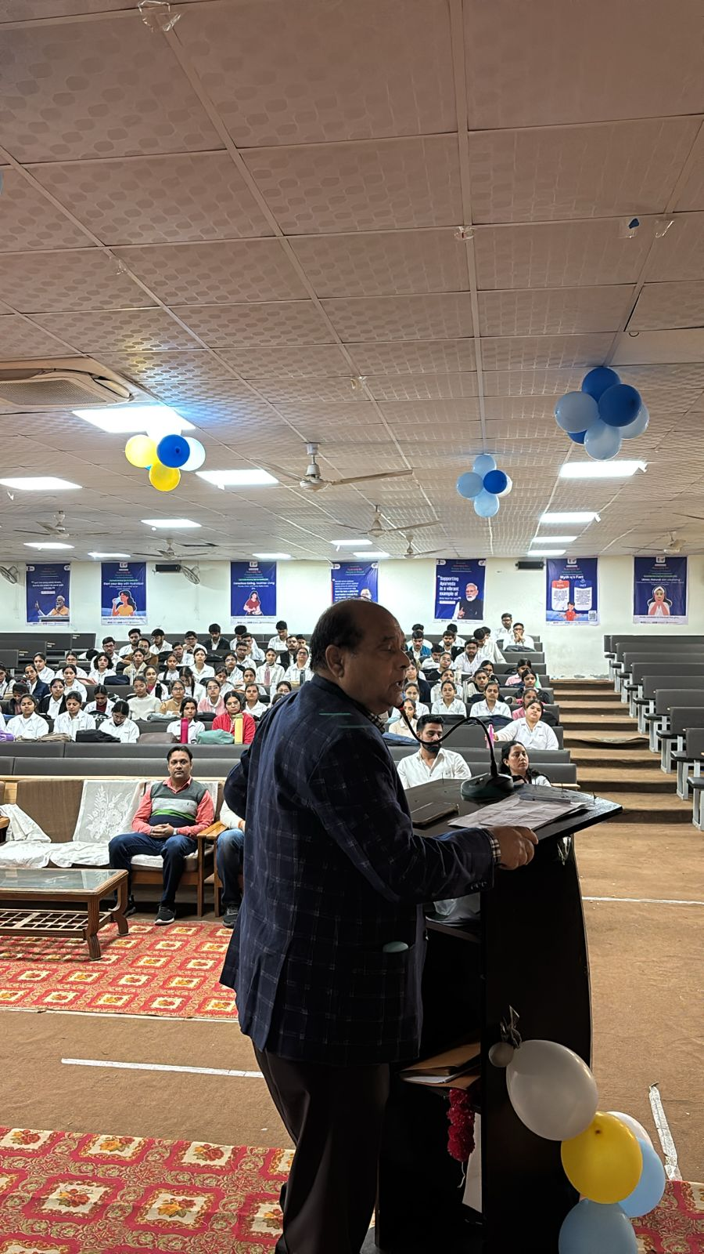

12:00 to 1:00 pm- Dr Naveenta has delivered Lecture on Ayurveda &personalised medicine she has told Prakriti as a key to preventive and curative health.
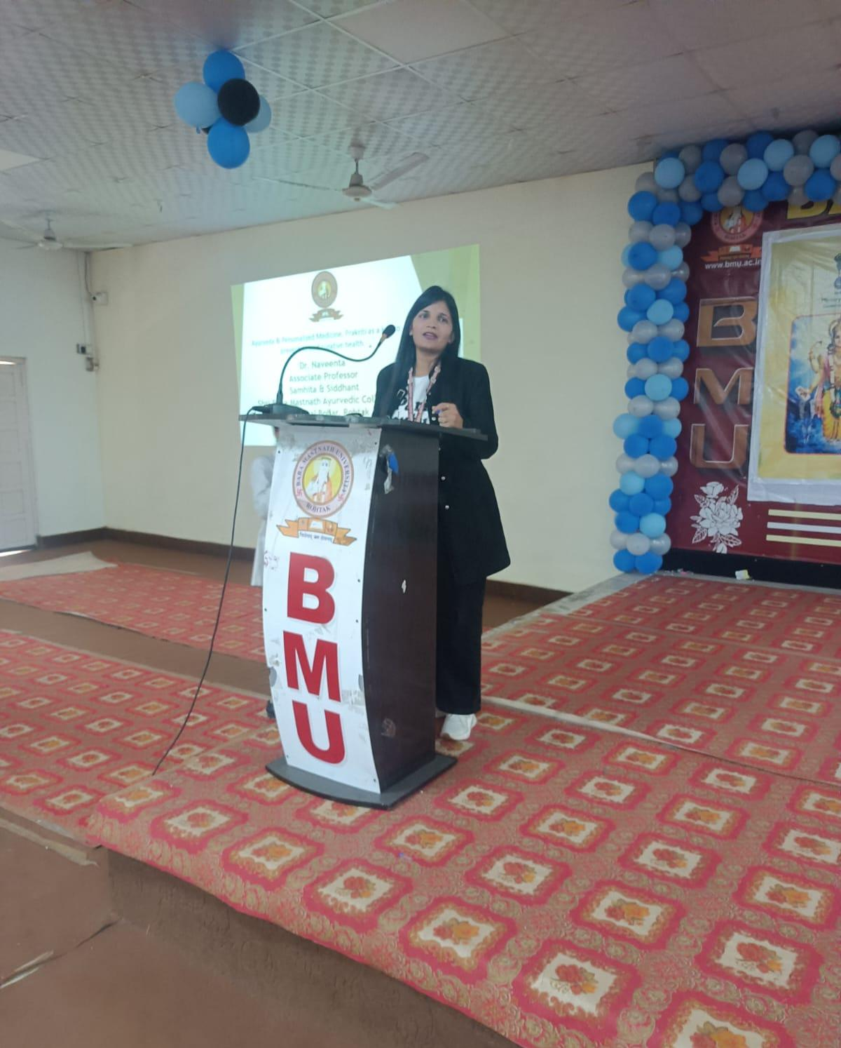

1:00 to 2:00 pm- LUNCH
2:00 to 4:00 pm – Dance Competition

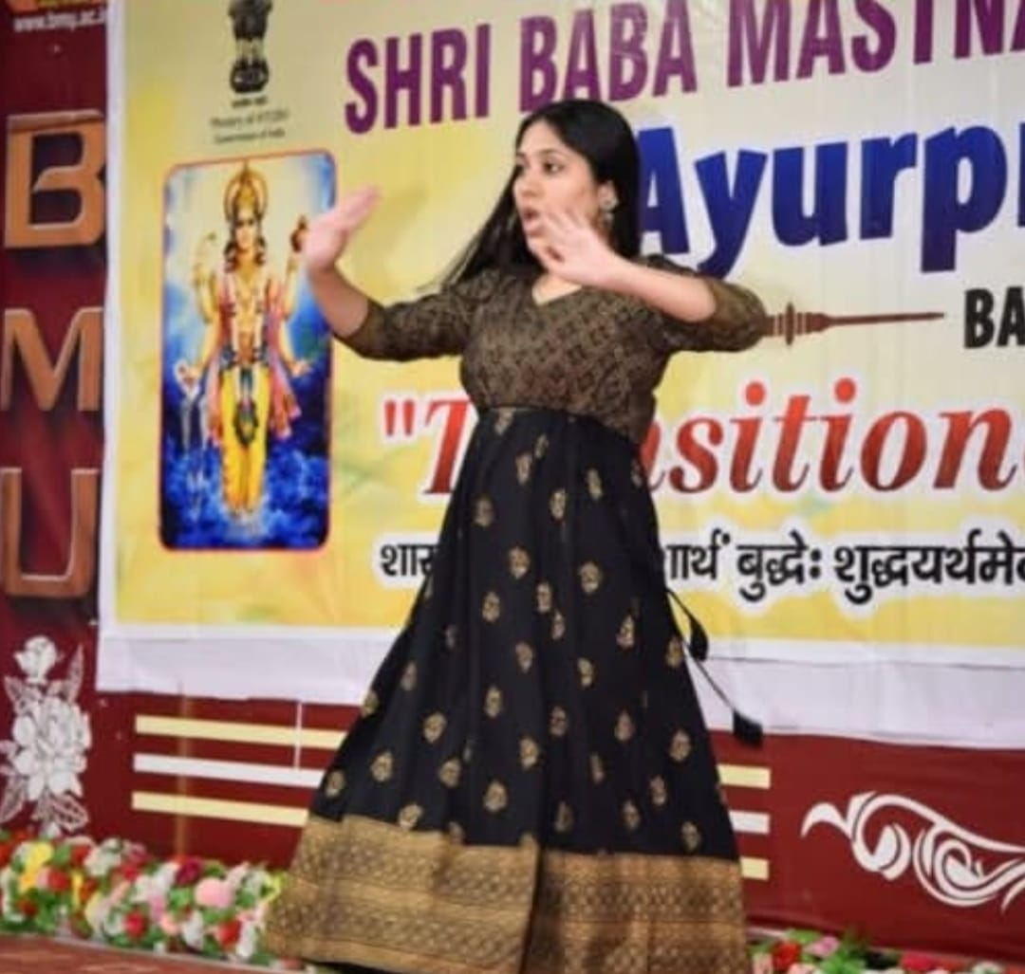

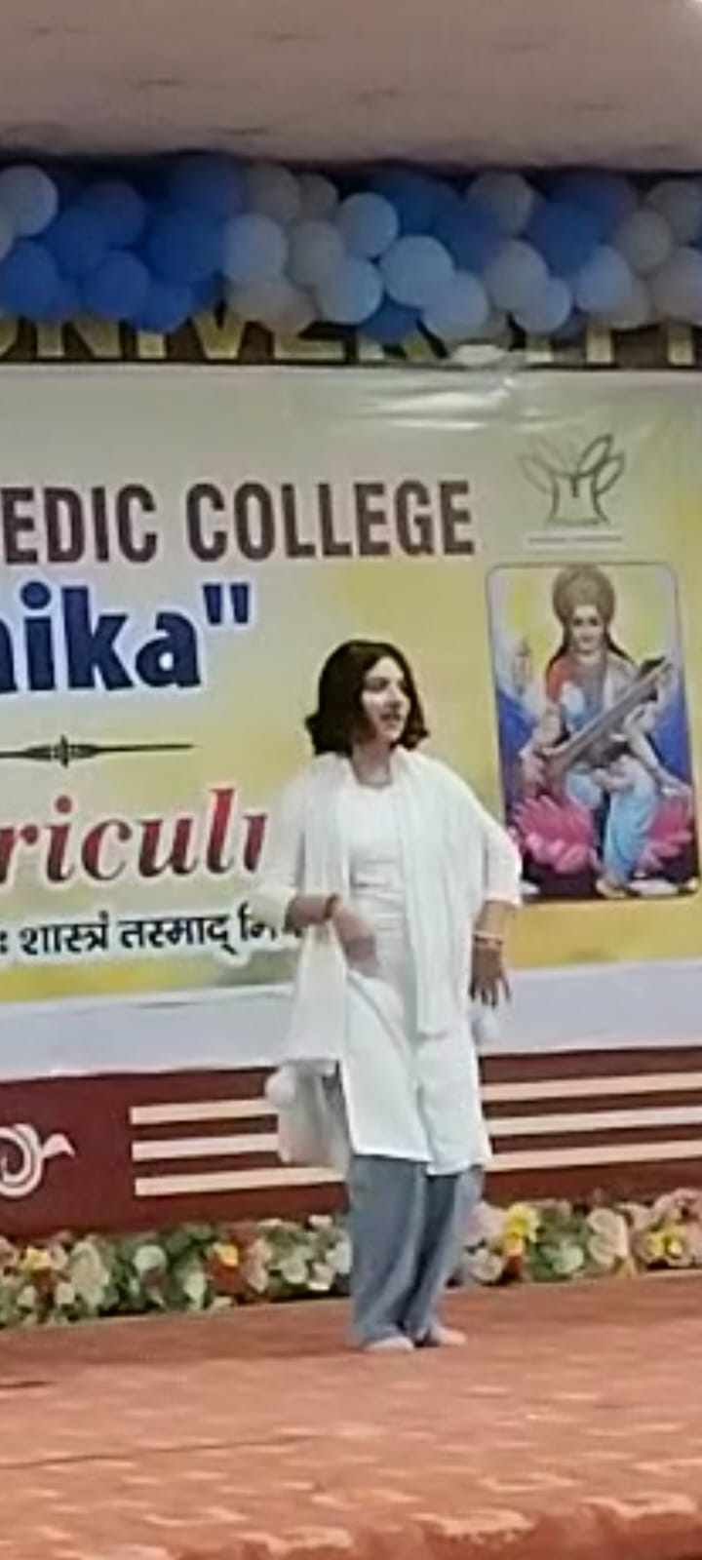
8th day
5/12/2024 friday
9:00 to 10:00 am- Language ( Vadatu Sanskritam) spoken class has been taken by Dr Jagdish
10:00 to 11:00 am- Dr Ajay Dhaiya lecture delivered on Ayurveda Physiology Corelation of Satav, Rajas Tamas with modern Physiology he has explained stava , Rajas, Tamas Prakriti.
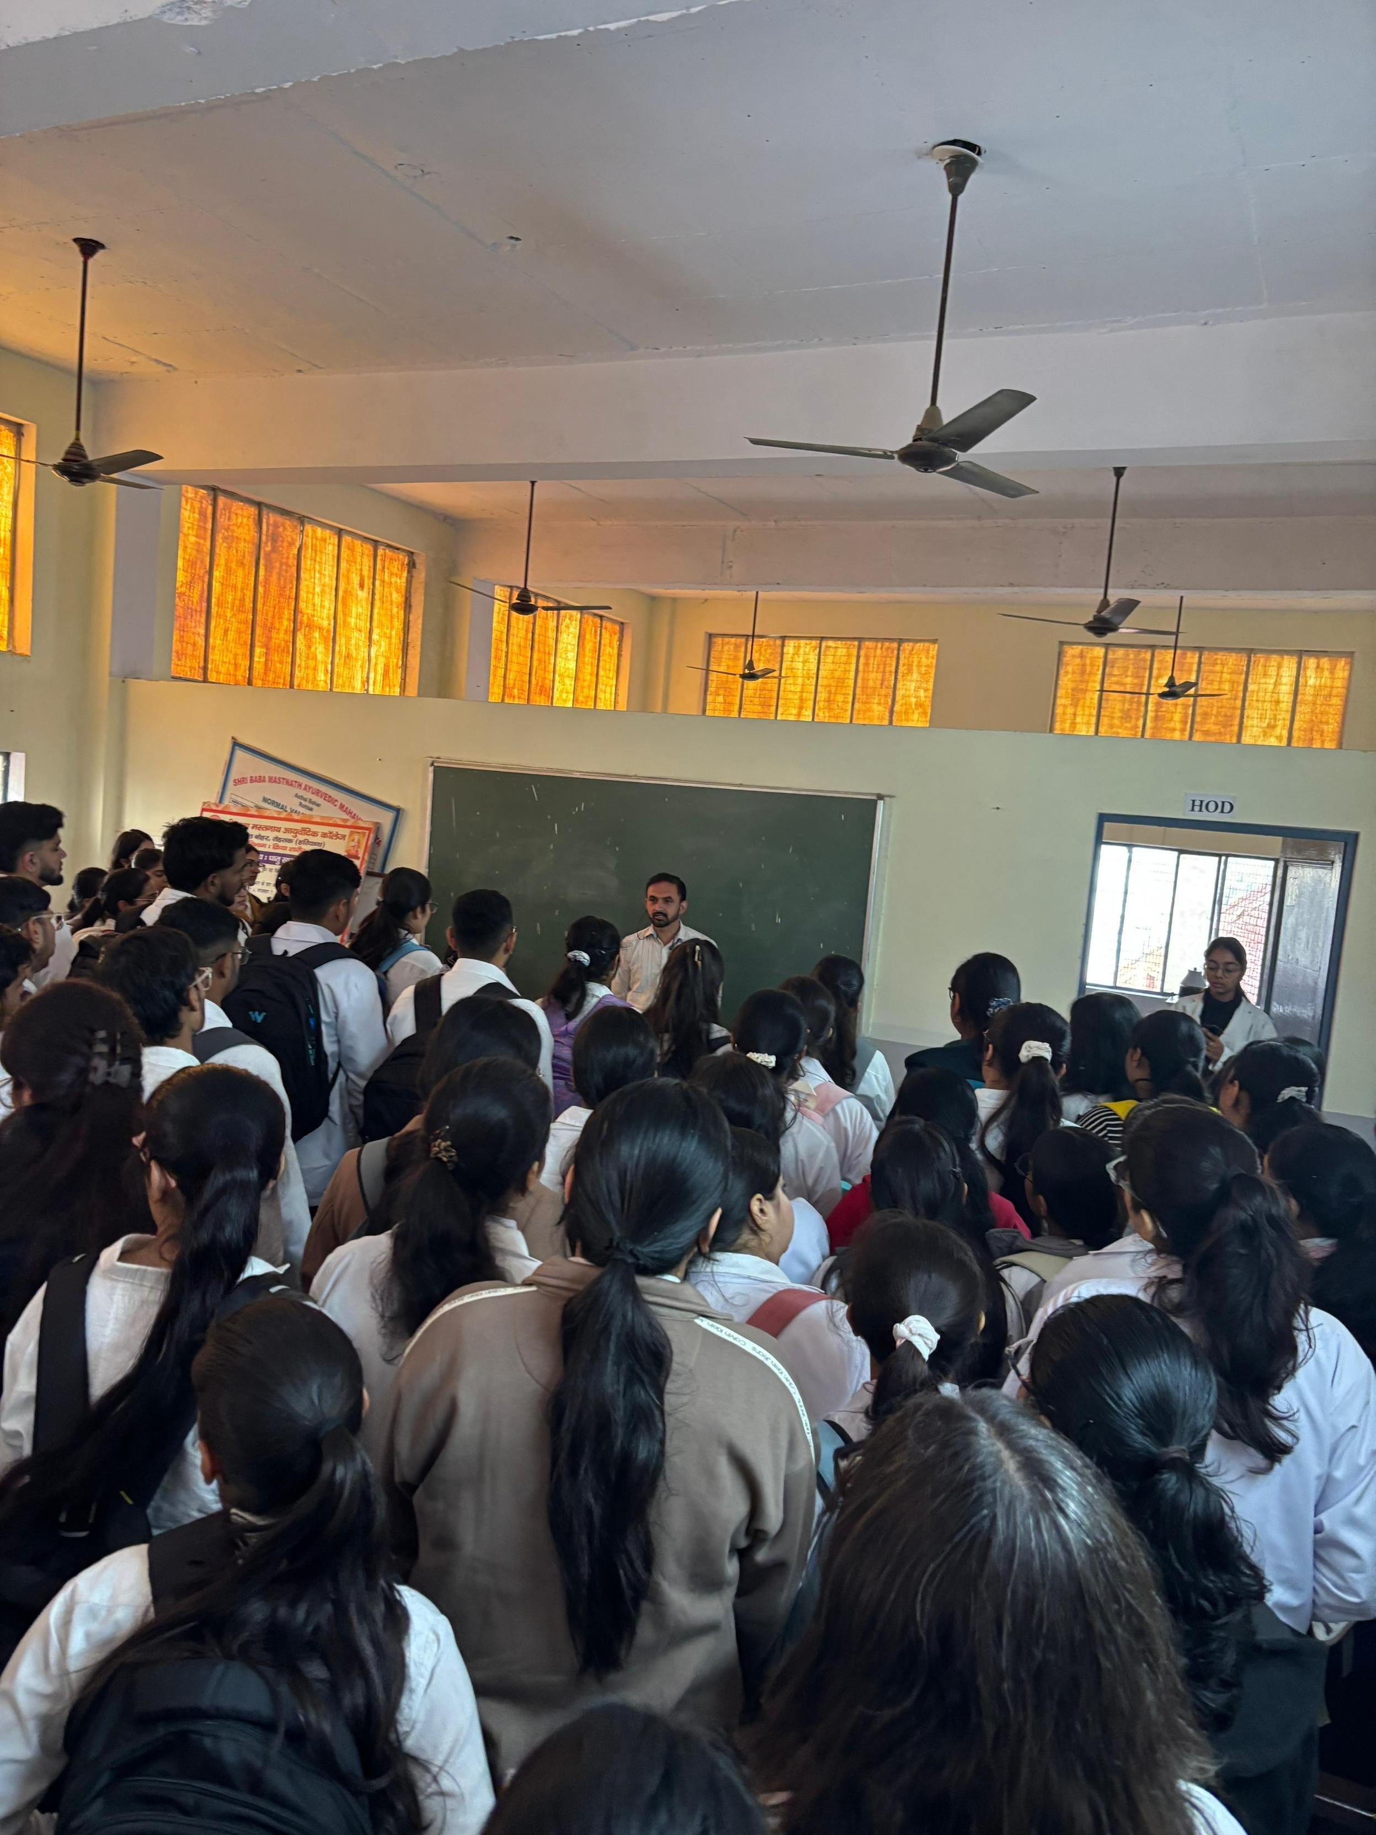

11:00 to 12:00 pm- Dr. Nitin, Assistant Professor, Department of darvyaguna delivered a lecture on the topic of orientation of regulating bodies. In this topic she has shared the knowledge of regulating bodies like AYUSH, NCISM, CCIM etc. related to their organisation, work, mission and objective.
12:00 to 1:00 pm- Dr. Chandranshu, Assistant Professor, Department of Panchakarma has delivered a lecture on the topic personal health and hygiene. In this topic she has shared knowledge to maintain personal hygiene and how to promote personal health and environmental health.

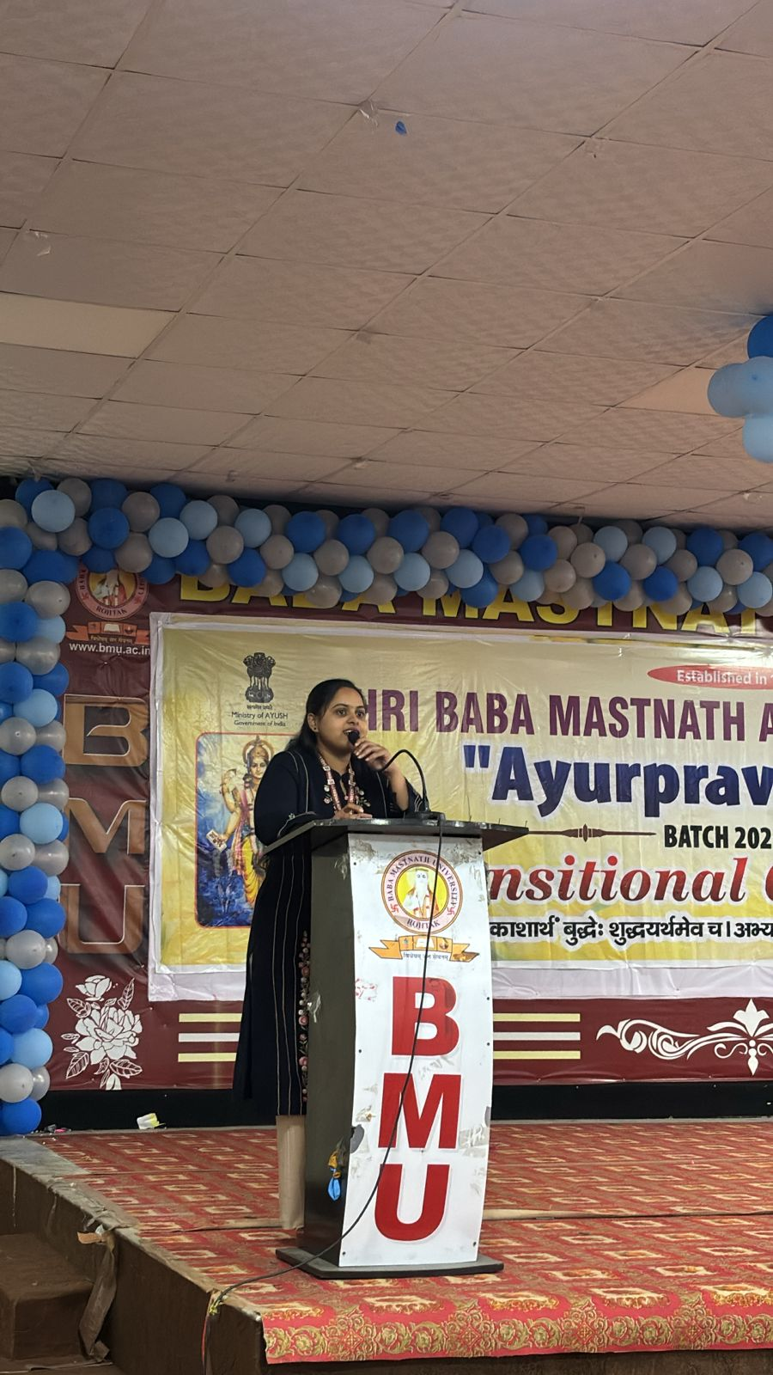

1:00 to 2:00 pm- LUNCH
2:00 to 3:00 Dr Deepak Assistant Professor Department of Samhita delivered lecture on smart goals for academic and professional life.

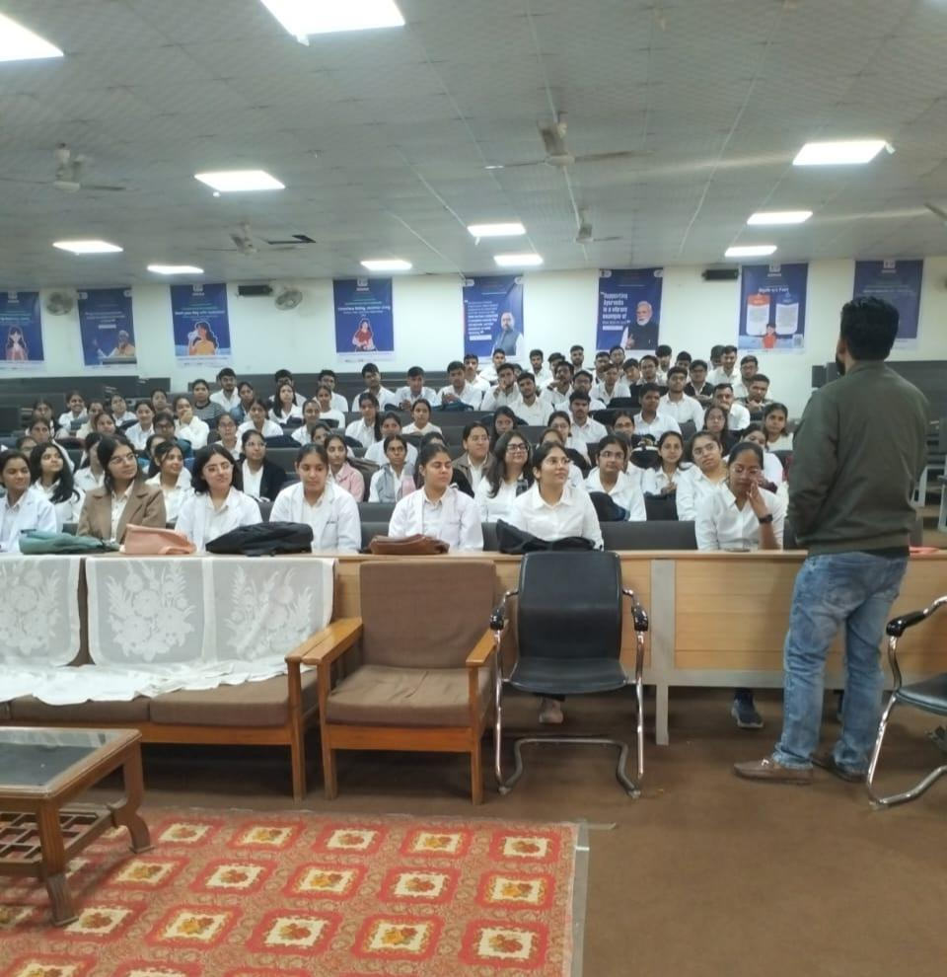

3:00 to 4:00 Dr Sonika Assistant Professor Department of Rachana sharir lecture delivered on Intergrative tradition with Ambition .
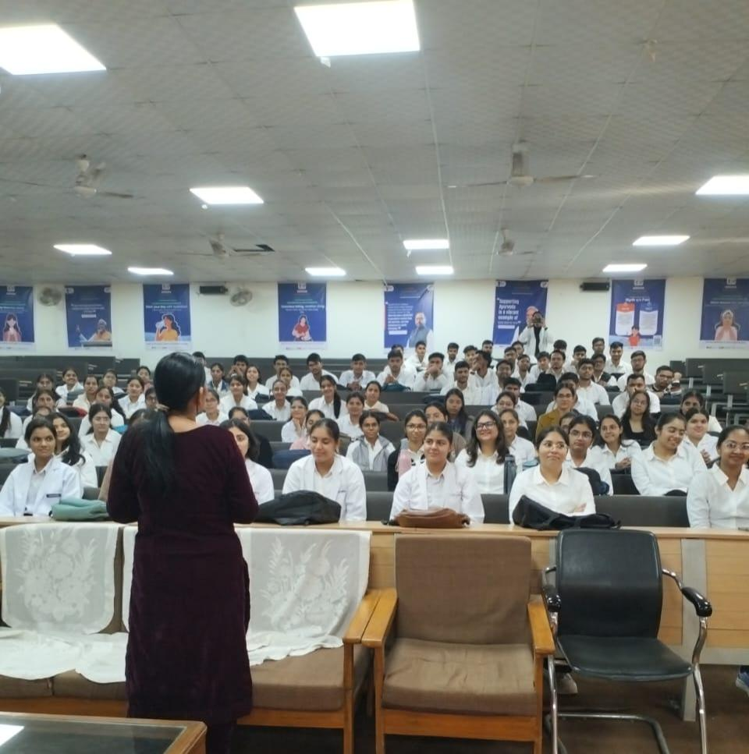

9th day
6/12/2025 Saturday

9:00 to 10:00 am- Language ( Vadatu Sanskritam) spoken class has been taken by Dr Jagdish
10:00 to 11:00 am- A lecture on Computer skills and basic knowledge of internet were taken by Dr. Devender Vashishtha
11:00 to 01:00 pm- Dr. Pooja, Assistant Professor, Department of Agad Tantra has delivered two hours lecture and demonstrated the skills basic life support (BLS) and first aid. She told what immediate steps are to be taken as a first aid to save the life of a patient before taking him into the hospital and have been explained by showing the live examples in his presentation and after that he gave motivational lecture on Ayurveda.

1:00 to 2:00 pm- LUNCH
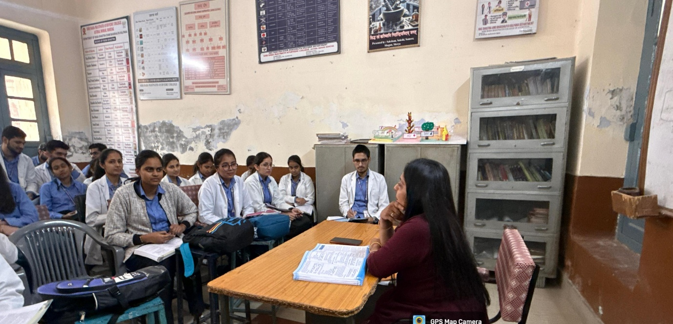
2:00 to 3:00 pm – Dr. Vijender Gupta, Professor, Department of darvyaguna has explained the Students about the Institutional officials and their role in hierarchy.

3:00 to 4:00 pm: Musical chairs

10th day
8/12/2025 Monday

9:00 to 10:00 am- Language ( Vadatu Sanskritam) spoken class has been taken by Dr Jagdish

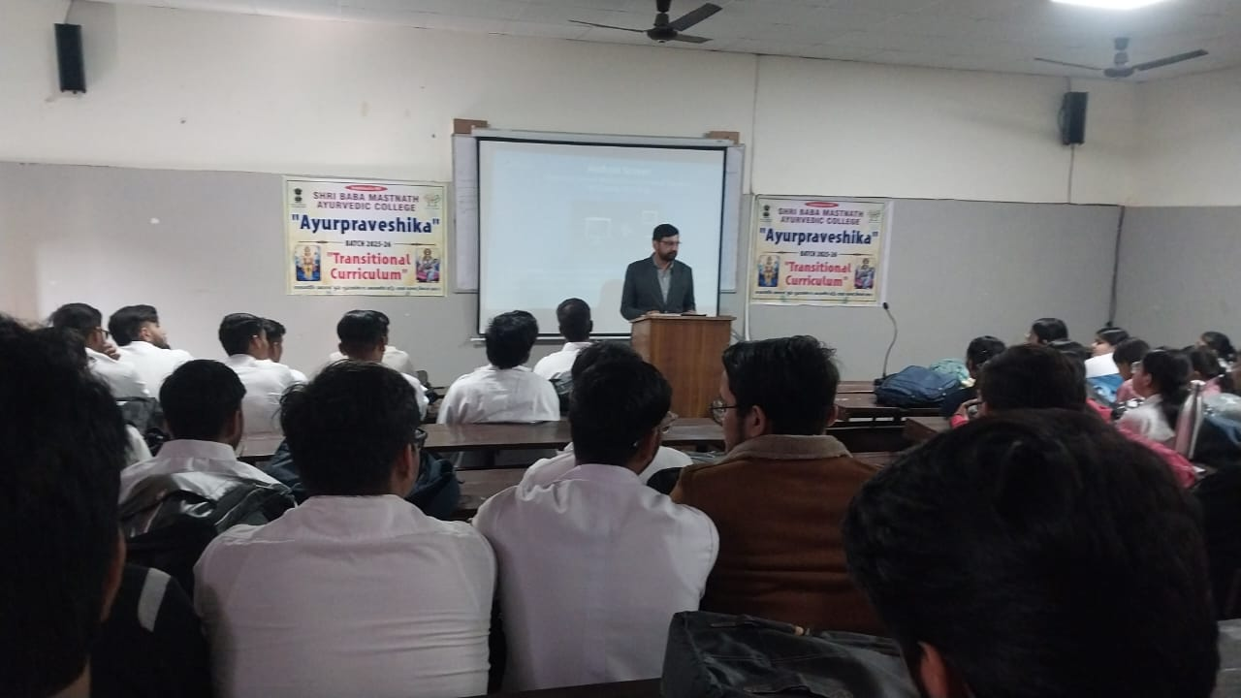

10:00 to 11:00 am- A lecture on Computer skills and basic knowledge of internet were taken by Dr. Devender Vashishtha
11:00 to 12:00 pm - Dr. Ajay dhaiya has delivered an orientation lecture. Students orientation gives new Students the opportunity to familiarise themselves with their Institutions, services, supports.
12:00 to 01:00 : Ms. Kusum, Librarian told Students about demonstration procedure and online documentation of all the books.
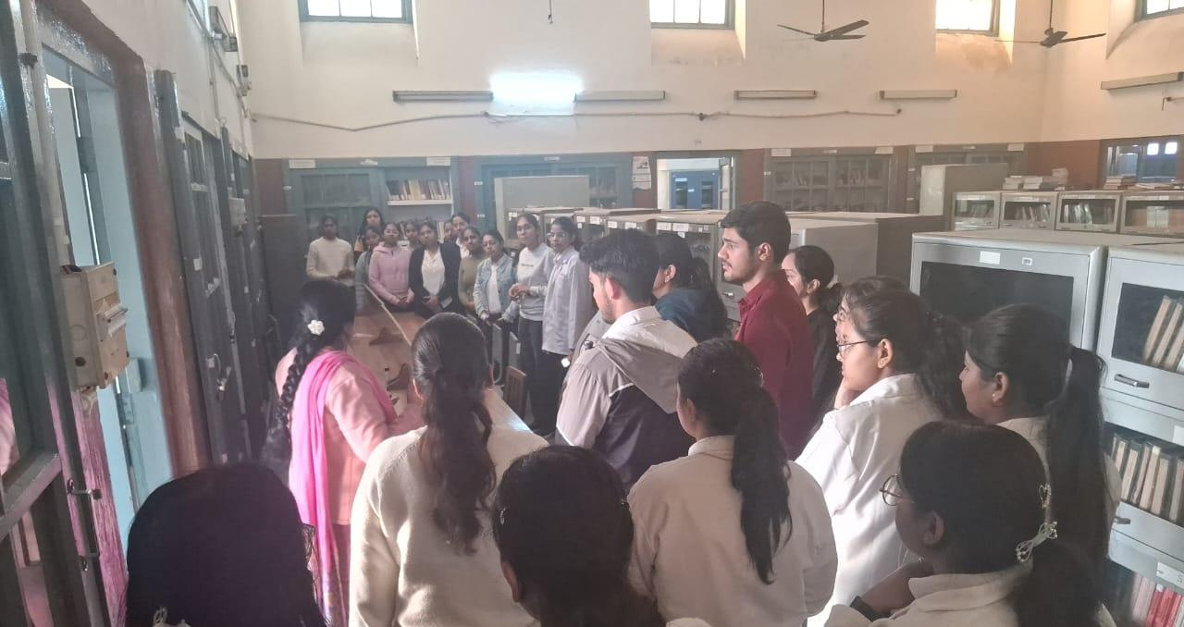

1:00 to 2:00 pm- LUNCH
2:00 to 4:00 pm – Visit to Computer Lab for practical purpose by Dr. Devender Vashishtha

11th day
9/12/2025 Tuesday

9:00 to 10:00 am- Language ( Vadatu Sanskritam) spoken class has been taken by Dr Jagdish
10:00 to 11:00 am- Dr. Sandeep, Professor, Department of Swasthvritta has delivered 1 hour lecture on importance of diet in Ayurveda. He has started his lecture by saying the vision of our ancestors regarding the diet and quoted the popular quote of Hippocrates as “Let Food be the medicine and medicine be the food” he said that just as the machine required fuel the body requires food to survive. He has clearly stated that the intake of food, sleep and observance of celibacy are the three supporting pillars of life and told that among these three foods plays a measure role in health and decease. He has covered various related to food such as classification and food substances, four types of food, Matra Ahaar etc.

11:00 to 12:00 : In this lecture various team building activities were performed by the Students in the supervision of Dr. Gourav Dalal such type of activity help them in their overall grooming, developing their personality, confidence, social cognition and sound bonding with each other.

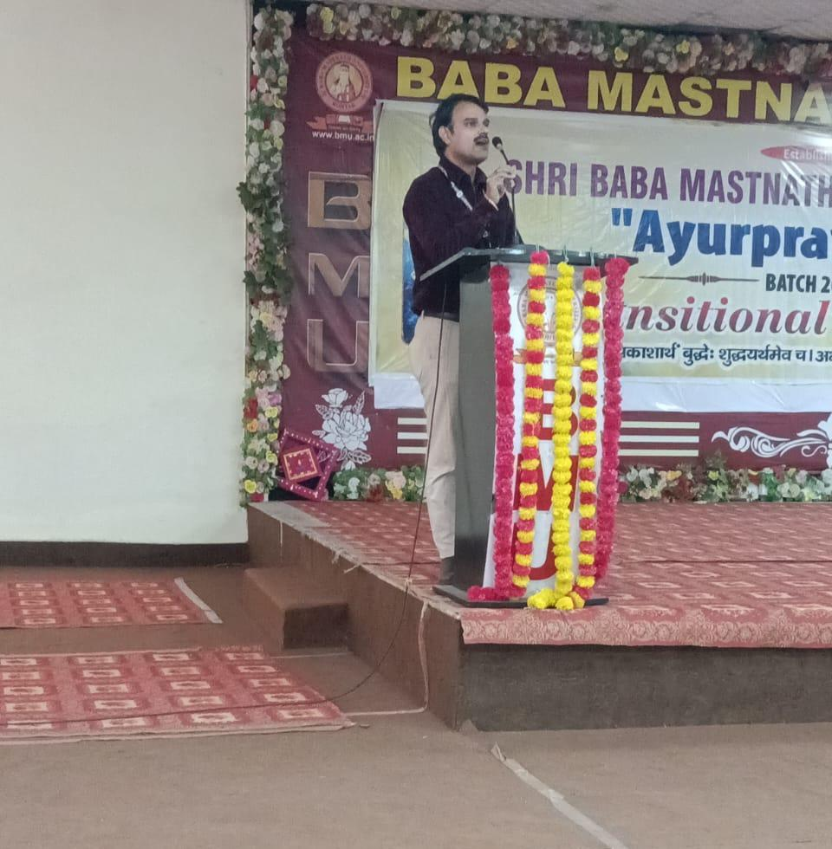

12:00 to 01:00 pm – Dr. Sushma, Assistant Professor Department of stri & parsuti Rog vibhagshared her views on gender sensitization she told gender sensitization is the process of creating awareness regarding gender equality issues and modifying the behavior and views that people hold about the process which helps in examining peoples personal attitudes and beliefs and questiongni the realities they thought they know. She told gender sensitization is a need of the hour. With the chaning time and changing gender roles it is important to spread awareness about the gender issues and take effective steps to create an enabling environment i.e. considerate towards the sentimetns and choices of all human beings. Gender in equalites are learned a young age and that too at various levels i.e. at school, home, family, community etc. Therefore gender sensitization can not take place in a day and is a long term process which requires consistent efforts. She motivated that education can play and important role in gender sensitization.
1:00 to 2:00 pm- LUNCH
2:00 to 3:00 pm – Dr. Amrit Assistant Professor, Department of Samhita delivered a lecture on availing health care facilities in campus. The College provides health care facilities to the Students by providing first aid and other basic facilities as and when required.

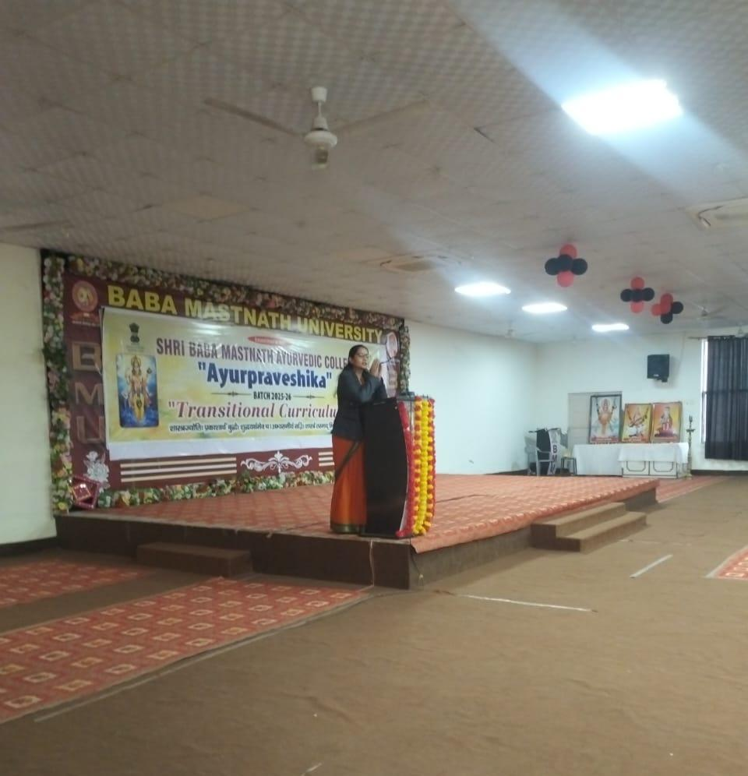

3:00 to 4:00 : Library Visit
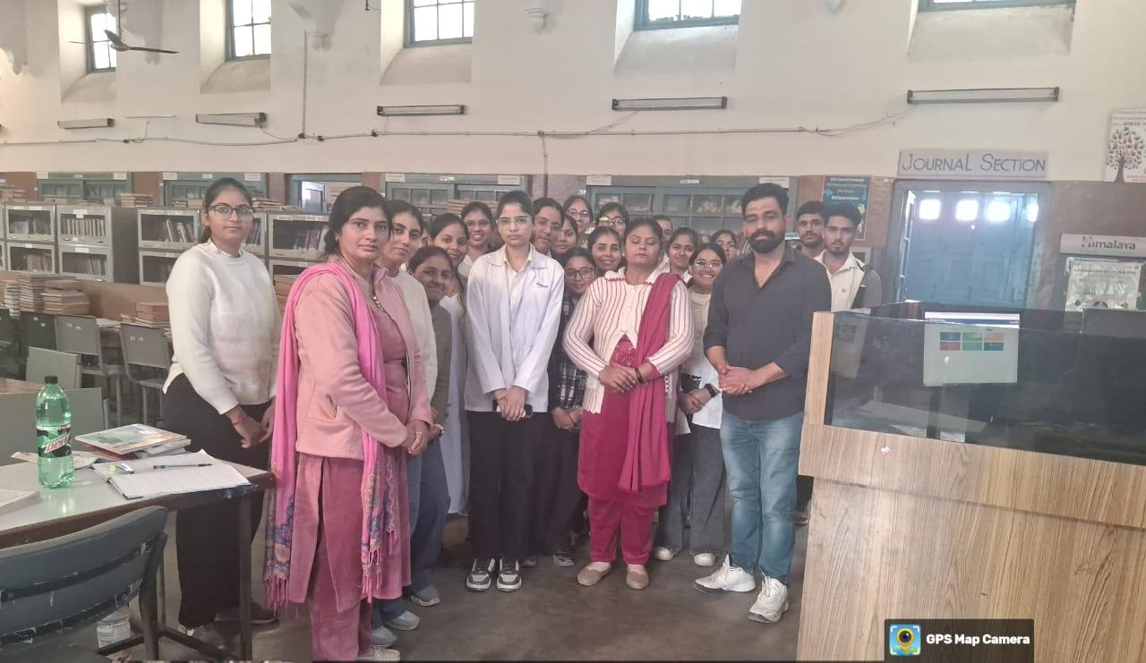

12th day
10/12/2025 Wednesday
9:00 to 10:00 – Language ( Vadatu Sanskritam) spoken class has been taken by Dr Jagdish
10:00 to 11:00 : Dr. Anjali, Assistant Professor, Department of Prasuti Tantra was delivered lecture on learning methods through powerpoint presentation about learners type like visual learner, auditory learner, kin esthetic learner etc. She had intraction with the student with the way of learning and taught them how to do their learning skill better with examples.
11:00 to 12:00 : In this lecture Dr. Gourav Dalal discussed the ultimate objector of everyone’s life is to be happy. He also told what is happiness and how to be happy by practicing scientific theory of happiness (PERMA Model) and spiritual theory of happiness (INDIAN Philosophy). In the end Yogic way to find happiness (Chitta Prasadnam) was also discussed with Students.
12:00 to 1:00 : Dr. Austluxmi Assistant, Professor, Department of Rasshastra has explained basic concepts of Rasashastra. She has explained about various types of drugs used in the filed of Rasashastra like Rasa, Uparasa, Dhatu, Upadhatu, Ratna, Uparatna etc. she told about difference between Sadharana Shodhana and Visishta Shodhana. She has concluded the last day closing remarks.

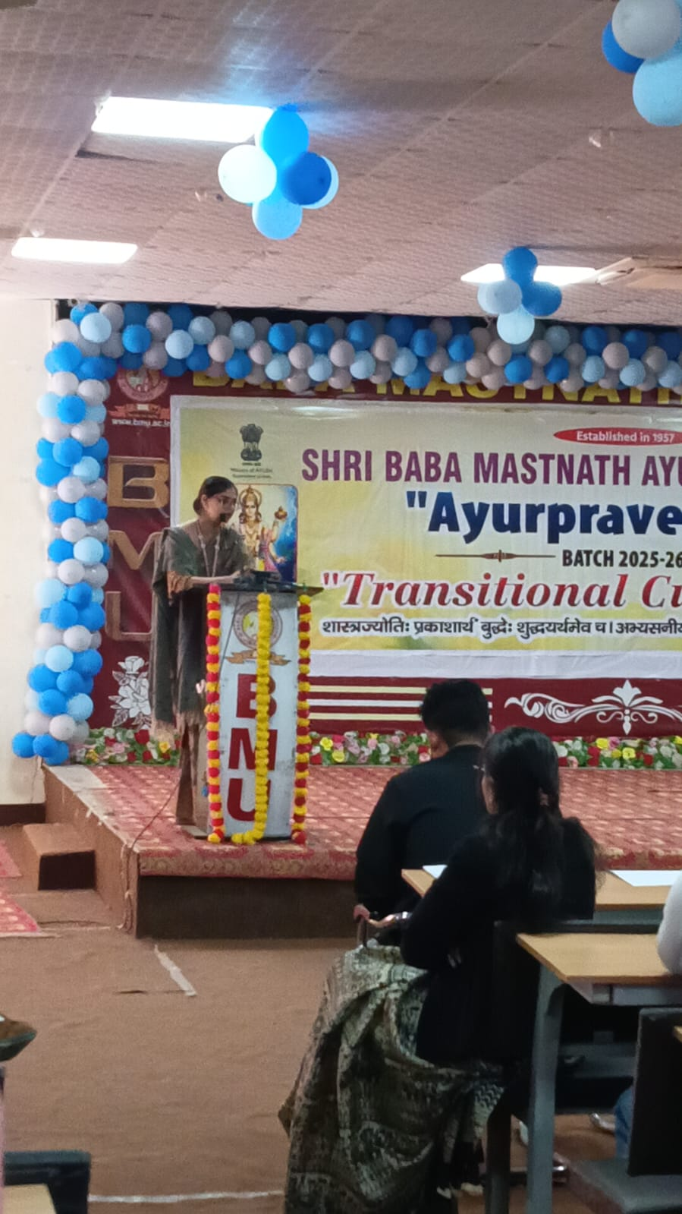

01:00 to 02:00 : LUNCH
02:00 to 03:00: Brahmkumari Ji delivered an enlightening lecture on Adhyatmik Shanti.

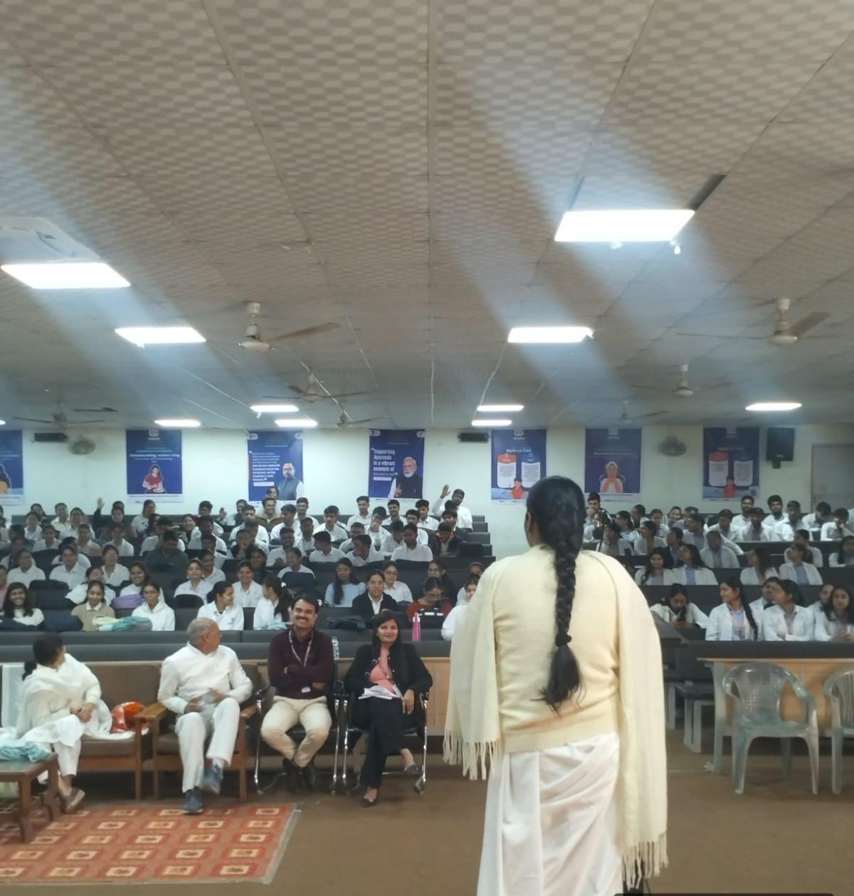

3:00 to 04 :00: Motivational lecture delivered by vadiya stayaparkah

13th day
11/12/2025 Thursday

9:00 to 10:00 – Language ( Vadatu Sanskritam) spoken class has been taken by Dr Jagdish

10:00 to 11:00 : Dr. Deepak, Assistant Professor, Department of Samhita lecture delivered on Smart goals for academic.

11:00 to 12:00 : In this lecture Dr. Gourav Dalal yoga meditation session

12:00 to 1:00 : Dr. Nisha Jaglan Associate, Professor, Department of Agadtantra. Delivered lecture on students safety & Ragging free campus.

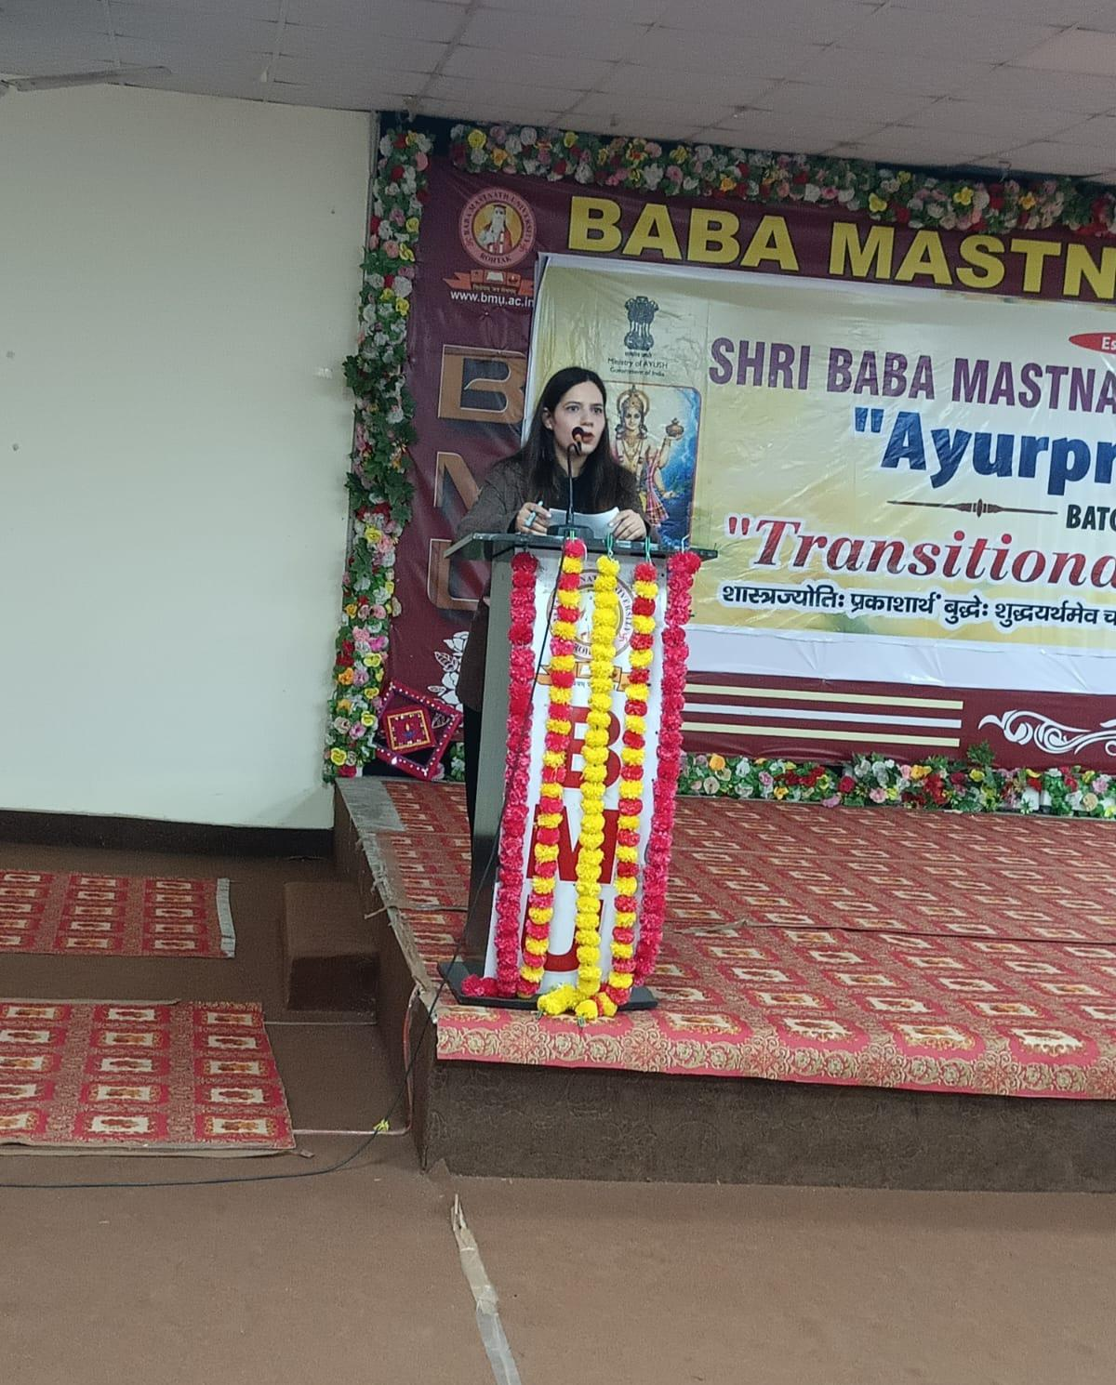

01:00 to 02:00 : LUNCH

02:00 to 03:00: proposed higher education pathways in Ayurveda delivered lecture dr Varun Setia

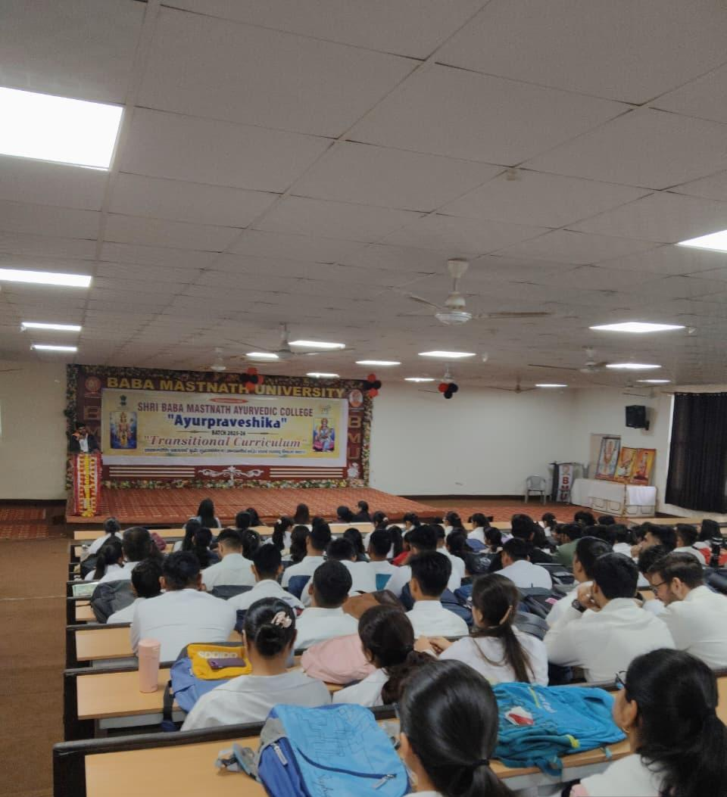

03:00 to 4:00 Timeline creation, time line of the institution milestone Math and Ayurveda college delivered lecture by dr Jagdish.

CLOSING CEREMONY

9:00 to 10:00 : Dr. Sonika , Assistant Professor, Department of Rachna Sharir have supplied feedback forms to all the Students and about 80% of the Studetns have expressed that this programme was help a lot to understand the basics of Ayurveda.

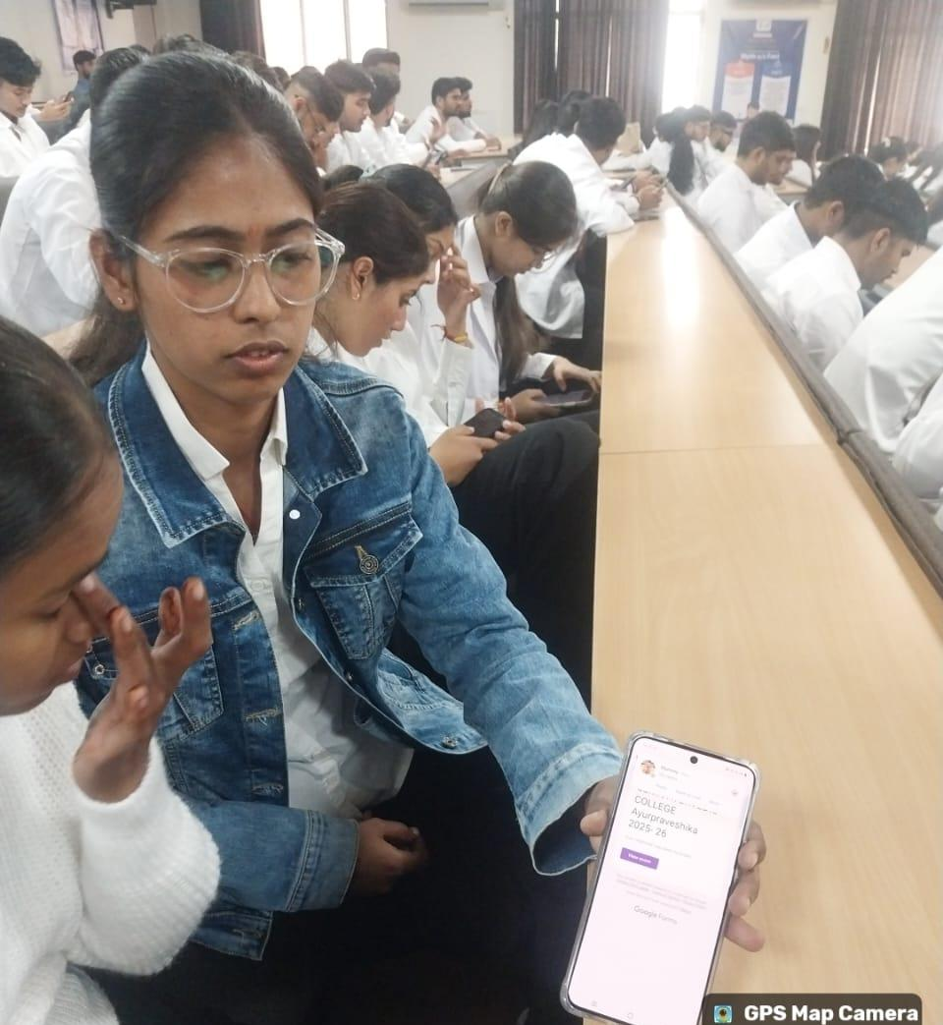

Acharya Balak Nath ji Chancellor, Dr. B MYadav, Vice Chancellor, Dr. Vinod Kumar, Registrar had to come as Chief Guest. It was a matter of great pride for us.

10:00 to 11:30 : The Chief Guest arrived on time our Principal and other Faculty welcomed them with planters. Later the function began with lamp lightening and Dhanvantri Vandna. Then the Students presented cultural performances. Immediately after that the prize distribution took place. The chief guest distributed the prizes to the Students who had want prizes in song, poetry, poster competition etc. during Transition curriculum. After that our chancellor delivered a very motivating speech and advised all the student to work harder in life to get sure success. He also narrated one or two incidents to inspire the students. In the end vote of thanks done by our Principal Dr. Neeraj Kumar Khare and the function ended with National Anthem.

LAMP Lightening
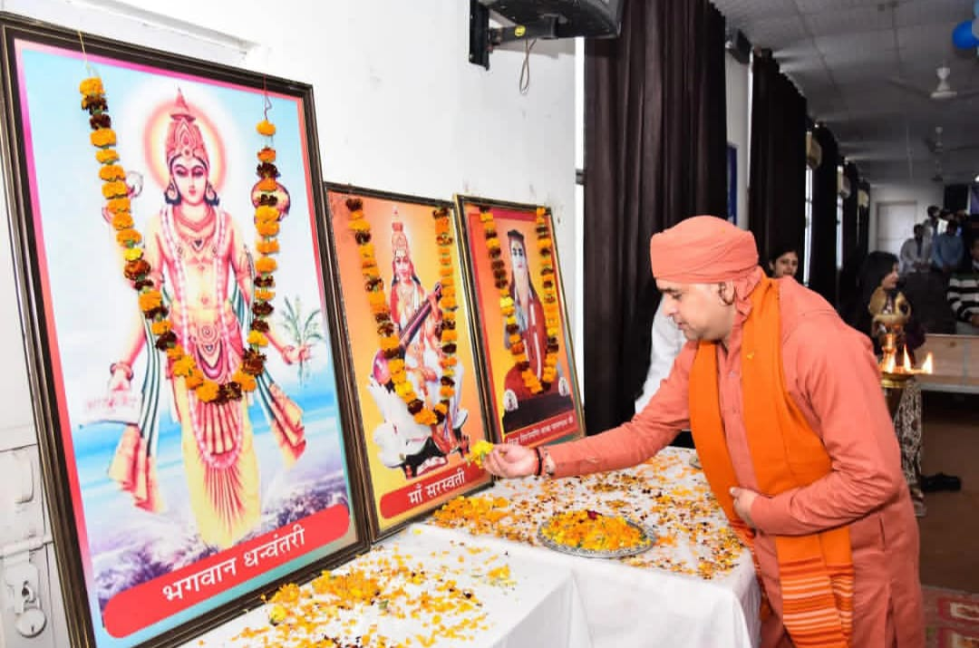
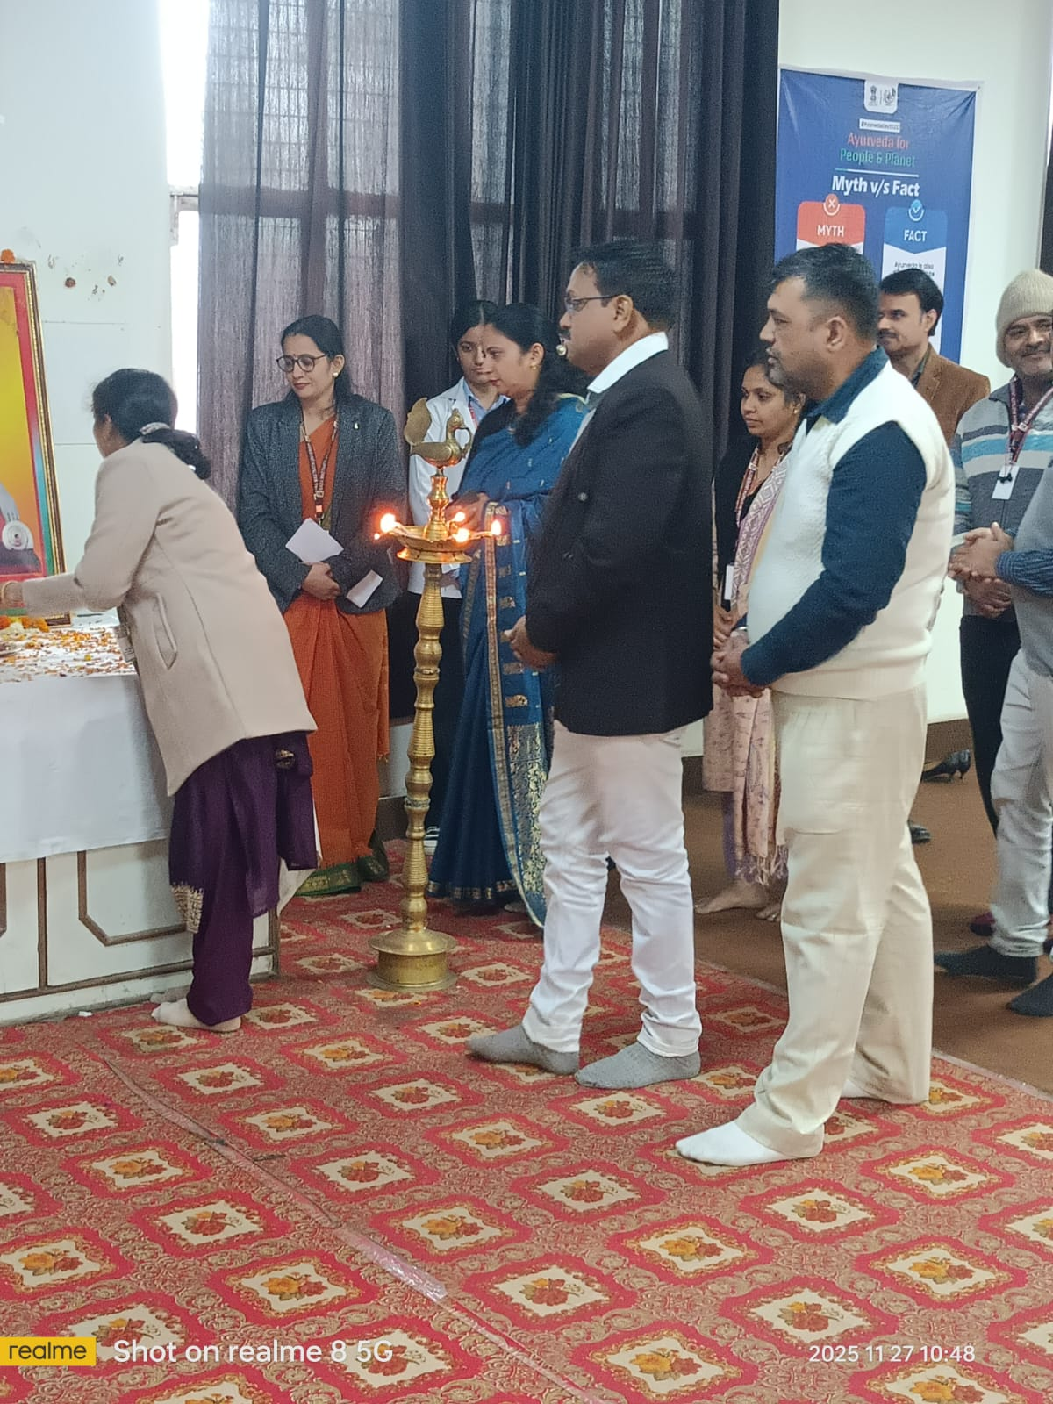

Felicitation

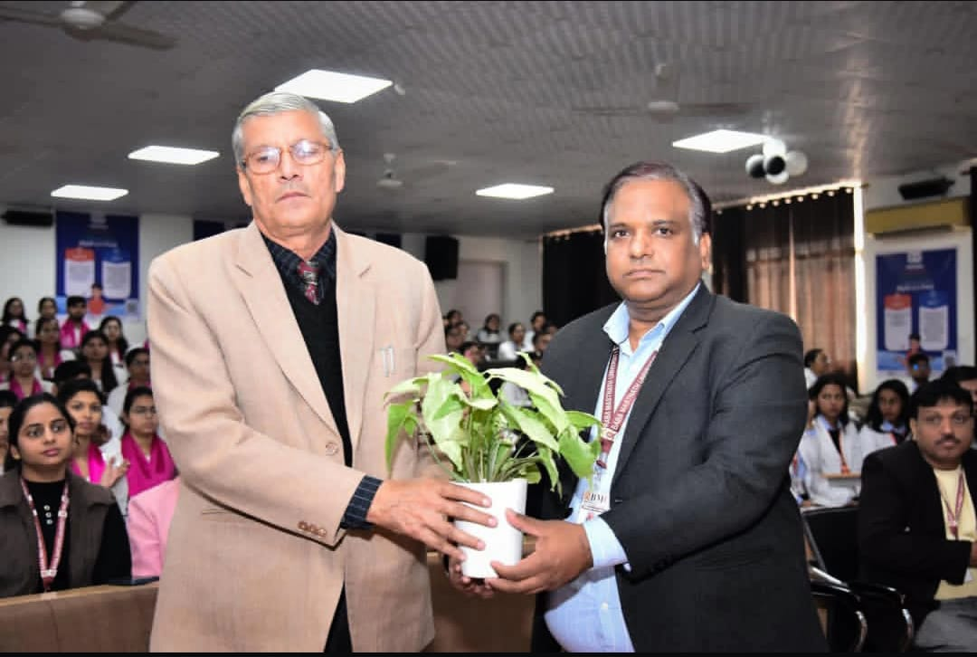
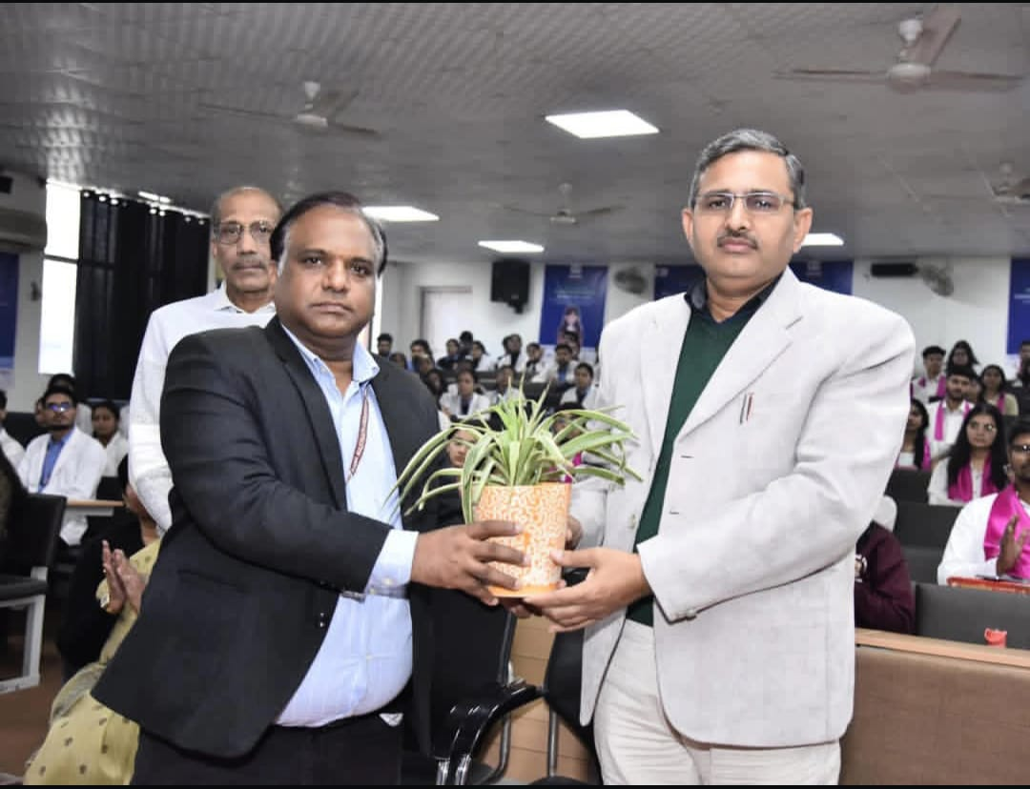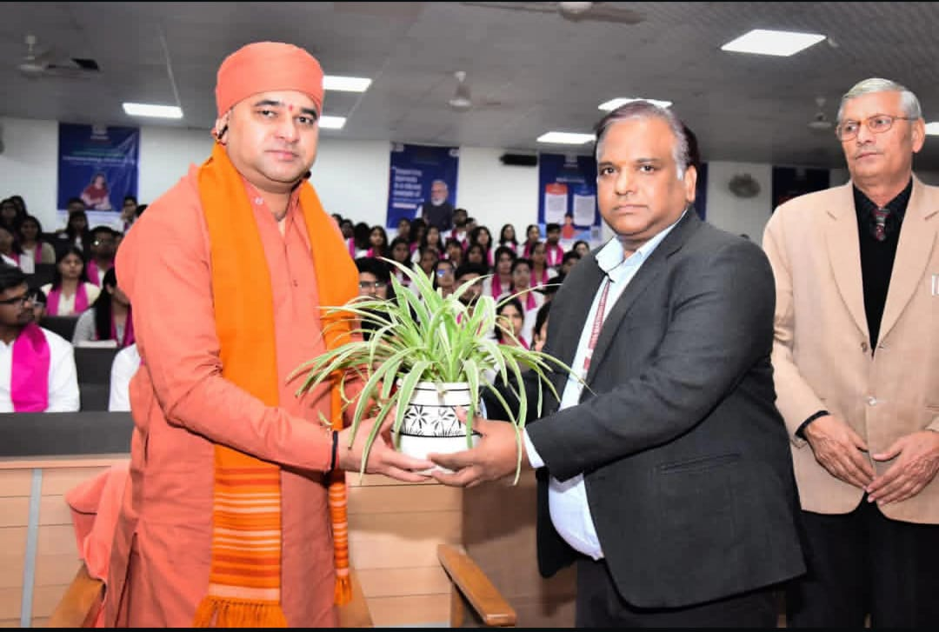

VOTE OF THANKS
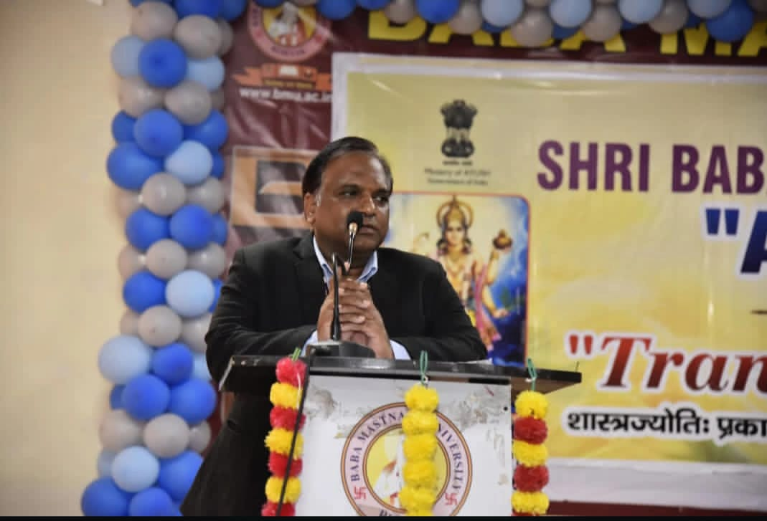

NATIONAL A NTHEM PHOTO
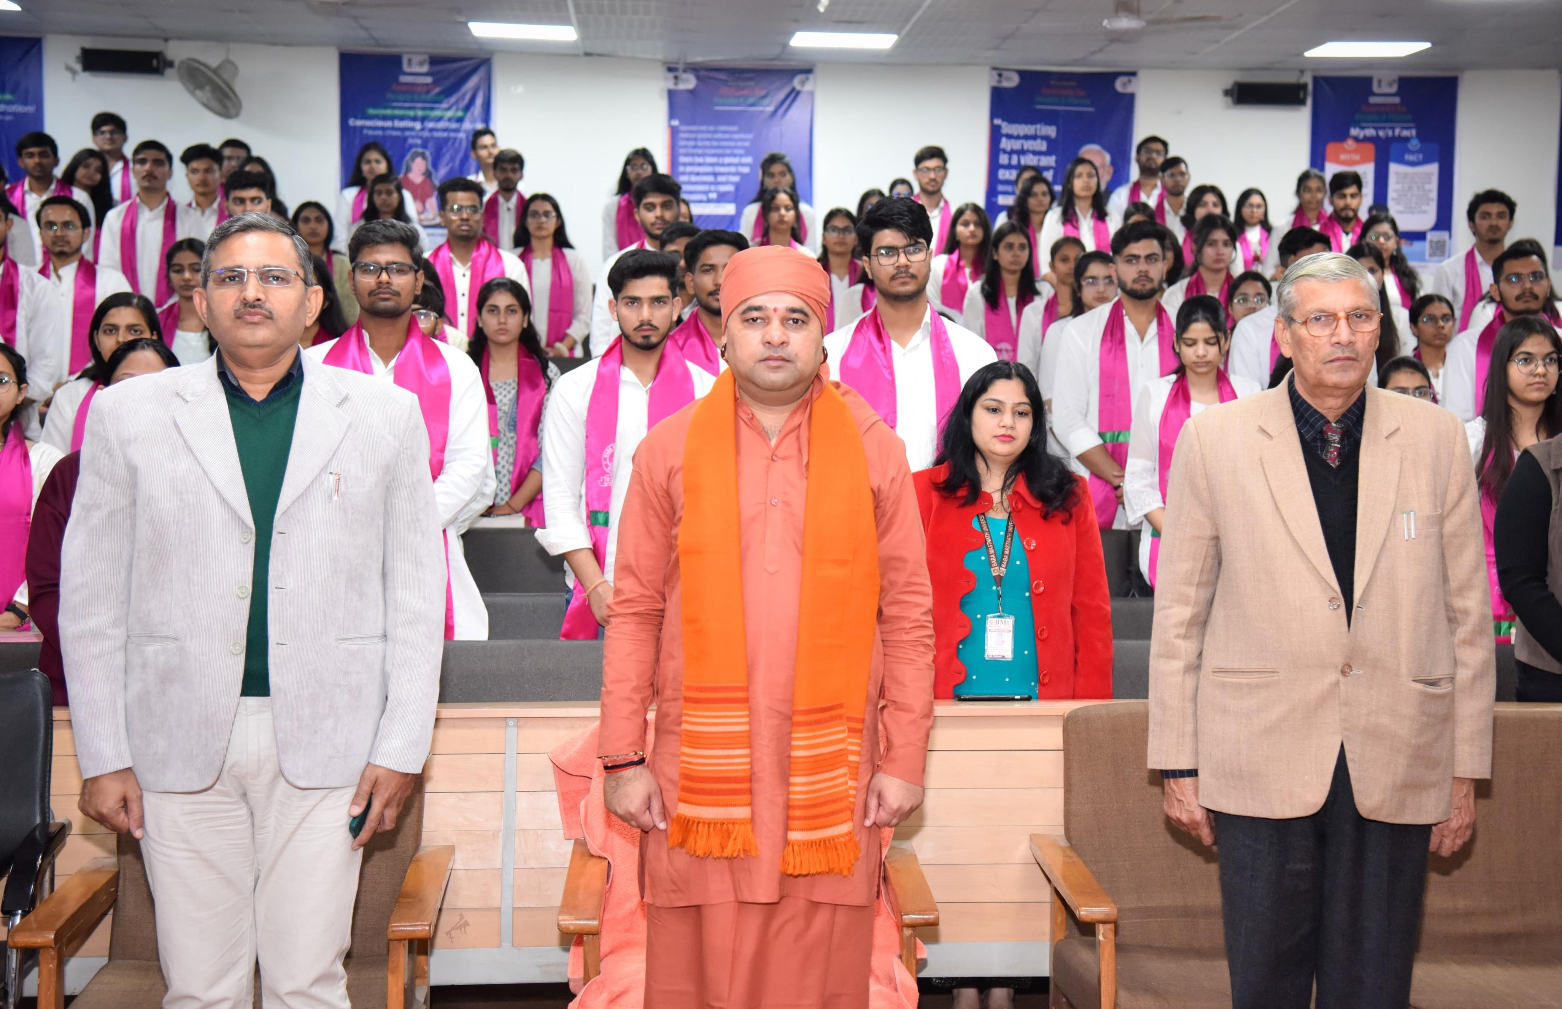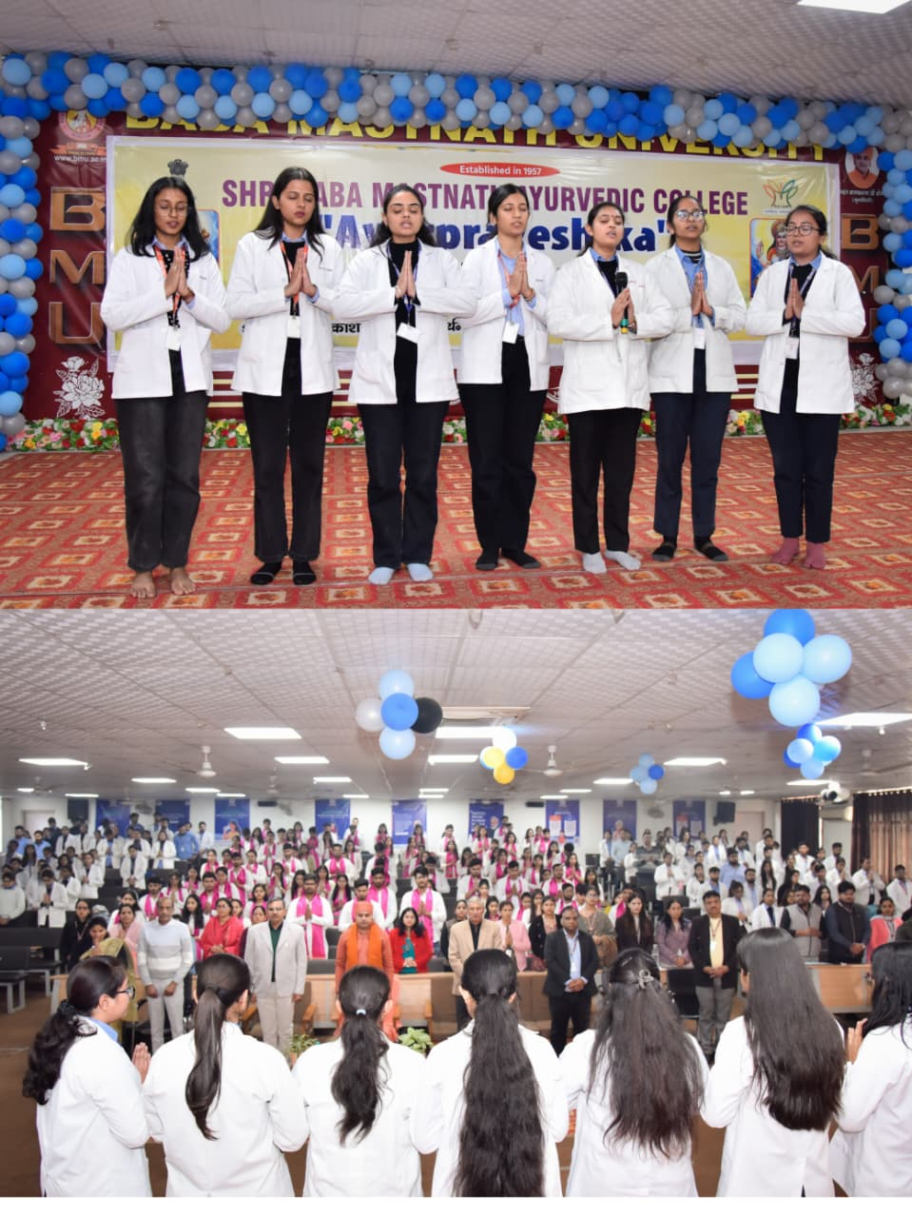

Certificate distribution

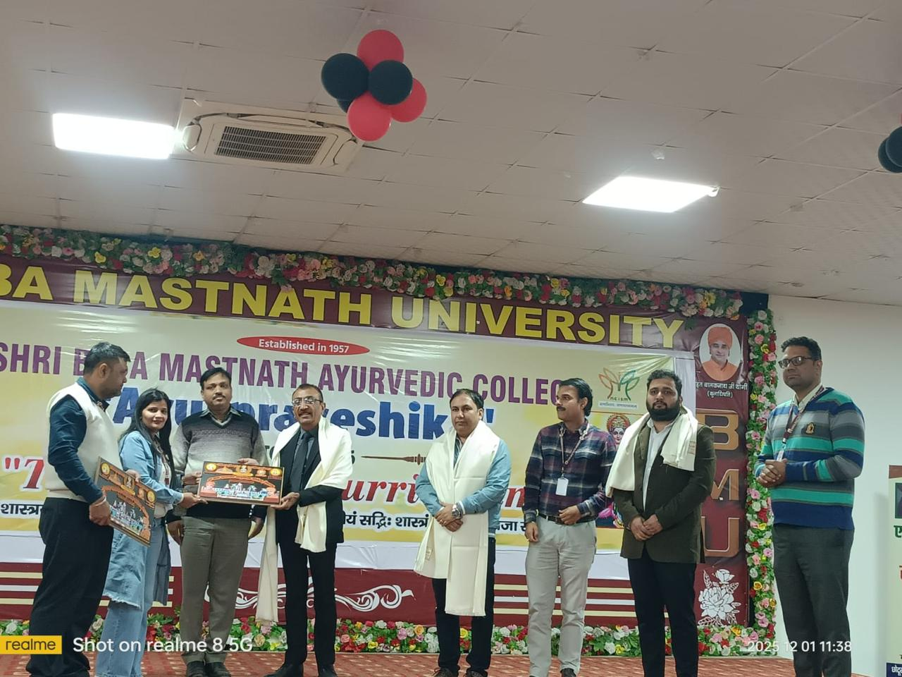

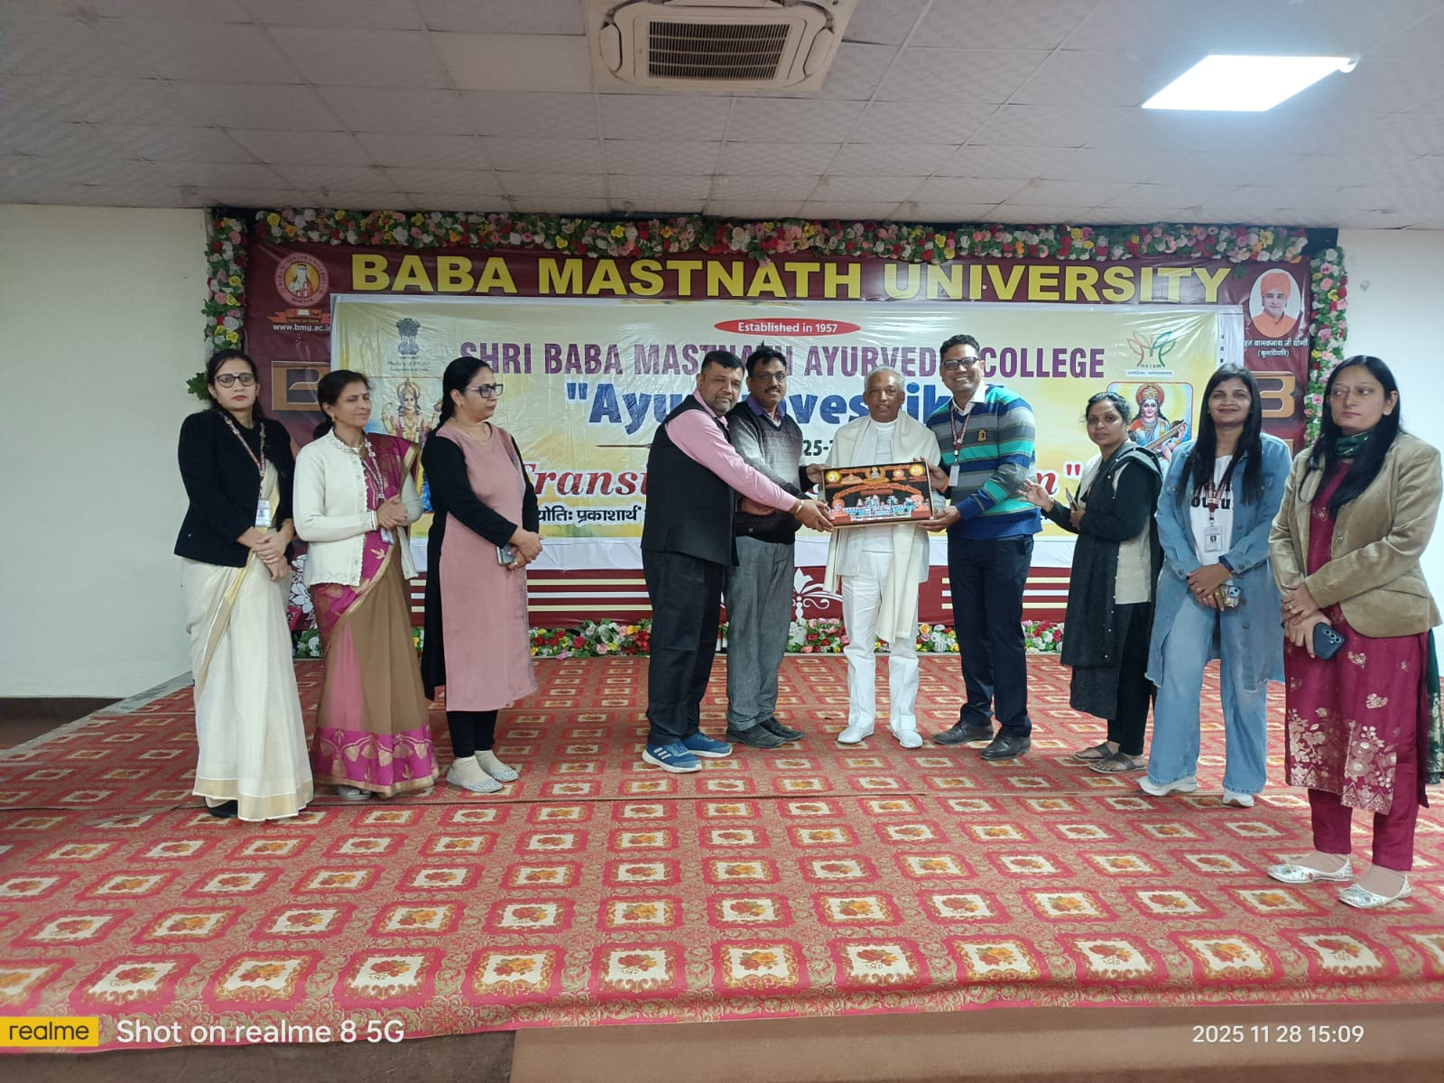

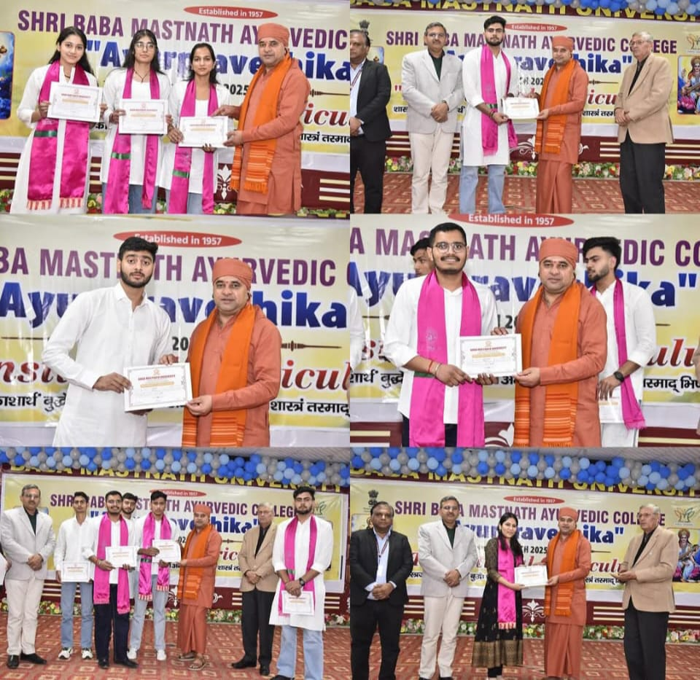
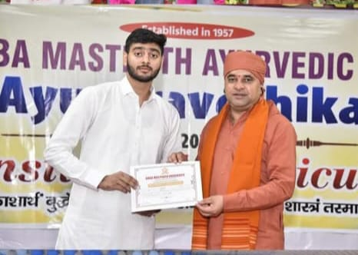
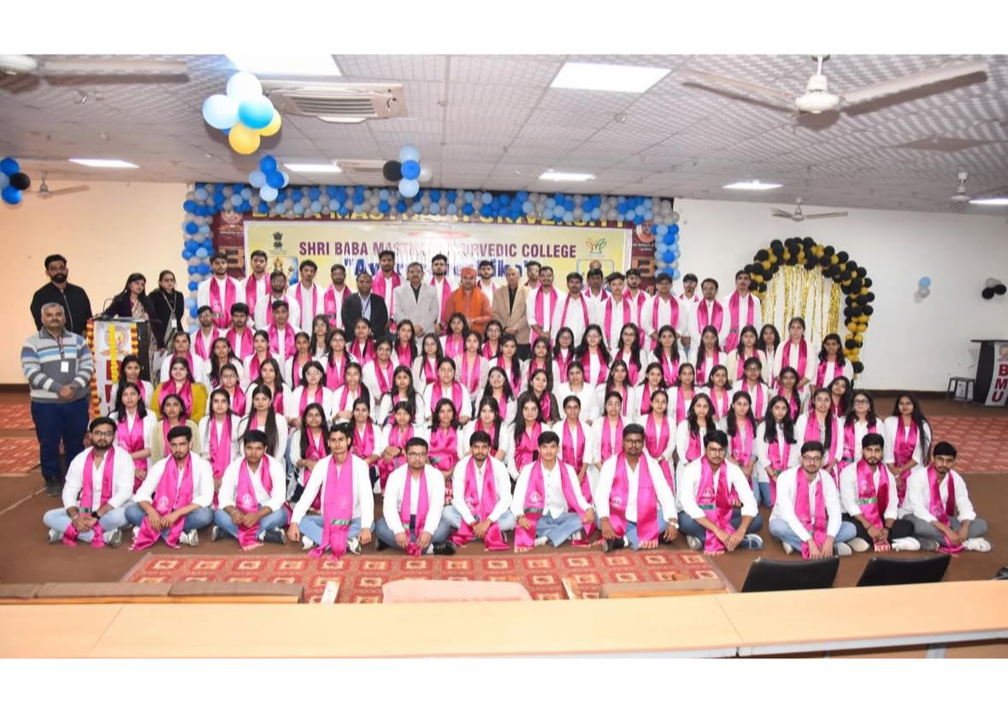

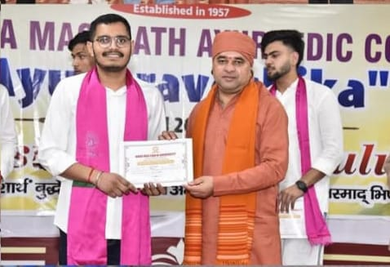

MINUTE TO MINUTE (20.03.2023)
CLOSING CEREMONY OF INDUCTION PROGRAM
(TRANSITIONAL Curriculum)

MINUTE TO MINUTE (12.12.2025)
CLOSING CEREMONY OF INDUCTION PROGRAM
(TRANSITIONAL Curriculum)

time | programme | co-ordinator
09:00 AM TO 10:45 AM – | Gathering of Students and Faculty members
10:45 AM TO 11:00 AM – | Shushrut Pratima Anavaran | Dr. Berkha and Dr. Austluxmi
11:00 AM TO 11:10 AM – | Welcome of Chief Guest | Dr. Nisha and Dr. Amrit Sharma
11:10 AM TO 11:20 AM – | Lamp Lightening | Dr. Amrit and Dr. Sapna
11:20 AM TO 11:30 AM – | Kulgeet | Dr. Sushma Dr Anjali
11:30 AM TO 11:35 AM – | Dhanvantri Vandana | Dr. Monika
11:35 AM TO 11:45 AM – | Felicitation | Dr. Sikha, Dr Neha
11:45 AM TO 11:50 AM – | Welcome Speech | Dr. Ajay Dahiya
11:50AM TO 12:15 PM – | शिष्योपनयन संस्कार  (Shishyopnayan Sanskar)  Induction Ceremony | Dr. Timci
12:15 PM TO 12:45 PM – | Performances by Students | Dr. Naveenta
12:45 PM TO 01:00 PM – | Prize Distribution | Dr. Nitin and Dr. Chandranshu
01:00 PM TO 01:10 PM – | Speech by Hon’ble Vice-Chancellor
01:10 PM TO 01:20 PM – | Speech by Hon’be Pro-Chancellor
01:20 PM TO 01:30 PM – | Thanks Note | Dr Neeraj Kumar Khare
01:30 PM | National Anthem | Dr Pooja

